Table of Contents

**Dynareg Additional field for an account in documents** 1

**Dynareg Additional field for an account in documents**

|  |  |
| --- | --- |
|  | ***Dynareg Additional field for an account in documents plugin*** *- Shop -* ***Licence*** *: Once-off license -*  ***Enable*** *: "Documenten - Extra rekening veld in documentregel"* |

The "*Dynareg Additional field for an account in documents*" plugin for osFinancials5 adds a debtor account in the last column of the lines in the document entry screen.

The debtor accounts can be selected in column for "*Debtors*" accounts in the last column of each line. The column for "*Debtors*" accounts is available in both sales documents, (invoices, credit notes and quotes) and purchase documents (purchases, supplier returns and orders).

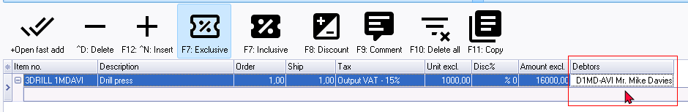

To add a debtor account, you need to double-click on the "*Debtors*" column heading.

The item code (stock code) will add the account code of the selected debtor account in the "*Item no.*" column.

In posted documents, you cannot add or change the debtor account.

Overall, the "*Dynareg Additional field for an account in documents*" plugin enhances the functionality of osFinancials5 by providing a convenient way to input and track debtor account information within document entries, contributing to improved accuracy and efficiency in financial management processes.