Table of Contents

**Dynareg Delivery date plugins** 1

***Dynareg Delivery date 1 plugin*** 2

***Dynareg Delivery date 2 plugin*** 2

***Dynareg Delivery date 3 plugin*** 3

***Dynareg Delivery date 4 plugin*** 3

**Dynareg Delivery date plugins**

Dynareg Delivery date plugins is a series of four plugins. Each successive plugin in the series, including Dynareg Delivery date 2, Dynareg Delivery date 3, and Dynareg Delivery date 4, offers the ability to add an additional delivery date field to document lines within osFinancials5.

By providing the option to add up to four delivery dates on document lines, these plugins offer significant flexibility for businesses to track and manage multiple aspects of their delivery schedules. Users can customize each delivery date field according to their specific requirements, allowing for more granular control over delivery management processes.

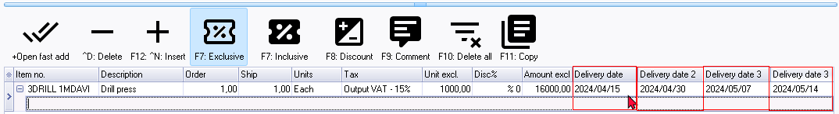

With this capability, users can handle complex scenarios such as staggered deliveries, partial shipments, or multiple stages in the delivery process more effectively. Additionally, it provides a comprehensive solution for businesses that require detailed tracking and reporting on various delivery dates associated with their sales and purchase transactions.

You may adjust or edit these date by selecting the dates in unposted documents.

In posted documents you need to enter a date on the "*Edit date*" screen.

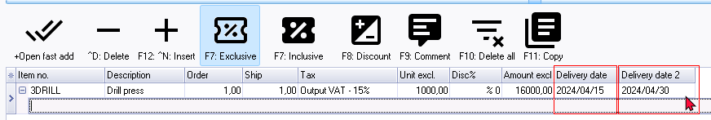

In posted documents, cannot select a date, but you may enter or edit a date.

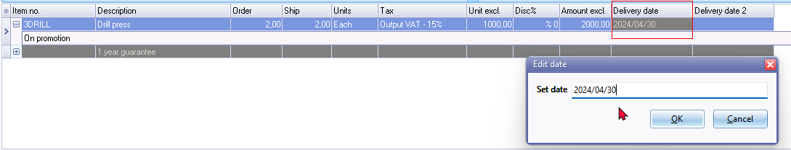

***Dynareg Delivery date 1 plugin***

|  |  |
| --- | --- |
|  | ***Dynareg Delivery date 1 plugin*** *- Shop -* ***Licence*** *: Once-off license -*  ***Enable*** *: "Documenten - Aflever datum in dokument regels"* |

The "*Dynareg Delivery date 1"* plugin will add a "*Delivery date*" column in the document lines in sales documents, (invoices, credit notes and quotes).

The "*Delivery date*" column in the document lines is also available in purchase documents (purchases, supplier returns and orders).

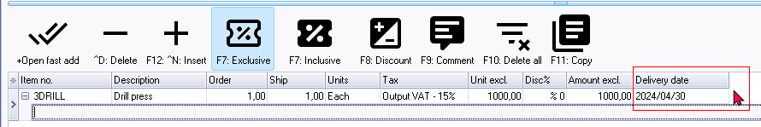

Provides an additional date field in document lines where you can enter a delevery date that can be edited even after you have processed the document.

Overall, the "*Dynareg Delivery date 1*" plugin likely aims to improve order management and logistics within osFinancials5 by introducing features related to specifying, tracking, and managing delivery dates for orders and transactions.

The "*Dynareg Delivery date 1*" plugin is designed to enhance document management in sales and purchase processes. Specifically, it adds a "*Delivery date*" column to the document lines within sales documents such as invoices, credit notes, and quotes.

Additionally, this column is also made available in purchase documents like purchases, supplier returns, and orders. This functionality likely streamlines tracking and managing delivery dates for both outgoing and incoming goods or services.

***Dynareg Delivery date 2 plugin***

|  |  |
| --- | --- |
| ***'n Foto wat wiel, teks bevat  Beskrywing outomaties gegenereer*** | ***Dynareg Delivery date 2 plugin*** *- Shop -* ***Licence*** *: Once-off license -*  ***Enable*** *: "Documenten - 2e Aflever datum in dokument regels"* |

In your documents you now have a 2nd date field per line. In combination with the "*Delivery Date*" plugin, you can, for example, indicate a delivery period between date 1 and date 2 on your invoices.



The "*Dynareg Delivery date 2*" plugin builds upon the functionality of the first delivery date, "*Dynareg Delivery date 1*" plugin by providing an additional delivery date field in document lines. This new field allows users to enter and edit delivery dates even after the document has been processed. This enhancement likely offers more flexibility and control in managing delivery schedules for sales documents such as invoices, credit notes, and quotes, as well as in purchase documents like purchases, supplier returns, and orders.

The plugin extends its features to both sales and purchase processes, adding the "*Delivery date 2*" column to document lines in sales documents such as invoices, credit notes, and quotes, as well as in purchase documents like purchases, supplier returns, and orders. By offering an extra date column, it further streamlines the process of tracking and managing delivery dates for both outbound and inbound items or services.

***Dynareg Delivery date 3 plugin***

|  |  |
| --- | --- |
|  | ***Dynareg Delivery date 3 plugin*** *- Shop -* ***Licence*** *: Once-off license -*  ***Enable*** *: "Documenten - Vrijedatum 3"* |

The "*Dynareg Delivery date 3*" plugin builds upon the functionality of the first two delivery dates, "*Dynareg Delivery date 1*" plugin and "*Dynareg Delivery date 2*" plugin by providing an additional delivery date field in document lines. This new field allows users to enter and edit delivery dates even after the document has been processed. This enhancement likely offers more flexibility and control in managing delivery schedules for sales documents such as invoices, credit notes, and quotes, as well as in purchase documents like purchases, supplier returns, and orders.

***Dynareg Delivery date 4 plugin***

|  |  |
| --- | --- |
|  | ***Dynareg Delivery date 4 plugin*** *- Shop -* ***Licence*** *: Once-off license -*  ***Enable*** *: "Documenten - Vrijedatum 4"* |

The "*Dynareg Delivery date 4*" plugin builds upon the functionality of the first three delivery dates, "*Dynareg Delivery date 1*" plugin, "*Dynareg Delivery date 2*" plugin and "*Dynareg Delivery date 3*" plugin by providing an additional delivery date field in document lines. This new field allows users to enter and edit delivery dates even after the document has been processed. This enhancement likely offers more flexibility and control in managing delivery schedules for sales documents such as invoices, credit notes, and quotes, as well as in purchase documents like purchases, supplier returns, and orders.