Table of Contents

**Dynareg - Free lookup plugin** 1

**Dynareg - Free lookup plugin**

|  |  |
| --- | --- |
|  | ***Dynareg Fee lookup plugin***  ***Enable*** *: "Documenten - Vrije keuzenlijst"* |

When activated, the "Free selection list" plugin adds "*Free lookup*" checkboxes in the document lines. These checkboxes are available in all unposted sales documents such as invoices, credit notes, and quotes, as well as purchase documents such as purchases, supplier returns, and orders.

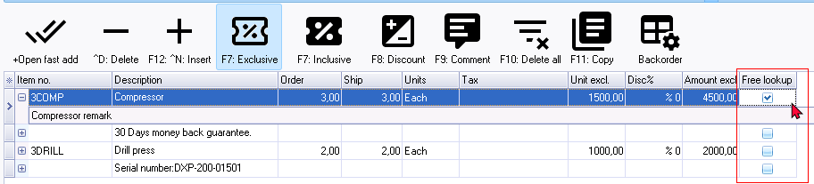

The "*Free lookup*" will be added as a "*Reporting group*" in **Setup → Groups**. You have the option to translate or edit the Group name "*Free lookup*" to suit your specific requirements. Additionally, you can create groups tailored to your specific needs.

