Table of Contents

**Dynareg - Selling prices in purchase documents plugin** 1

**Dynareg - Selling prices in purchase documents plugin**

|  |  |
| --- | --- |
|  | ***Dynareg - Directly Edit Sales Prices in Purchase Documents Plugin*** *- Shop -* ***Licence*** *: Once-off license -*  ***Enable*** *: "Verkoopprijs bij inkoop documenten"* |

This plugin allows you to edit the three sales prices within a purchase document (purchase, supplier return, and order) for a selected item. The updated selling prices will be reflected in the **Ledger** tab of the stock item.

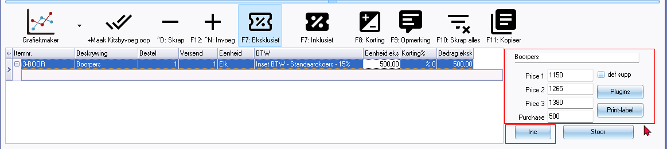

You can edit the prices inclusive or exclusive of Tax (VAT/GST/Sales tax). Additionally:

* **Default Supplier**: You may choose to apply these changes for the default supplier, if one is set for the selected stock item.
* **Plugins button**: If any supported activated plugins are available for the selling price feature, such as the "*Charter plugin*", you may launch them from the **Plugins** button.

Please note that this option is not available for sales documents (invoices, credit notes, and quotes).