Table of Contents

**Dynareg - Transitional Posting in Documents Plugin** 1

**Dynareg - Transitional Posting in Documents Plugin**

|  |  |
| --- | --- |
|  | ***Dynareg - Transitional Posting in Documents plugin*** *- Shop -* ***Licence*** *: Once-off license -*  ***Enable*** *: "Documenten - Transitorisch boeken"* |

The "*Dyna Transitional Posting in Documents*" plugin for osFinancials5 introduces an additional column with a sub-screen to input transitory data within documents. This feature streamlines the management of transitional or temporary information linked with each line item in the document.

Once this plugin is enabled and your Set of Books is reopened, it will incorporate the "*Trans details*" column in sales and purchase document entry screens.

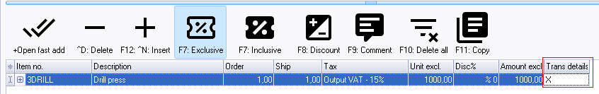

Within each document line, you can select the stock item and double-click on the "*Trans details*" column. This action opens the "*Transitional items*" screen.

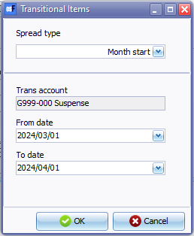

Here you can specify:

* **Spread type**: Choose between "*Month start*", "*Month end*", or "*Week*".
* **Trans account**: Select a transitional account. **Note** that only Balance sheet type ledger accounts (excluding Bank accounts and Tax codes) will be available for selection.
* **Dates**: Confirm or choose the "*From date*" and "*To date*".

Clicking **OK** saves the transitional data. Upon moving to another line, an "*X*" appears in the "*Trans details*" column for the item, indicating the presence of transitional data.

If you need to edit the transitional data for the item, simply double-click on the "*Trans details*" column or click the "*Lookup*" icon at the end of the column.

Overall, the "*Dyna Transitional Posting in Documents*" plugin enhances osFinancials5 by offering a convenient method to manage and record transitory data within documents, contributing to improved organization and detail.

Transitory data refers to temporary or short-lived information not intended for permanent storage or retention. It is typically used for immediate processing or transmission purposes and is often discarded once its purpose is fulfilled.