Table of Contents

**Known issues - Bank import plugin** 1

***Balance batch option*** 1

***List the transactions in the batch (Exclude Tax amounts)*** 2

***List the transactions in the batch (Include Tax amounts)*** 3

**Known issues - Bank import plugin**

***Balance batch option***

**Balancing batches**

If a batch is not balanced, the Tax amounts in not included in the F8: Batch list **List batch - Unposted batch** report. Once batches are balanced, the **F8:List** on the **List batch - Unposted batch** report, will include the Tax amounts.

* As with normal batches, the **F5:Balance** icon is accessible on the Batch entry (normal batches for Bank accounts).
* In the Bank import there is no **F5:Balance** icon but it is accessible in the **F9:Process** and select **Balance batch** option.
* In the Bank import plugin, it only populates the Contra account when a bank account is balanced.

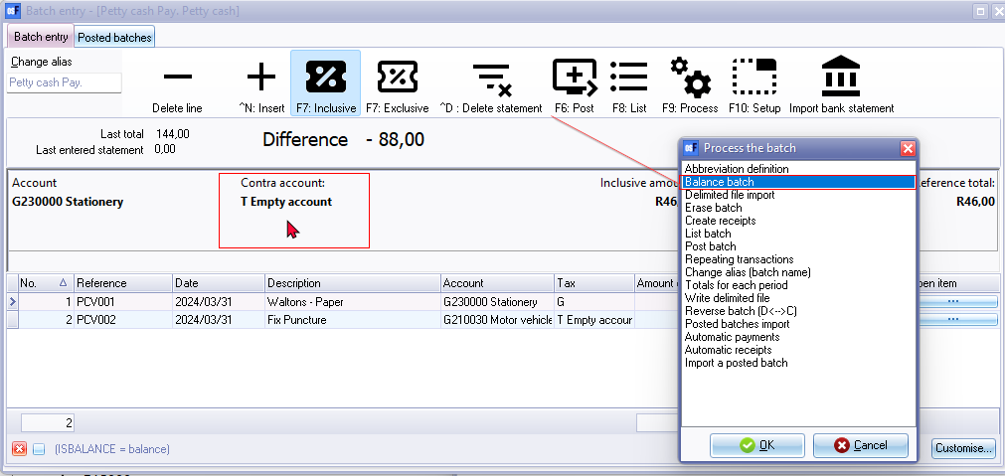

In Firebird databases could not find any issues with dates causing issues with the unbalanced and balanced batches.

Balancing and Posting a Bank Import plugin batch and the Posting the Batch does not duplicate transactions when Posting a Balanced Bank import batch.

Maybe the **F5:Balance** icon could be added to the top with the other icons in Bank import plugin batches.

***List the transactions in the batch (Exclude Tax amounts)***

Once the transactions is imported and allocated to accounts, including Tax (VAT/GST/Sales tax) the Tax amounts is not included in the **F8:List** on the **List batch - Unposted batch** report.

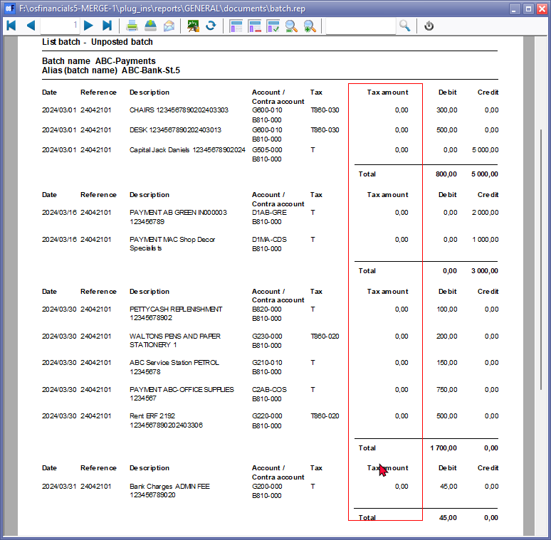

**NOTE** : Once you Post the batch, it generated the balancing entries including Tax

To include the Tax transactions, you need to go to **F9:Process** and select **Balance batch** option.

Once this is done, you need to access the unposted batch and Delete the balancing entries.

This will include the Tax (VAT/GST/Sales tax) in the **F8:List** on the **List batch - Unposted batch** report.

***List the transactions in the batch (Include Tax amounts)***

Click on the **F8: List** icon to print a list of the imported and allocated transactions in the unposted bank account batch.

