Table of Contents

**Known issues - Drill down plugin** 1

**Drill down plugin - Stock item Invoice AV Error** 2

Other options – No Errors 3

**Known issues - Drill down plugin**

|  |  |
| --- | --- |
|  | ***DrillDown plugin*** *- Manual - Shop -* ***Licence :*** *Once-off -*  ***Documentation*** *: Help documentation -* ***Online Help documentation*** *: Drill down plugin*  ***Translations*** *: Outstanding* |

**Drill down plugin - Stock item Invoice AV Error**

Stock items invoice option includes serial numbers - When Filter select a Stock item on the filter, produces Access violation error (usually happens once a Stock item is filtered and select the (All) option on the filter list)

*Access violation at address 61618965 in module 'TCDrillDown.of5'. Read of address 00000000*

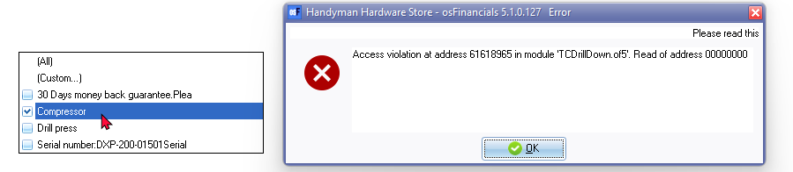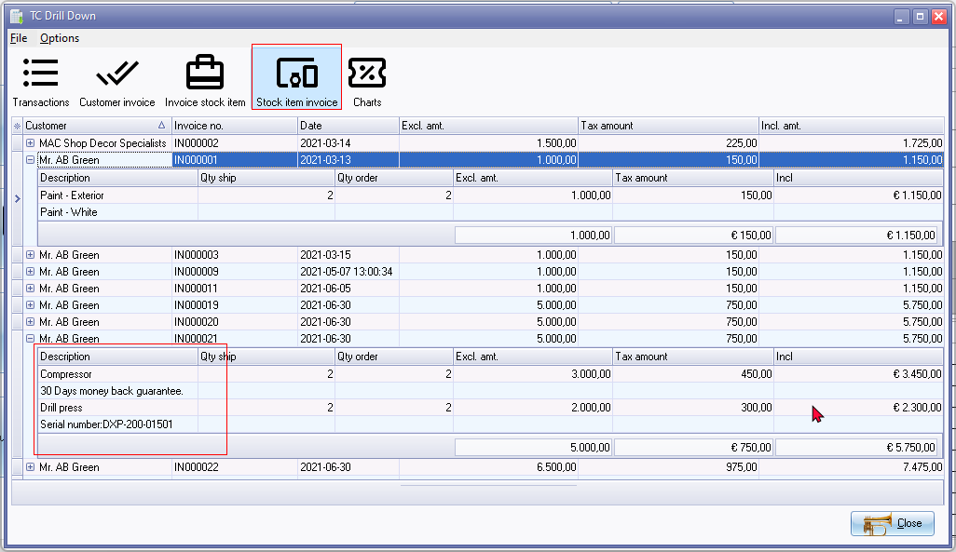

Need to close osFinancials with the End task on Windows Task Manager

You cannot print invoice on the Stock item Invoice option

# Other options – No Errors

**Other options** (i.e **Customer invoice** and **Invoice stock item**)

No access violation error produced.

No remarks and comments is displayed on the grid.

On the other options you can double-click to print the invoice.

