Table of Contents

**Known issues - E-MailPro** 1

Setup Wizard (Not launched) 1

**Access violations Plugin - E-MailPro** 4

***Access violation – Sudden Internet connection lost*** 4

***Replicated Access violation from the E-Mail Pro tab on Debtors account*** 5

***Access violation – UBL - With SQL UBL*** 5

**Known issues - E-MailPro**

|  |  |
| --- | --- |
|  | ***Document EMail Pro Plugin -*** *Manual - Shop -* ***Licence*** *: Once-off - This Plugin is included in the osFinancials5 subscription.*  ***Documentation*** *: Help documentation* ***Online Help documentation*** *: Document email pro*  ***Translations*** *: Outstanding* |

# Setup Wizard (Not launched)

If Setup Wizard should be launched, these screens should be translatable

In addition to the **Settings** tab, you may also launch the “*Setup Wizzard*” to configure your connection details, for your SMTP and POP servers:

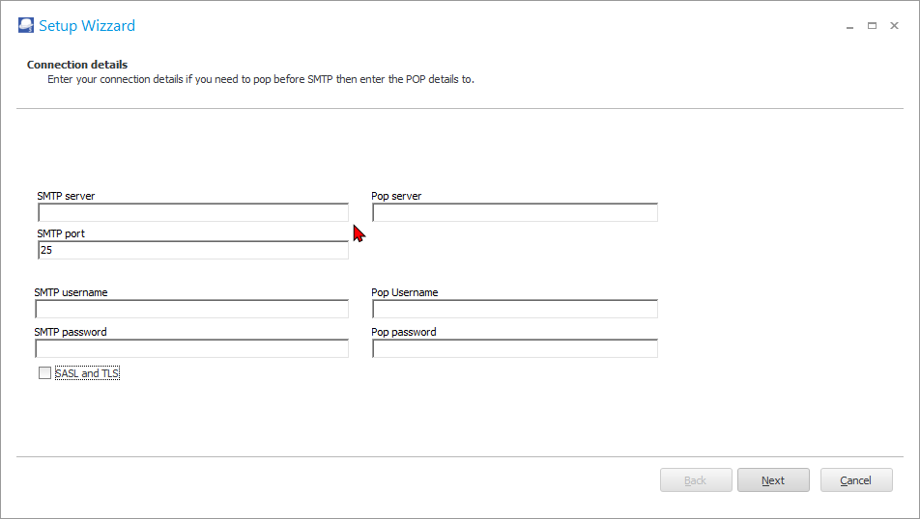

The options, is as follows:

|  |  |
| --- | --- |
| ***Field*** | ***Description*** |
| *SMTP server:* | *Enter a valid SMTP (outgoing mail server) as registered with your ISP (Internet Service Provider) for your e-mail account settings.*  *Note - with POP before SMTP (usually if you do not send e-mails via your provider) it is best to create an e-mail box that no one else will read. This is because if mail is read with multiple IPS on the mail box, the pop for SMTP will not work properly.*  *It is best to use an account that is not used by anyone else.* |
| *SMTP Port:* | *The default port is “25”. This is determined by the default configuration of your operating system.* |
| *SMTP username:* | *Enter the SMTP username as registered with your ISP (Internet Service Provider) for your e-mail account settings.* |
| *SMTP password:* | *Enter the SMTP password as registered with your ISP (Internet Service Provider) for your e-mail account settings.* |
| *POP server:* | *Enter the POP server as registered with your ISP (Internet Service Provider) for your e-mail account settings.* |
| *POP Username:* | *Enter the POP username as registered with your ISP (Internet Service Provider) for your e-mail account settings.* |
| *POP password:* | *Enter the POP password as registered with your ISP (Internet Service Provider) for your e-mail account settings.* |

Click **Next**.

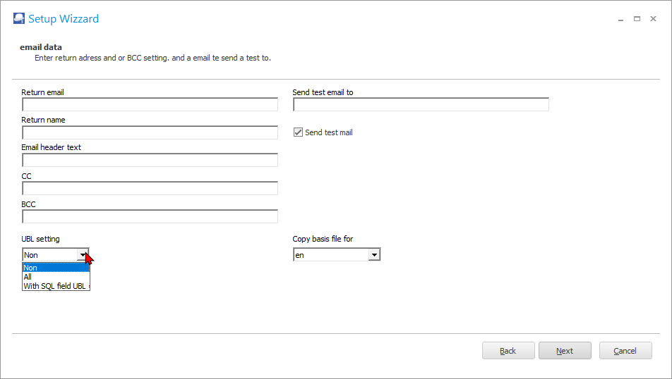

The options, is as follows:

|  |  |
| --- | --- |
| ***Field*** | ***Description*** |
| *Return e-mail:* | *This field is optional. You may enter your own e-mail address.* |
| *Return name:* | *Enter your name.* |
| *E-mail header text:* | *Add the text you need to send as the e-mail subject.* |
| *CC: (multiple separate with ;)* | *This abbreviation* ***CC*** *“Carbon Copy” indicates secondary recipients of a message. Those recipients who are to receive a copy of a message directed to another. The list of recipients in the CC field is visible to all other recipients of the message.*  *Enter a valid e-mail address, if necessary.* |
| *BCC: (multiple separate with ;)* | *This abbreviation* ***BCC*** *“Blind Carbon Copy” allows you to send a copy of your correspondence to a third party when you do not want to let the recipient know that you are doing this (or when you do not want the recipient to know the third party's e-mail address). You may also wish to enter this filed, when sending an e-mail to multiple recipients, you can hide their e-mail addresses from each other.*  *Enter a valid e-mail address, if necessary.* |
| *Send test mail to:* | *Here you can enter your own email address for the test.* |
| *Send test mail to:* | *Thick this option if a valid e-mail address is entered in the “Send test mail to” field.* |
| *Copy basis file for:* | *The default setting is “nl for the Dutch language. Select “en” for English.* |
| *Certificate password:* | *If you have selected a certificate, you need to enter a valid password for that certificate.* |
| *UBL:* | *From osFinancials version 4.0.0.1102 and TurboCASH5.2 (365) it is possible to send UBL2.0 files with the document.*  *The option can be enabled on the settings tab and has 3 settings*  *• Do not send UBL (standard)*  *• Always send a UBL*  *• Based on a UBL field in the dataset that contains the value T.*  *The output can be checked for validity via this website*  *https://peppol.helger.com/public/locale-en_US/menuitem-validation-bis2*  *By default, EUR is used for currency exports.*  *For stock unit standard SK is used or the first 2 letters of the stock unit.* |

Click **Next** to check your settings.

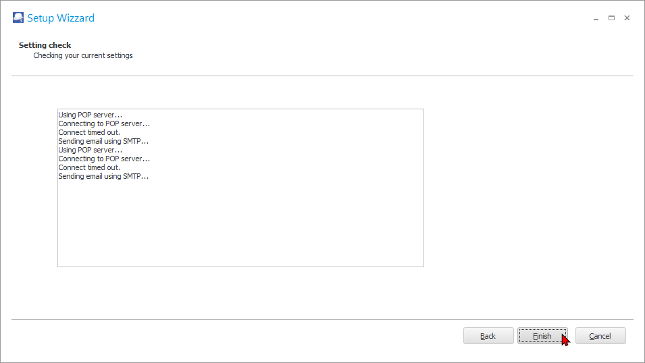

If there are any errors, you need to click **Back** and correct your settings and configuration.

**Access violations Plugin - E-MailPro**

***Access violation – Sudden Internet connection lost***

osFinancials 5.0.0.374

Replicated when we had a Load shedding and lost Wifi connection all of a sudden whilst busy with email pro processes

*Access violation at address 0F30F000 in module 'accounting.exe'. Read of address 0F30F000.*

***Replicated Access violation from the E-Mail Pro tab on Debtors account***

osFinancials 5.0.0.374

*Access violation at address 5005FD90 in module 'rtl260.bpl'. Read of address 0E5D7248.*

Copied a layout file (TRN_3174 Document layout) from DOCUMENTS / DOCUMENTS to

D: \ osfinancials5 \ plug_ins \ reports \ REPORTS\DEBTOR \ reports folder – Available for selection then selected and then produced the access violation error clicking on the Email pro screen.

The files in that folder is LANG_906062 – Selected debtor label and LANG_906065 – Selected debtor delivery label

***Access violation – UBL - With SQL UBL***

If the With SQL UBL is selected on the Settings tab of E-mail Pro access violation error:

*“Access violation at address 124D52F6 in module 'emailDll.tpd'. Read of address 00000000”*

UBL Setting (Not saving correctly) en – Defaults to nl

