Table of Contents

**Known issues - Multimedia plugin** 1

***Search - View details for BATCH type*** 1

***Delete confirmation*** 2

**Known issues - Multimedia plugin**

|  |  |
| --- | --- |
|  | ***Multimedia plugin*** *-* [*Manual*](https://www.osfinancials.org/en/plugin-manuals/522-multimedia-plugin) *-* [*Shop*](https://www.osfinancials.org/en/webshop/most-sold/multimedia-pack) *-* ***Licence*** *: Once-off -* |

***Search - View details for BATCH type***

Search does not view details for BATCH type (EMPTY) multimedia screen. All other Types (GROUP, STOCK, DEBCR) list the details of Multimedia files

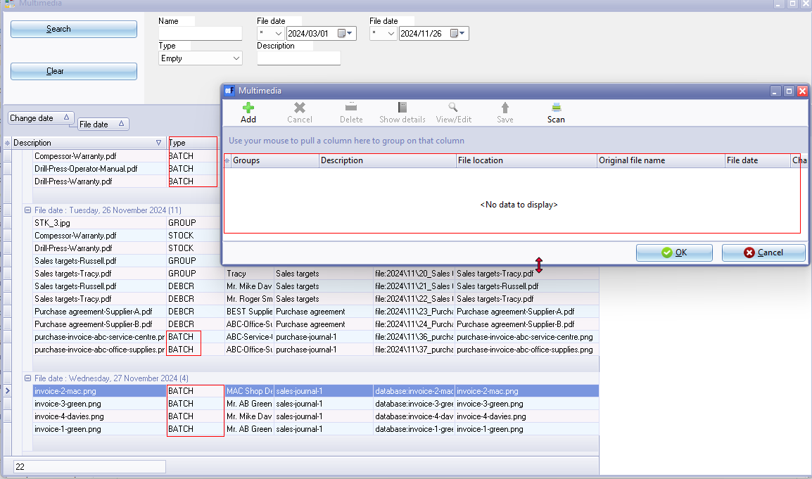

Could possibly mean that the Batch number "***00000001***" does not include a prefix while in many Sets of Books the batch number may include a prefix "***B0000001***" or "***J0000001***"

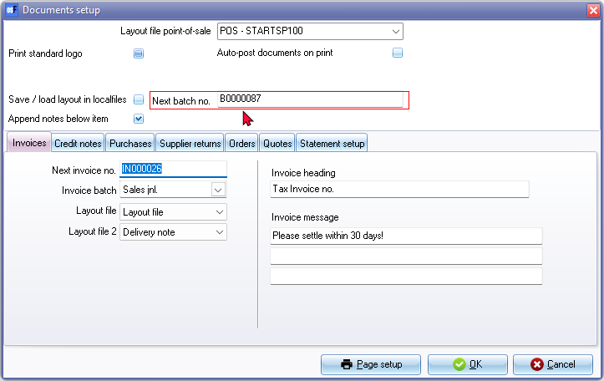

***Delete confirmation***

Delete multimedia files there is no confirmation message.