Table of Contents

**Known issues - StockCheck plugin** 1

**QuickOrder StockCount (Voorraadtelling) tab** 1

**Error - Closed Dataset** 1

***Orders tab*** 2

**StockCheck Plugin - Bulkcheck tab - Errors** 3

**Known issues - StockCheck plugin**

**QuickOrder StockCount (Voorraadtelling) tab**

|  |  |
| --- | --- |
|  | ***Quick Order*** *- Manual - Shop -* ***Licence*** *: Once-off*  ***Documentation*** *: Help documentation*  ***Translations*** *: Translations outstanding* |

**Error - Closed Dataset**

ZQGenSearch: Cannot perform this operation on a closed dataset error is replicated when clicking on the **Voorraadtelling** tab.

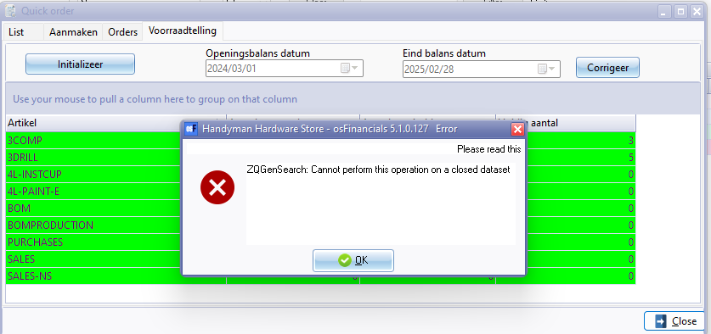

# Orders tab

When the Quick order plugin is initiated, and the "*Just quickorder*" option on the "*Setup QuickOrder*" screen is not selected, the entire QuickOrder module (comprising three tabs: List, Generate documents, and Orders) will be available. You may click on the **Orders** tab.

When the Quick order plugin is initiated, and the "*Just quickorder*" option on the "*Setup QuickOrder*" screen is selected, only the **Orders** component of the entire QuickOrder plugin module will be available.

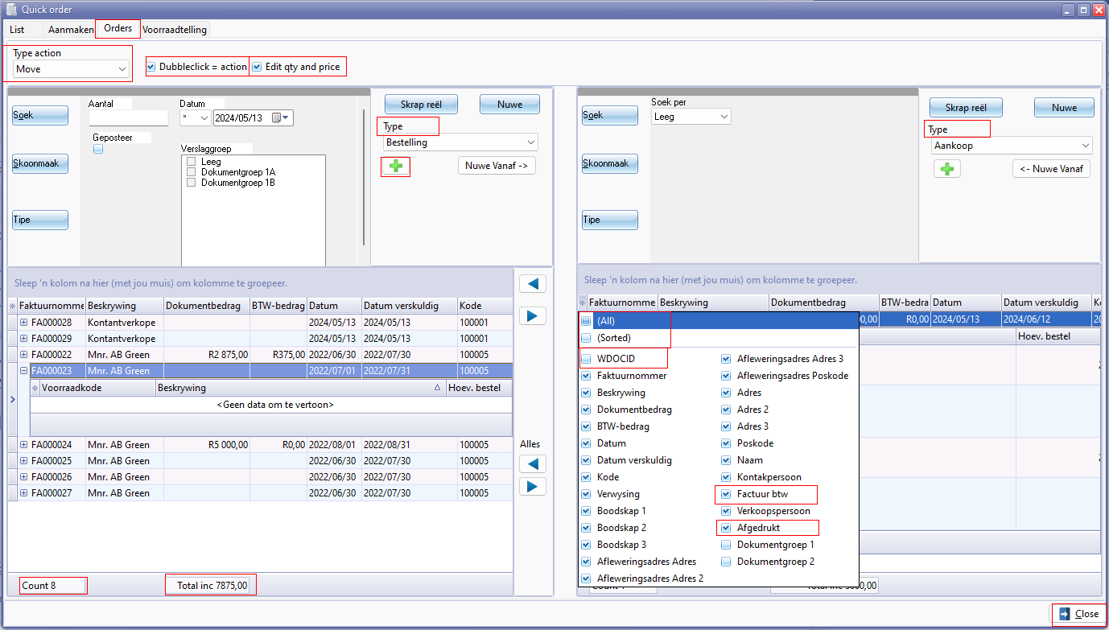

Nuwe - Selecteer rekening (lookup titlebar caption)

Type action

* Move 21022
* Copy 3293 / 21010

Dubbleclick = action

Edit qty and price

**Columns**

* (All) 20055
* (Sorted)
* WDOCID
* Factuur btw
* Afgedrukt 2964

**StockCheck Plugin - Bulkcheck tab - Errors**

|  |  |
| --- | --- |
|  | ***Stock check / Stock correction*** *- Manual - Shop -* ***Licence*** *: Once-off*  ***Documentation*** *: Help documentation*  ***Translations*** *: Translations outstanding* |

To be advised.

The **Post difference** button, generate blank credit notes with no adjustments or corrections on the unposted credit notes.

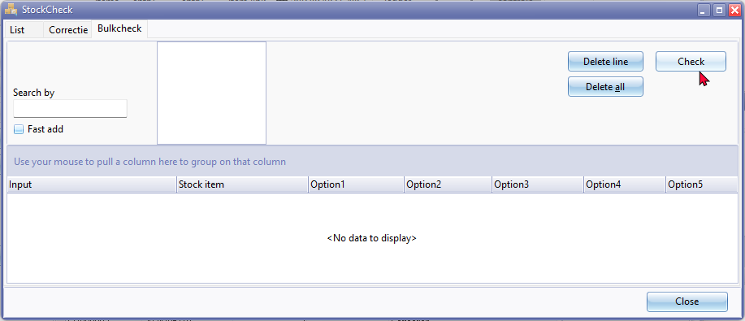

Delete line - No Confirmation message

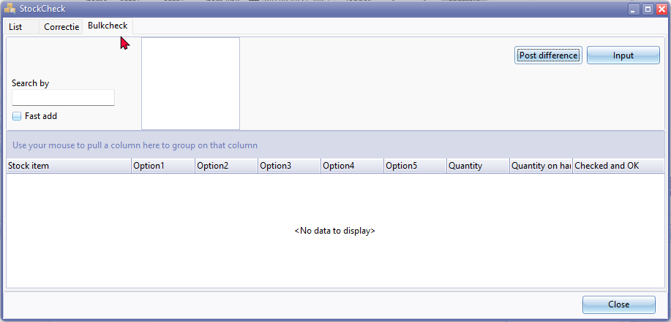

Confirmation message

*There ao check active do you want to see this? No wil make a new check and all current check data will be lost!*

Post difference log entry on **Correctie** tab

*Correction credit note Done!*

Confirmation message **Post difference** button.

*Are you sure you want to post the new inventory data?*

Post difference button - Access violation error on **Bulk check** tab

This is replicated by typing text, e.g. "*Drill*" and enter. The when click in the **Check** button or the **Post difference** button the Access violation error occurs.

*violation of FOREIGN KEY constraint "FK_DOCLINE_STOCK" on table "DOCLINE"  
Foreign key reference target does not exist*

The **Post difference** button, generate blank credit notes with no adjustments or corrections on the unposted credit notes.

