Table of Contents

**Known issues - StockCheck Plugin** 1

**StockCheck Plugin - Bulkcheck tab - Errors** 1

**Known issues - StockCheck Plugin**

**StockCheck Plugin - Bulkcheck tab - Errors**

|  |  |
| --- | --- |
|  | ***Stock check / Stock correction*** *- Manual - Shop -* ***Licence*** *: Once-off*  ***Documentation*** *: Help documentation*  ***Translations*** *: Translations outstanding* |

To be advised.

The **Post difference** button, generate blank credit notes with no adjustments or corrections on the unposted credit notes.

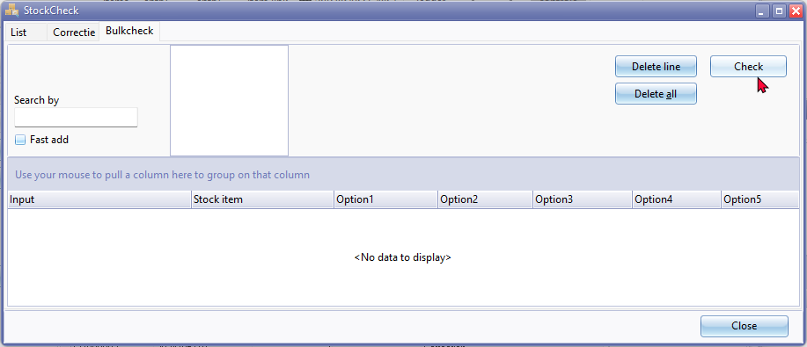

Delete line - No Confirmation message

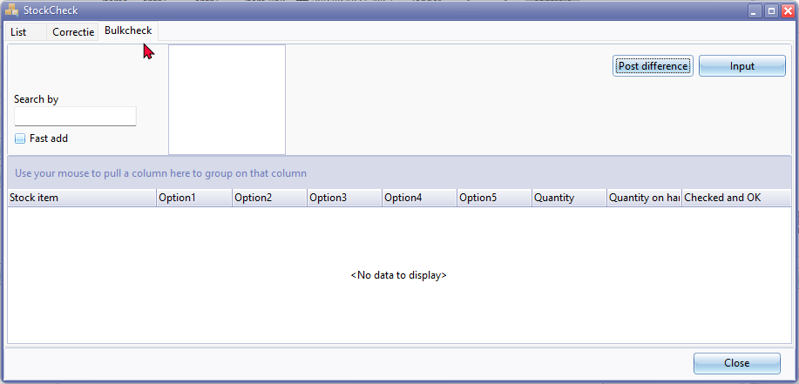

Confirmation message

*There ao check active do you want to see this? No wil make a new check and all current check data will be lost!*

Post difference log entry on **Correctie** tab

*Correction credit note Done!*

Confirmation message **Post difference** button.

*Are you sure you want to post the new inventory data?*

Post difference button - Access violation error on **Bulk check** tab

This is replicated by typing text, e.g. "*Drill*" and enter. The when click in the **Check** button or the **Post difference** button the Access violation error occurs.

*violation of FOREIGN KEY constraint "FK_DOCLINE_STOCK" on table "DOCLINE"  
Foreign key reference target does not exist*

The **Post difference** button, generate blank credit notes with no adjustments or corrections on the unposted credit notes.

