Table of Contents

**Known issues - Subscriptions plugin** 1

**Subscriptions - Search - Column Country / Address 3** 2

**Subscriptions Next run / Transaction dates 1900 year** 3

***Subscriptions to process*** 3

***Debtors - Subscriptions tab*** 3

***Quote*** 3

***Invoice*** 4

**Known issues - Subscriptions plugin**

|  |  |
| --- | --- |
|  | ***Subscriptions*** *- Manual - Shop -* ***Licence*** *: Annual licence -*  ***Documentation*** *: Help documentation* ***Online Help documentation*** *: Subscriptions plugin*  ***Translations*** *: Outstanding* |

# Subscriptions - Splash screen on top

Replicated in osFinancials5.1.0.189 Update install.

If Subscriptions activated and when starting osFinancials5 and opening a Set of Books, the osFinancials splash screen stays on top. 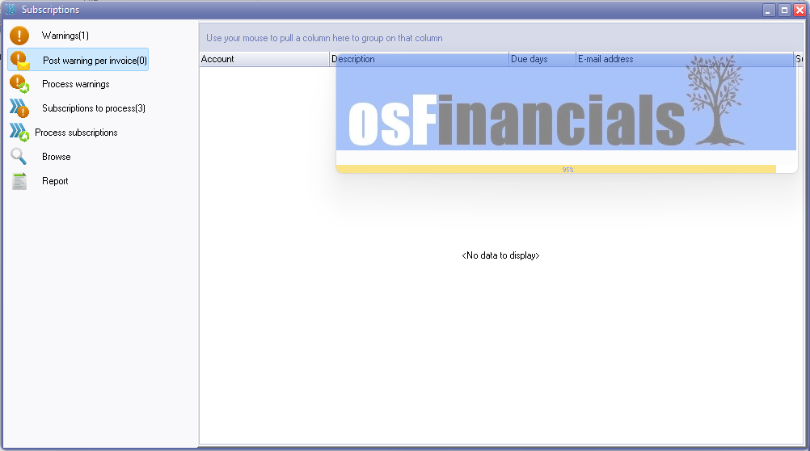

There is a Building process behind the Subscriptions that does not finish.

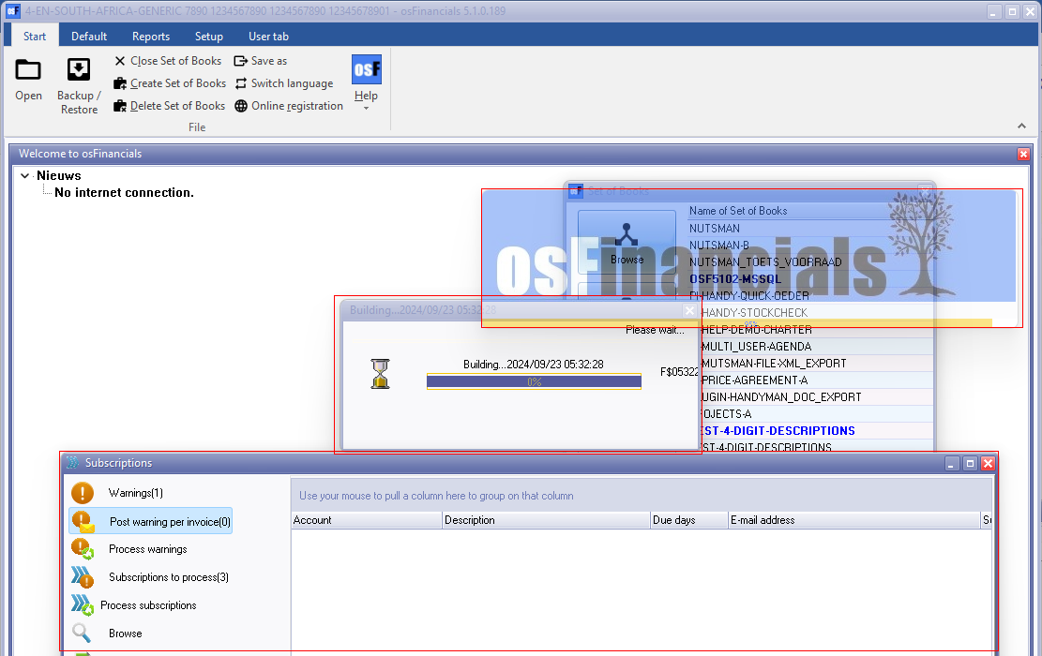

To resolve this, you need to close the Subscriptions screen to complete the Building process.

You may need to Manually launch the **Subscriptions** from the **Default** ribbon.

This is only replicated when opening a Set of Books in a new osFinancials session. Reopening the Set of Books in a current session, does not replicate this error.

**Subscriptions - Search - Column Country / Address 3**

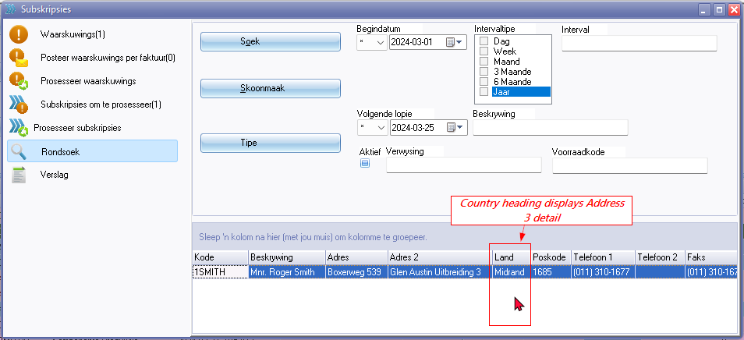

The Country column heading "*Land*" should be Address 3 since the data entered in Address 3 field is displayed in thee Country column.

Address 3 (2420)

**Subscriptions Next run / Transaction dates 1900 year**

***Subscriptions to process***

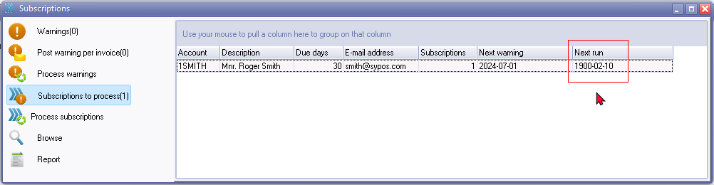

***Debtors - Subscriptions tab***

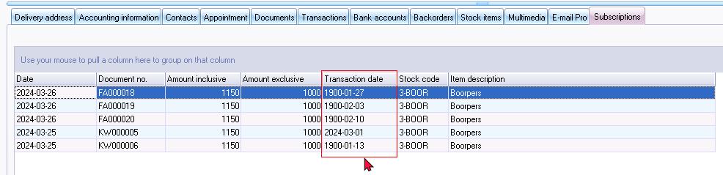

***Quote***

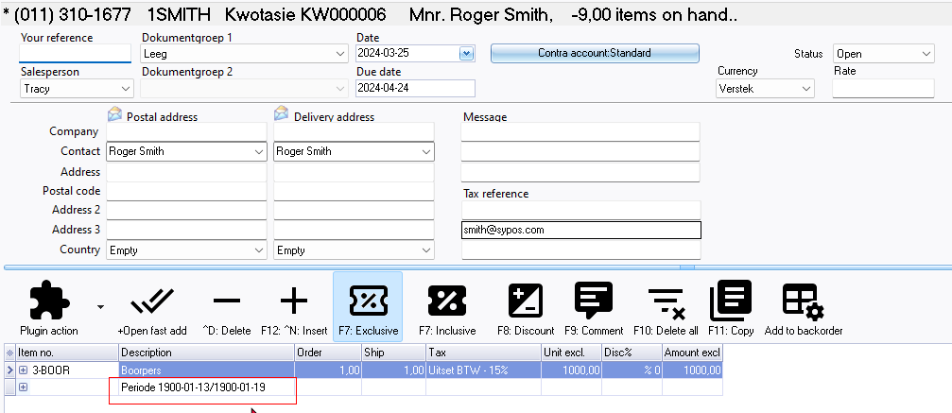

***Invoice***

