Table of Contents

**Dynareg - Extra document types - BUG - Stock in** 1

**Dynareg - Separate Item Issue Plugin** 1

**Known issues** 2

***Input menu*** 2

***Print posted transactions - Cannot print posted transactions for Stock in*** 2

***Update ledger / Delete documents - Titlebar captions*** 2

***Print layout files*** 2

***Stock in - Statement*** 4

**Activation of the "*Dynareg Only purchase via new type*" plugin** 4

**Access to Stock in document type** 5

**Document grid - Search and Filter options** 6

***Filter and Search options*** 6

**Stock in** 6

**Update to ledger** 7

**View the posted transactions** 8

***Stock items (Default ribbon)*** 8

***Document groups tab*** 8

***Transactions tab*** 8

***Creditors (Default Ribbon)*** 8

***Documents tab*** 9

***Stock item tab*** 9

**Input → Stock out menu** 9

**Dynareg - Extra document types - BUG - Stock in**

**Dynareg - Separate Item Issue Plugin**

|  |  |
| --- | --- |
|  | ***Dynareg - Separate Item Issue Plugin*** *- Shop -* ***Licence*** *: Once-off license -*  ***Enable*** *: "Documenten - Aparte artickel uitgifte"*  ***Enable*** *: "Documenten -> Alleen inkoop"*  ***Enable*** *: "Documenten -> Verminder herbestel by doorboeken inkoop"*  ***BUG*** *- Disables the Ledger tab of all Stock items- See - Dynareg - Extra documnent types - BUG - Stock items -* |

**Known issues**

***Input menu***

Input menu - Stock out - launches Stock in can process creditors. On Documents grid document type Stock in launches creditors.

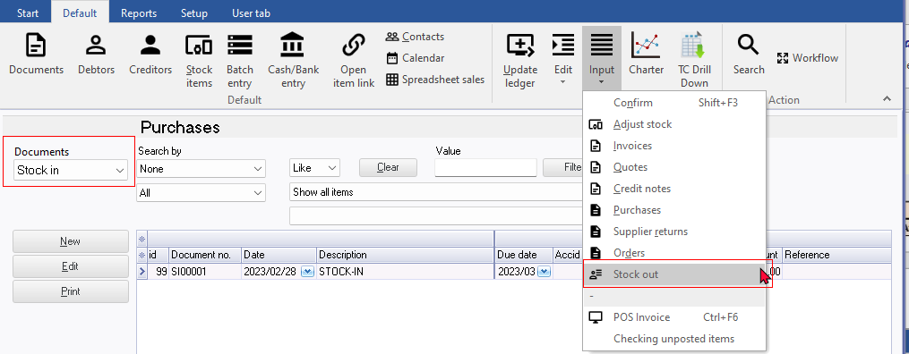

***Print posted transactions - Cannot print posted transactions for Stock in***

**Creditors - Documents tab** - "*Show transactions*" context menu. Cannot view and print "Transactions" screen "*Batch type report - Posted batches*" report. Transactions screen is empty and "*No data to print*!" error. When create Stock in Document - Output tax is included in the selected stock item and not Input tax. In Ledger analyser cannot trace and print the transactions for the Stock in document type.

"Right-click and select "*Show transactions*" on the context menu. This lists the transactions on a "*Transactions*" screen for the selected document. **Note**: For the **Stock out** document type, the quantities will be adjusted, and the transactions for cost of sales will be adjusted in a journal. Additionally, for the **Stock in** document type, the "*Transactions*" screen may be empty, as it primarily adjusts quantities. For the **Stock out** document type, the cost of sales transactions, will be listed the "*Transactions*" screen."

***Update ledger / Delete documents - Titlebar captions***

* Update documents - Stock in - Delete supplier returns
* Delete documents - Stock in - Delete supplier returns

***Print layout files***

The plugin prints the layout file selected in the "*Layout file point-of-sale*" field within **Documents setup**. This setting does not work for the "*Stock in*" document type By default, the "*Stock in*" will print the till slip layout file "*POS Tax invoice*".

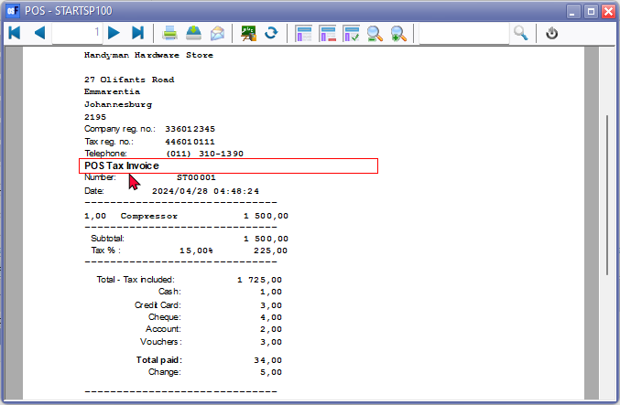

**NOTE** If "*Layout file*" is selected as the option within **Documents setup** for other document types, the "*Default*" option on Document grid does not work. You need to select the "*Layout file*" or other layout file. You have the option to choose a different layout file for "*Stock in*" document types.

Layout file - The default "*Layout file*" for all document types, will print the headings in the Types on **Tools → Customise language**.

***Stock in - Statement***

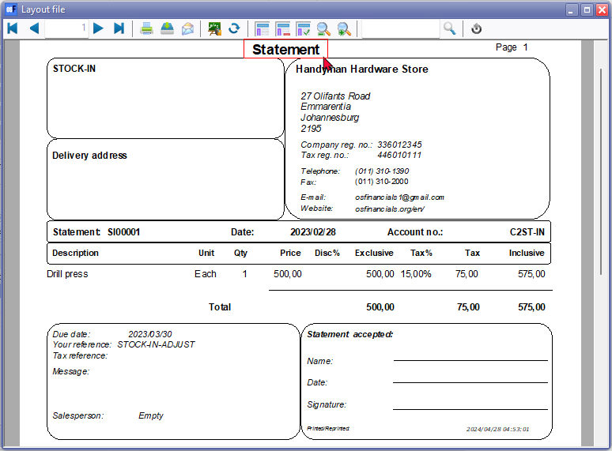

|  |  |
| --- | --- |
|  | ***Dynareg - Separate Item Issue Plugin*** *- Shop -* ***Licence*** *: Once-off license -*  ***Enable*** *: "Documenten - Aparte artickel uitgifte"*  ***Enable*** *: "Documenten -> Alleen inkoop"*  ***Enable*** *: "Documenten -> Verminder herbestel by doorboeken inkoop"* |

**Activation of the "*Dynareg Only purchase via new type*" plugin**

To activate the "*Dynareg Only purchase via new type*" plugin and enable the "*Stock in*" as an additional document type, you'll need to follow these steps:

1. Enable the "*Aparte artickel uitgifte*" plugin. This plugin adds the "*Stock in*" and "*Stock out*" document types.
2. Enable the "*Alleen inkoop"* plugin. This plugin also adds the "*Stock in*" and "*Stock out*" document types.
3. Enable the "*Verminder herbestel by doorboeken inkoop*" plugin. This plugin specifically adds the "*Stock in*" document type. **Note** that the "Stock out" document type, which is added when you enable the previous two plugins, will be removed.

After enabling each of these plugins, be sure to reopen your Set of Books. This step is crucial to ensure that the changes take effect properly.

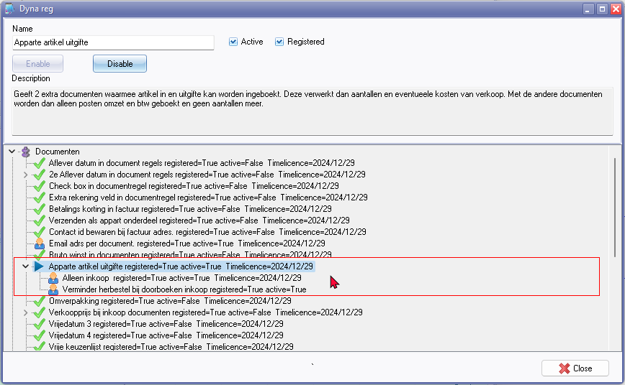

|  |  |
| --- | --- |
|  | ***Dynareg - Separate Item Issue Plugin*** *- Shop -* ***Licence*** *: Once-off license -*  ***Enable*** *: "Documenten -> Aparte artickel uitgifte"*  ***Enable*** *: "Documenten -> Alleen inkoop"*  ***Enable*** *: "Documenten -> Verminder herbestel by doorboeken inkoop"* |

Reduce reorders when rebooking purchases

When transferring a purchase, reduce the reorder. (2nd hand store)

**Access to Stock in document type**

In addition to the standard document types, this plugin adds **Stock in** document type, serving distinct purpose.

The **Stock in** is added alongside the existing purchase document types: purchases, supplier returns, and orders. Document numbers for Stock in start with "*SI00001*".

**Accessing the Stock in additional document type**:

You may access the Stock in additional document types via the following options:

1. **Default ribbon**: Navigate to Documents and select either the standard document types or the **Stock in** document type. This launches the document entry screen as an integrated part of the document grid.

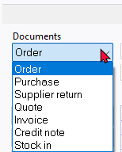

1. **Input menu**: Choose from the standard document types or the **Stock in** document type from the **Input** menu. This launches the document entry screen as a separate screen.

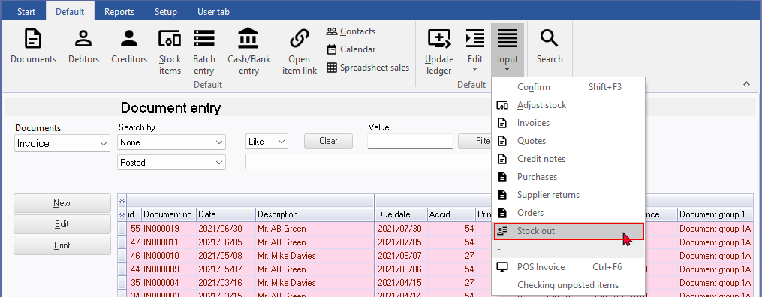

Additionally, the "*Stock in*" document type is available as options on the context menu of the document grid, accessible via **Documents → Copy to → Stock in**.

**Document grid - Search and Filter options**

***Filter and Search options***

For the Stock in document type, utilize the powerful grid for filtering and searching. Some of the available options include:

* **Document status**: Filter by Unposted, Posted, or view All documents.
* **Groups**: Filter for specific document groups.
* **Document details**: Access all available document details, including references, dates, and more.

Additionally, you can build custom filters tailored to your specific needs.

**Stock in**

The "*Stock in*" document type resembles the "*Purchase*" document type. To create a new document for the **Stock in** document type, click **New**. On the "*Creditor accounts*" screen, select a creditor (supplier/vendor) account and click **Open**. If no account exists, you may create a new creditor account.

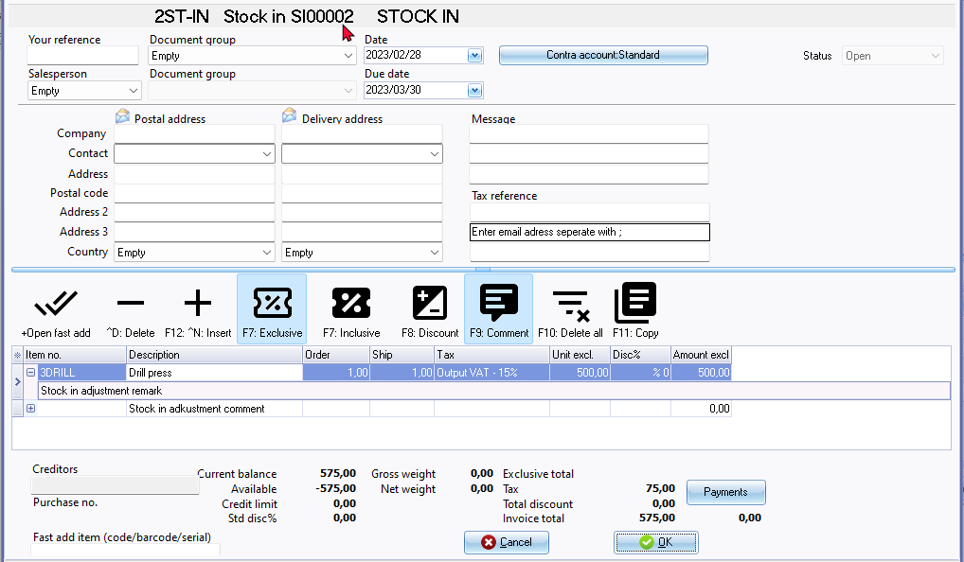

On the **Stock in** document entry screen, select the stock item. You may enter references in the "*Your reference*" field in the document header. Additionally, you can include remarks and comments:

* **Remarks**: Beneath each stock item, you can add remarks. These remarks will print in document layout files but are not searchable in the central search.
* **Comments**: Use the **F9: Comment** option to enter comments for each item.

The document references entered in the "*Your reference*" field in the document header, along with the comments, are searchable using the central search option (accessible via the **Search** on the **Default** ribbon).

**Update to ledger**

If the "*Auto-post document on print*" setting on the **Documents setup** in the **Setup** menu (accessible via the **Setup** ribbon) is not activated, or if you have not yet printed the document, you will need to manually post the Stock in documents.

To do this, press **F3** or select **Update Ledger** on the **Default** ribbon. The "*Update Invoices*" screen is displayed:

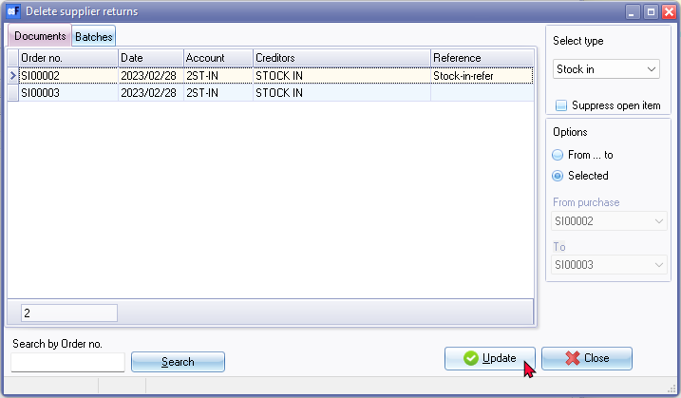

* Select the **Stock in** document type and click **Update**.

**View the posted transactions**

Once the Stock in documents have been posted (updated to the ledger), you may view the transactions in the following options:

***Stock items (Default ribbon)***

Includes the Stock in document types if processed for the selected stock item.

***Document groups tab***

This tab will include posted as well as unposted documents for the Stock in document type.

* Double-click to print the selected document or choose a different layout file.
* Right-click to open the document entry screen in a separate window. Note that both posted and unposted documents cannot be edited.

***Transactions tab***

This tab will only include posted documents for the Stock in document types.

* Right-click and select "*Open document*" from the context menu. Note that posted documents cannot be edited.

***Creditors (Default Ribbon)***

The Stock in document type should be listed since you can only select a creditor account.

***Documents tab***

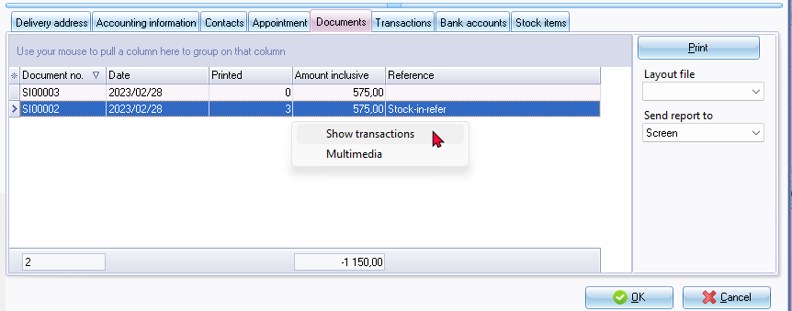

* Includes both posted and unposted documents for the Stock In document type.
* Here, you may:
  + **Print the document layout file**: Double-click to print the selected document or click the **Print** button. You may select a different layout file.
  + **View and Print transactions**: Right-click and select "*Show transactions*" on the context menu. This lists the transactions on a "*Transactions*" screen for the selected document. **Note**: for Stock In document type, the "*Transactions*" screen may be empty, as it primarily adjusts quantities.

***Stock item tab***

* Includes both posted and unposted documents for the Stock in document type type.
* The stock in document type numbers will consist of 7 digits of which the first two is prefixed with "*SI*" .The document type for the Stock out is indicated as "*Stock-*"

**Input → Stock out menu**

**Input → Stock out** menu should read **Stock in** - See document type on the Documents grid.

The **Input → Stock out** menu launches the Document entry in a separate window. New Invoice will create an Invoice "X IN000025, etc. instead of a Stock in document type with document number "SI00001"

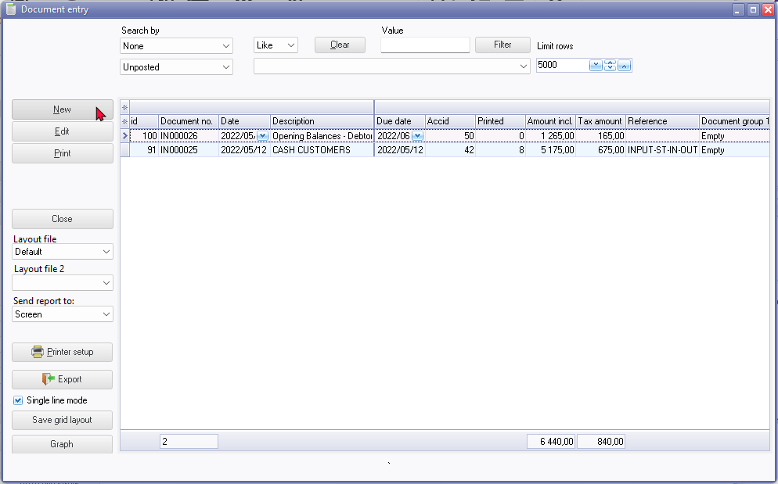

The invoice on document entry

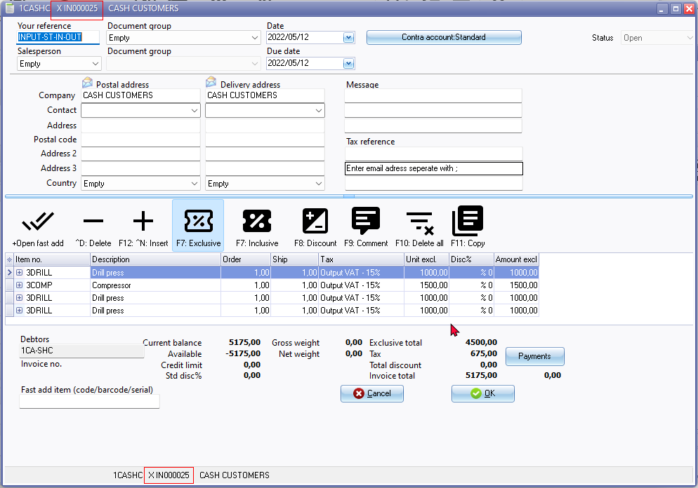

**NOTE** : This document "Invoice" only listed from the **Input → Stock out** menu and is not available on:

* Documents grid (both Invoices and Stock in document types)
* Update ledger (cannot post)
* Delete documents (cannot delete)
* Print uses the *"Layout file point-of-sale" field setting* within Setup → Documents setup.

Stock type

Stock tab - Disassemble (Stock item type)

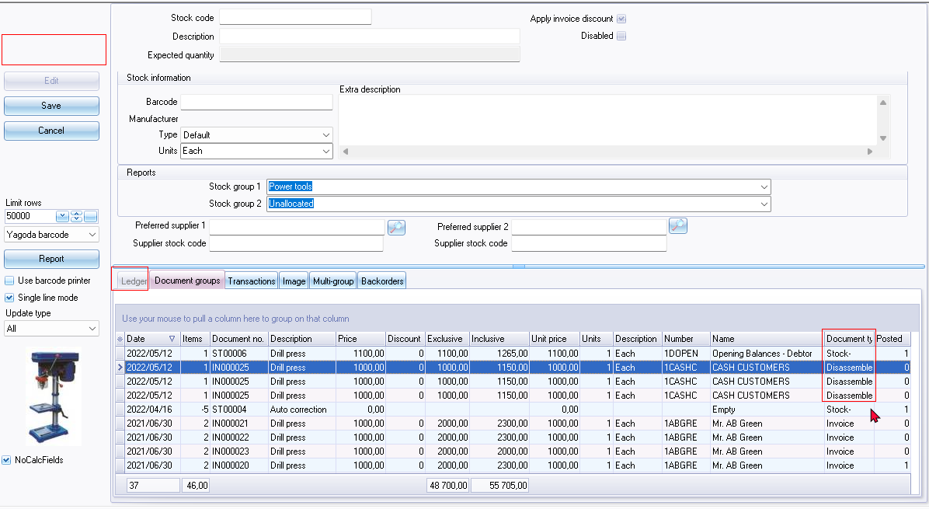

Disassemble (Stock item type)

BOM Production on Stock in / Stock out report

