Table of Contents

**Dynareg - Show inactive items in documents plugin** 1

**Dynareg - Show inactive items in documents plugin**

|  |  |
| --- | --- |
|  | ***Dynareg Show inactive items in documents plugin*** *- Shop -* ***Licence*** *: Once-off license -*  ***Enable*** *: "Documenten - Toon inactive artikelen in documenten"* |

When processing documents, you're required to choose the stock item within the document lines section. By default, only the active stock items are displayed. If a stock item is marked as inactive (disabled) on the Stock form, it won't appear in the Stock lookup. This ensures that only active or enabled items are available for selection in the documents.

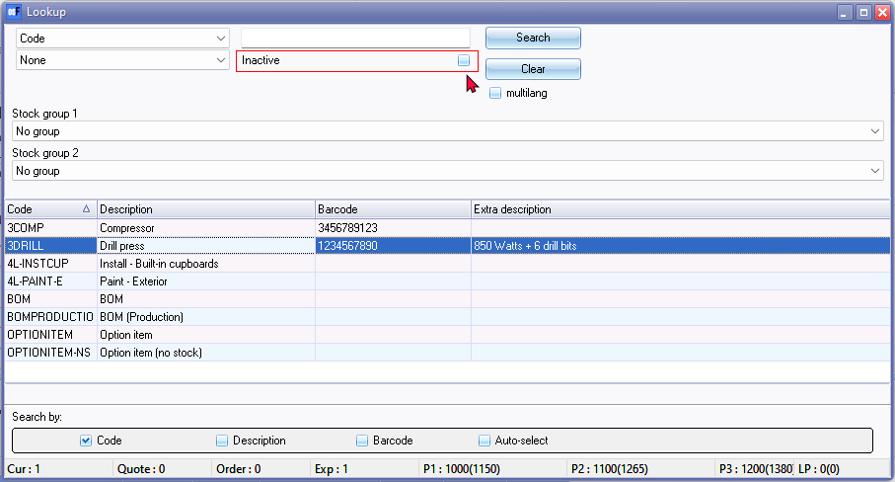

If you need to select disabled items in documents, simply check the "*Inactive*" box and click the **Search** button. This action will include inactive or disabled stock items in the lookup results.

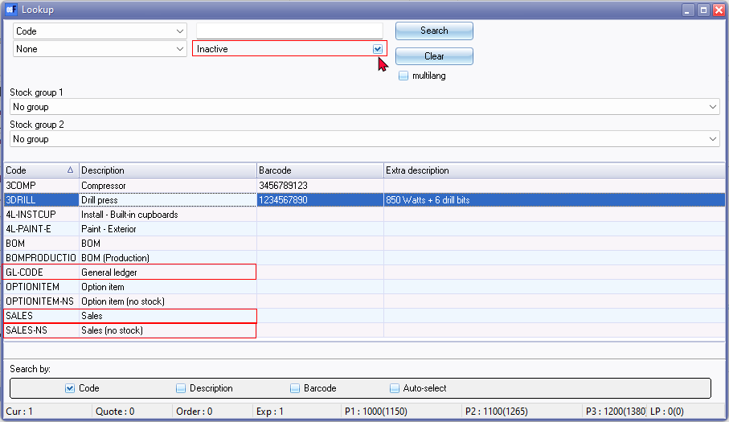

If you've selected an inactive (disabled) item and included it in your sales or purchase documents, you'll still be able to update (post) the transactions involving inactive items that are part of the document.