Table of Contents

**Activa** 1

**Activa - Pivot** 2

**Activa - Reports - Data** 2

**Activa**

|  |  |
| --- | --- |
|  | ***Activa Plugin*** *- Shop -* ***Licence :*** *Once-off -*  ***Documentation : osFinancials website*** *- Manual*  ***Documentation*** *: Help documentation* |

Activa 3384 / 3518

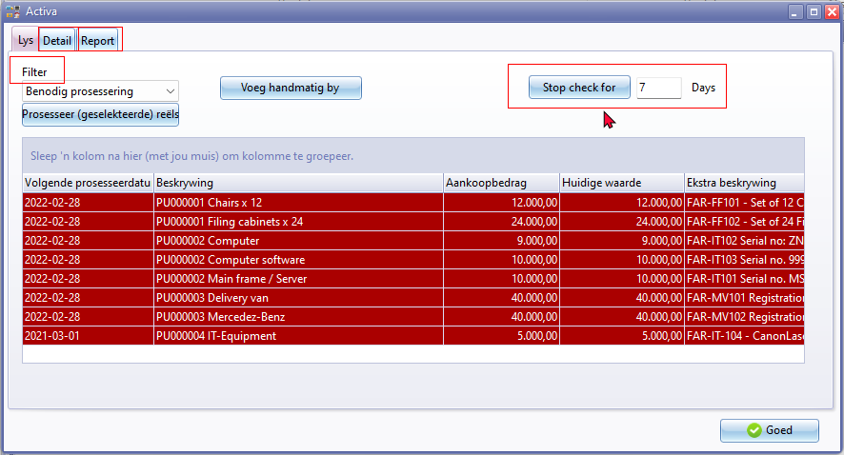

Filter 20097

Stop check for

Days 2331

Tabs

* Detail 930
* Report
  + Pivot
  + Data 1296

**Activa - Pivot**

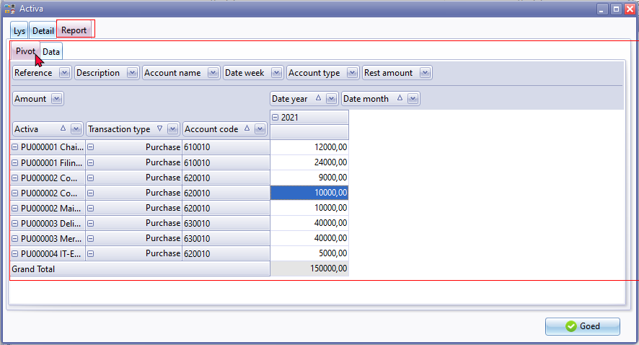

**Activa - Reports - Data**

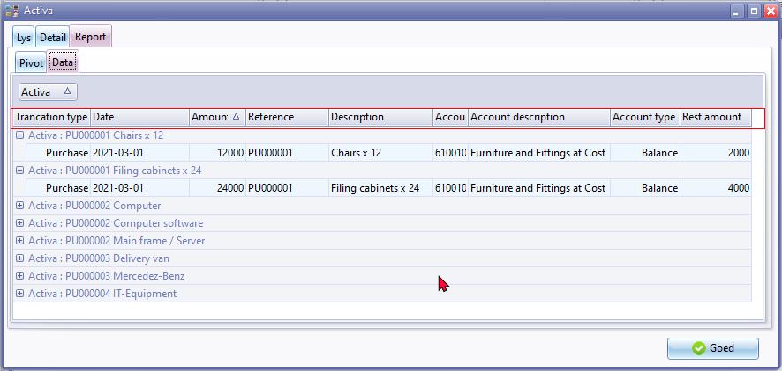

Transaction type

Date 238 / 1802 / 1875 / 1973

Amount 946 / 1712

Reference 607 / 1285 1719 / 1974 /

Description 178 / 355 / 606 /653 / 1708 / 1773

Account code

Account description 1108

Account type 1109 / 1935

Rest amount 3508