Table of Contents

**Charter Plugin** 1

**Known issues - Charter plugin** 1

***Access violation error - Creditors - Charter tab - Creditor detail*** 1

***Charter Plugin - Debtors for Purchase document types*** 1

**Graph details - title captions on X-axis- and Y-axis** 2

**Charter Plugin** 2

**Charter - Charts available from other options** 3

***Debtors - Charter tab*** 3

***Creditors - Charter tab*** 3

***Stock - Charter tab*** 3

***Documents - Plugin action - Charter*** 4

***Charter Plugin integration*** 4

**Charter Plugin**

|  |  |
| --- | --- |
|  | ***Charter******Plugin*** *- Shop -* ***Licence*** *: Once-off*  ***Documentation : osFinancials website*** *- Manual*  ***Documentation*** *: Help documentation* |

**Known issues - Charter plugin**

***Access violation error - Creditors - Charter tab - Creditor detail***

**Build** button produces error

*Access violation at address 60DB848E in module 'Charter.of5'. Read of address 00000000*

***Charter Plugin - Debtors for Purchase document types***

Within the Documents grid - You may right-click to launch the "*Charter*" screen from the on the **Plugin action → Charter** context menu to launch the "*Doc value*" or "*Debtors*" chart.

In the document entry screen for posted and unposted sales documents such as invoices, credit notes and quotes it seems correct.

**Debtors** - In the document entry screen for posted and unposted **purchase documents** such as purchases, supplier returns and orders, an icon will be available to launch the "*Charter*" screen. Should launch the Creditors option.

**Graph details - title captions on X-axis- and Y-axis**

Graph details such as titles captions on X-axis- and Y-axis need to be translated and depends on the graph.

**Charter Plugin**

**Menu**: **Plugins → Financial tools → Charter** (**Setup** ribbon).

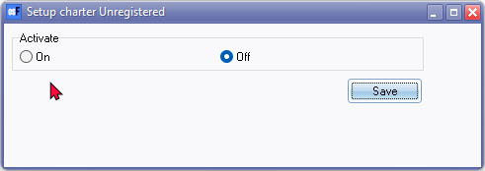

On the entire screen only the titlebar caption and Menu item is translatable - Rest not translatable.

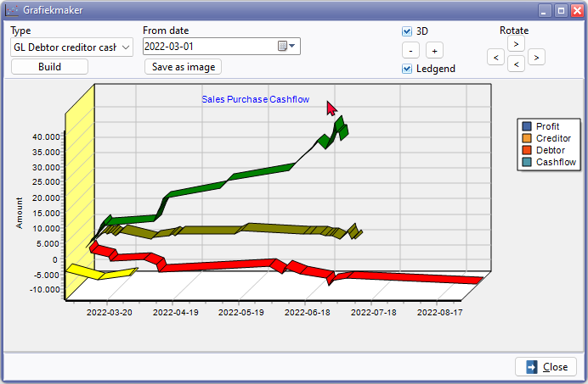

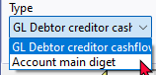

diget should read digit

Save as screen **Save as image** button Save as screen is translatable via the Windows system - except the Save as type "*Bitmap and WMF will be saved! (*.bmp,*.wmf)*"

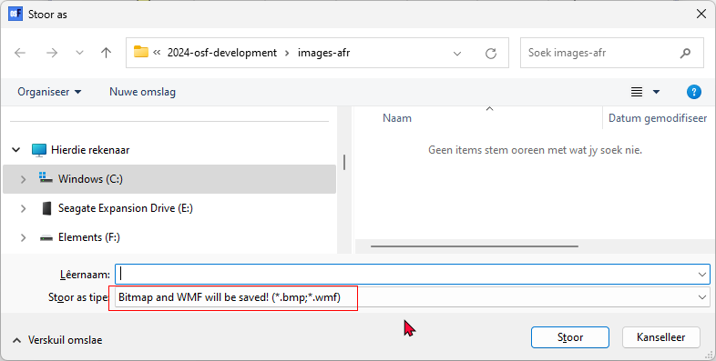

**Charter - Charts available from other options**

***Debtors - Charter tab***

Debtors

**Context menu access**: From the Debtors item grid, similar charts may be generated on the **Plugin action → Charter** context menu for a selected debtor (customer / client) account.

***Creditors - Charter tab***

Creditors

Creditor detail

Creditor Group current value

**Context menu access**: From the Creditors item grid, similar charts may be generated on the **Plugin action → Charter** context menu for a selected creditor (supplier / vendor) account.

***Stock - Charter tab***

Stock value

Stock Days

Stock Sales

Creditor Group current value

Creditor

Creditor detail

**Context menu access**: From the Stock item grid, Similar charts may be generated on the **Plugin action → Charter** context menu for a selected stock item

***Documents - Plugin action - Charter***

Doc value

Debtor (Note on Sales documents such as Invoices, credit notes and quotes this is option displays charts. On purchase documents such as purchases, supplier returns and orders the charts does not display any detail in charts.

***Charter Plugin integration***

The "*Charter*" plugin is also available in other plugins in supporting the "*Charter*" plugin.