Table of Contents

**Email Pro Setup** 1

**Send mail** 2

**Send mail - Settings tab** 3

**Send mail - Free fields tab** 4

**Mass email selection** 5

**Documents - Plugin action** 5

**Email Pro Plugin**

|  |  |
| --- | --- |
|  | ***Document EMail Pro Plugin*** *- Manual - Shop -* ***Licence*** *: Once-off - This Plugin is included in the osFinancials5 subscription.*  ***Documentation*** *: Help documentation* |

**Email Pro Setup**

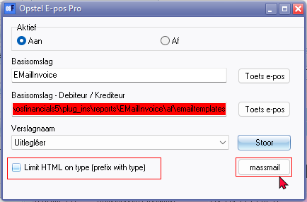

**Send mail**

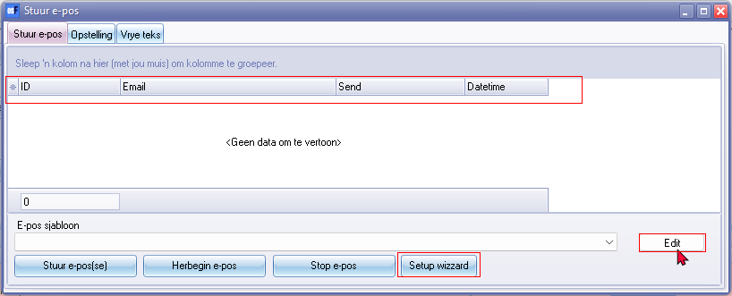

Columns

* ID 906446
* Email 191 / 2387
* Send 3215
* Datetime 306445

Edit

Setup wizzard

**Send mail - Settings tab**

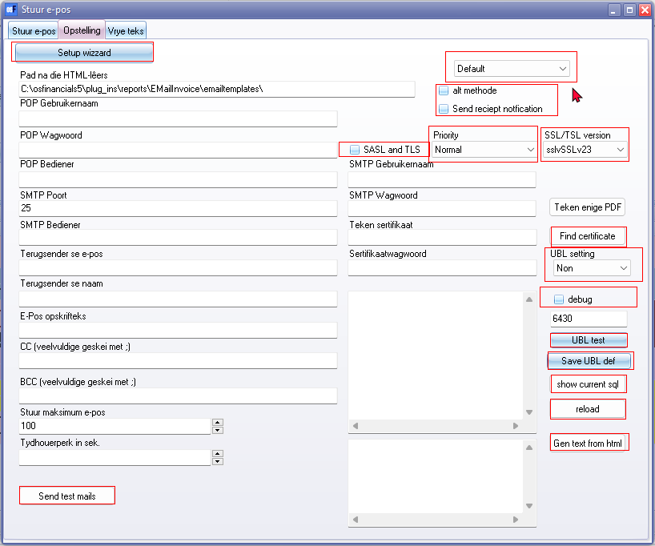

Setup wizzard

Send test mails

Rest of blocks and lists in red rectangle on right hand side of screen

**Send mail - Free fields tab**

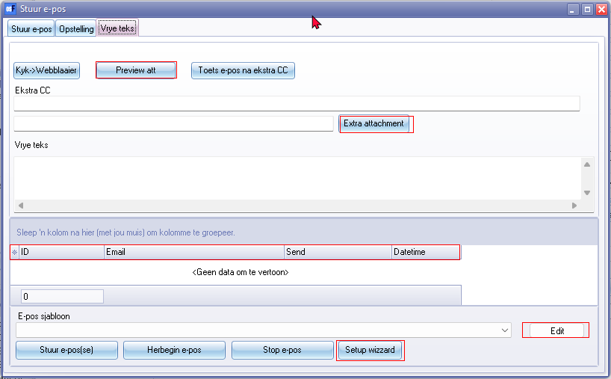

Preciew att

Extra attachment

Columns

* ID 906446
* Email 191 / 2387
* Send 3215
* Datetime 306445

Edit

Setup wizzard

**Mass email selection**

Entire screen

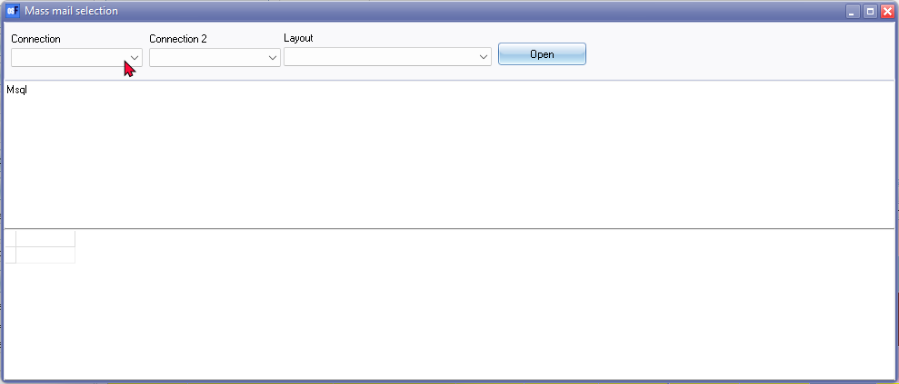

**Documents - Plugin action**

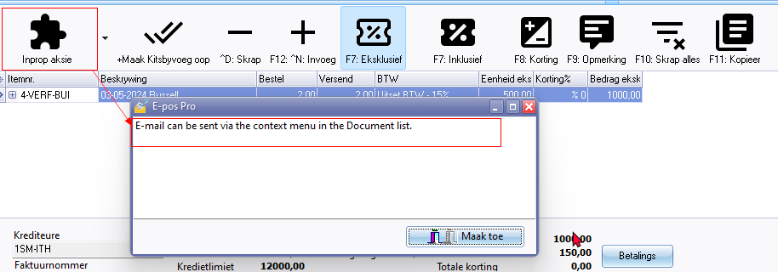

Message E-mail can be sent via the context menu in the Document list. 3219

On documents context menu the Plugin action - E-mail pro is translatable

