Table of Contents

**Free Fields Plugin** 1

***Design search fields 3541*** 1

***Design edit fields 3540*** 3

**Free Fields Plugin**

|  |  |
| --- | --- |
|  | ***Freefields plugin*** *- Shop -* ***Licence :*** *Once-off -*  ***Documentation : osFinancials website*** *- Manual*  ***Documentation*** *: Help documentation* |

**Menu**: **Plugins → Generic → Free Fields** (**Setup** ribbon).

***Design search fields 3541***

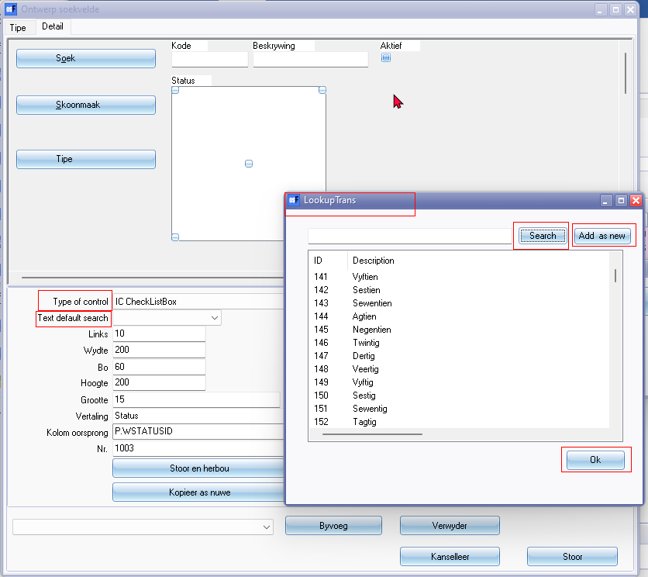

Similar to Reportman Parameters

* Type of control
* Text default search

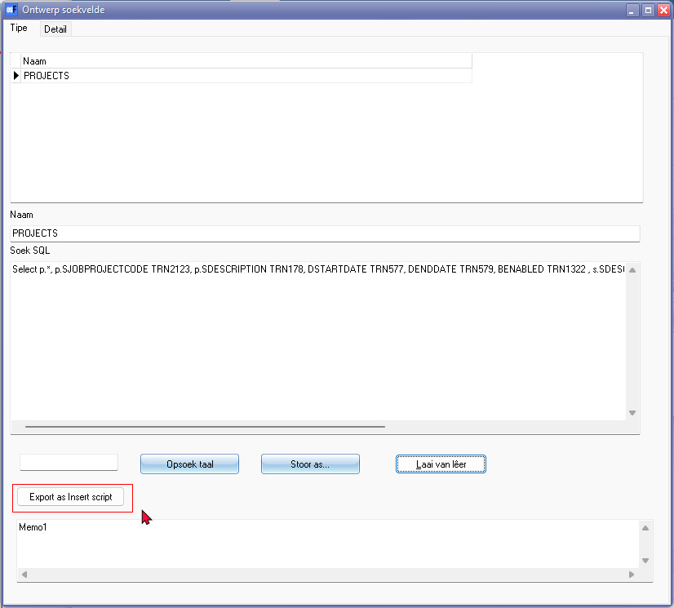

***Design edit fields 3540***

