Table of Contents

**RetailPOS plugin – Translations** 1

**HORRECAPOS - Errors** 1

***Error reading Series1.Marks.OnTop: Property*** 1

***SQL error - Seats*** 2

***SQL Error - Order setup*** 2

**HORECAPOS Setup** 3

***HORECAPOS Setup - General*** 3

***HORECAPOS Setup - Paymentstypes*** 3

***HORECAPOS Setup - Buttons*** 4

***HORECAPOS Setup - Order setup*** 5

**RetailPOS plugin – Translations**

**HORRECAPOS - Errors**

***Error reading Series1.Marks.OnTop: Property***

*Error reading Series1.Marks.OnTop: Property OnTop does not exist Error in Plugin   
C:\osfinancials5\plugins\HORECAPOS.of5*

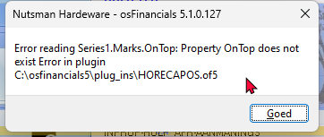

Click OK then opens the books but does not load HORECAPOS in Default ribbon

***SQL error - Seats***

*Dynamic SQL Error  
SQL error code = -206  
Column unknown  
ROOM  
At line 1, column 37*

***SQL Error - Order setup***

*Dynamic SQL Error  
SQL error code = -204  
Table unknown  
HORECAPOS_OPENTIMES  
At line 1, column 15*

**HORECAPOS Setup**

***HORECAPOS Setup - General***

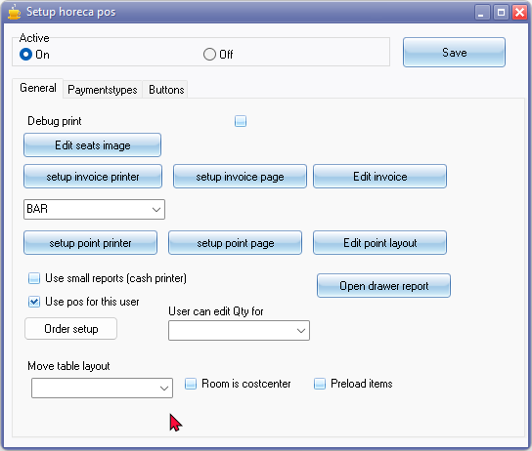

***HORECAPOS Setup - Paymentstypes***

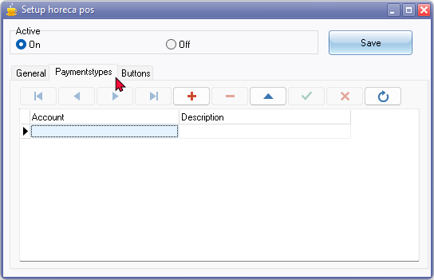

***HORECAPOS Setup - Buttons***

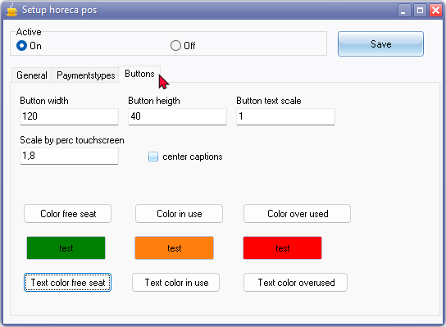

Color picker is translatable via Windows operating system, while it is not in RetailPOS, and Setup - Groups.

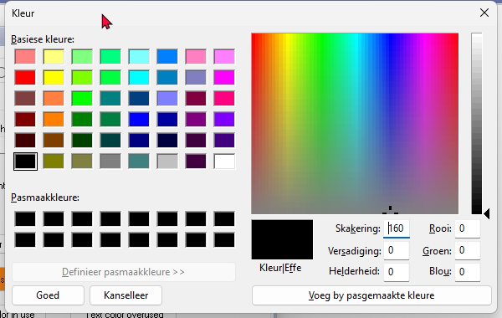

***HORECAPOS Setup - Order setup***

