Table of Contents

**QuickOrder Plugin** 1

***Quick Order*** 1

**Activation** 2

***Setup QuickOrder*** 2

***Drop data messages*** 2

**Default ribbon icon** 3

**QuickOrder tabs** 3

***List tab*** 4

***Aanmaken tab*** 5

***Orders tab*** 6

***Voorraadtelling tab*** 7

**Documents Orders** 7

**QuickOrder Plugin**

**Menu**: **Plugins → Stock → QuickOrder** (**Setup** ribbon).

***Quick Order***

|  |  |
| --- | --- |
|  | ***Quick Order*** *- Manual - Shop -* ***Licence****: Once-off*  ***Documentation*** *: Help documentation* |

Simplify your product ordering process with our "*Quick Order*" plugin. This plugin offers a quick and convenient method for ordering products from your PC or using a handheld PC or smart phone (through Remote Desktop / Terminal Services or RDP).

* + You walk with a handheld through your warehouse, and scan or selected the product to order while standing next to the shelf.
  + You see immediately actual stock numbers so that a good decision of the quantity to order can be made.
  + After pressing a button it creates an order with the specified numbers.
  + After which only a few clicks of the mouse will break down the order by vendor.

Optimize your ordering workflow with the "*Quick Order*" plugin, providing you with a seamless and efficient solution for managing your product orders.

**Activation**

***Setup QuickOrder***

***'n Foto wat skermskoot, teks bevat

Beskrywing outomaties gegenereer***

Entire setup screen

Save button 726

***Drop data messages***

The message screens is already translatable but not the confirmation and error messages.

'n Foto wat teks, skermskoot, lyn, nommer bevat

Beskrywing outomaties gegenereer

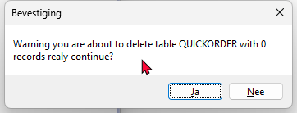

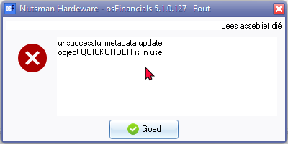

**Default ribbon icon**

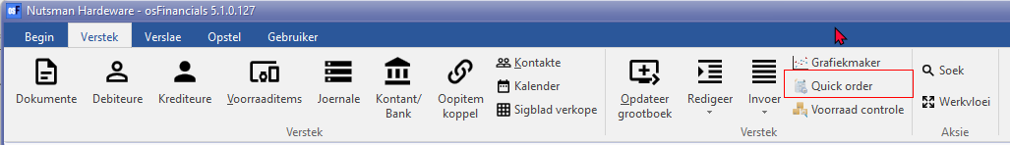

QuickOrder - used in titlebar captions

On Activate plugins the Plugins Stock is already translated as Kits Bestelling (LabelID 3382)

QuickOrder 3382 (Title bar captions)

**QuickOrder tabs**

List 903011

Aanmaken (Generate 1888 / 3145)

Orders 798 / 1871

Voorraadtelling 415

***List tab***

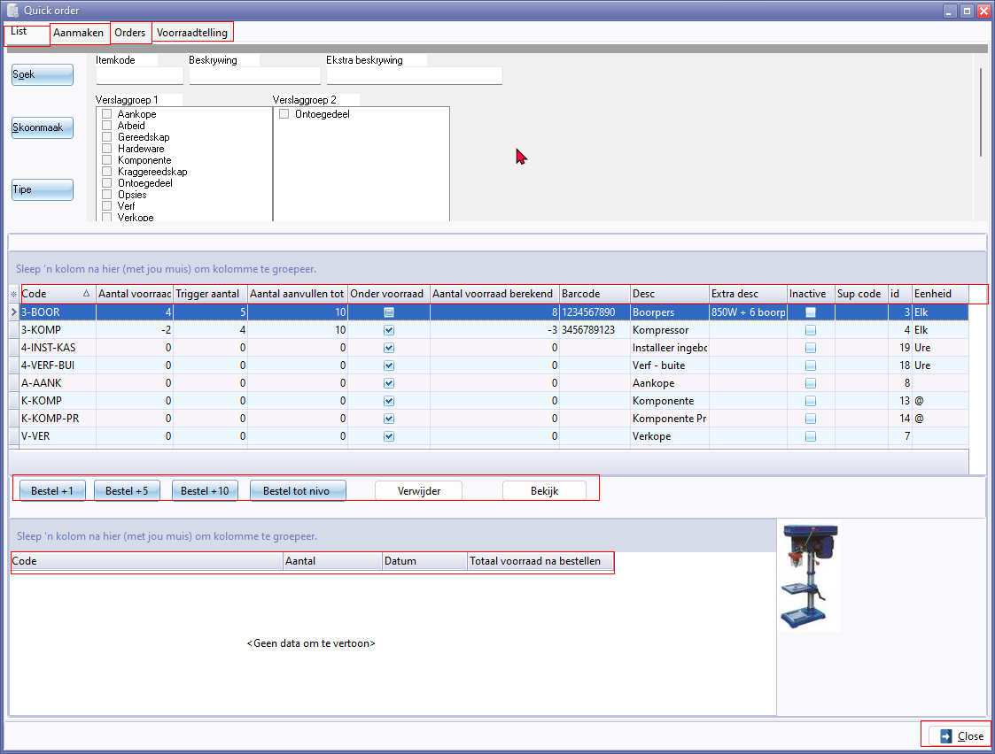

**Columns**

* Code 605
* Aantal voorraad
* Trigger aantal
* Aantal aanvullen tot
* Onder voorraad
* Aantal voorraad berekend
* Barcode 990 / 991 / 1774 / 1801
* Desc 1708
* Extra desc 2919
* Inactive
* Sup code
* id 906446
* Unit 1131 / 1775

**Buttons**

Bestel +1

Bestel + 5

Bestel + 10

Bestel tot nivo

Verwijder Delete 173/ 293 / 984 / 1842 / 2248 / 21150

**Verwijder confirmation message -** Delete confirmation

*Weet u het zeker? 903178*

Bekijk (View 3700)

**Bottom columns**

Code 605

Aantal

Datum

Totaal voorraad na bestellen

Close button 828

***Aanmaken tab***

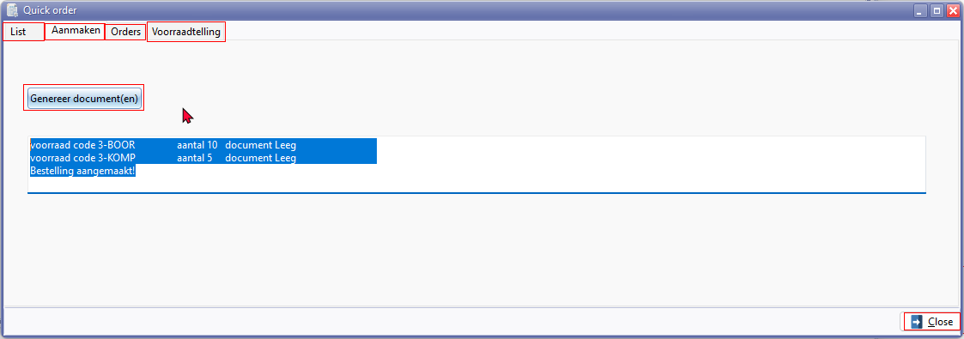

Aanmaken tab

Genereer document(en)

Example text for generated document.

*voorraad code 3-BOOR aantal 10 document Leeg   
voorraad code 3-KOMP aantal 5 document Leeg   
Bestelling aangemaakt!*

***Orders tab***

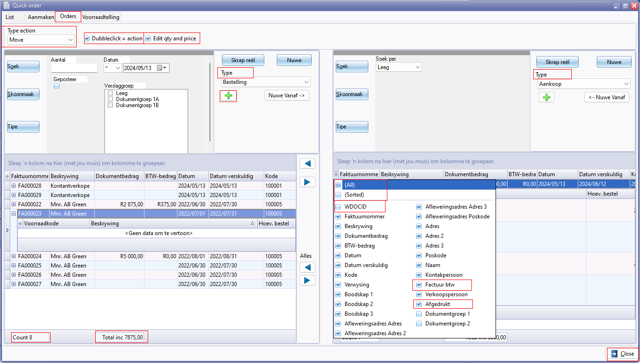

Nuwe - Selecteer rekening (lookup titlebar caption)

Type action

* Move 21022
* Copy 3293 / 21010

Dubbleclick = action

Edit qty and price

**Columns**

* (All) 20055
* (Sorted)
* WDOCID
* Factuur btw
* Afgedrukt 2964

***Voorraadtelling tab***

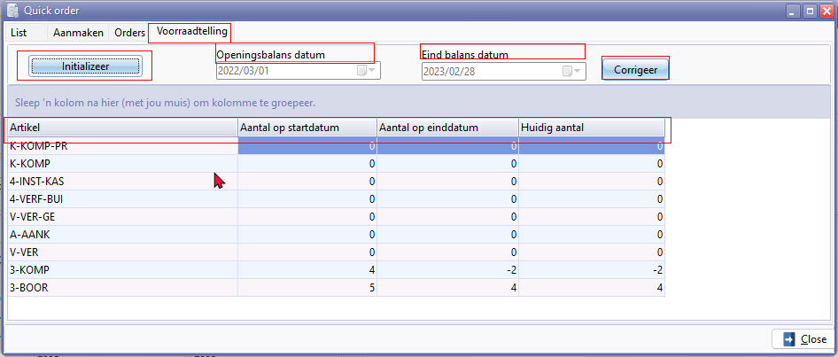

Voorraadtelling 415

Initializeer

Openingbalanse datum

Eindbalans datum

Corrigeer

**Columns**

Artikel (Item 1140)

Aantal op startdatum

Aantal op einddatum

Huidig aantal

**Documents Orders**

Seems totally translated