Table of Contents

**RetailPOS plugin - Translations** 2

***RetailPOS - Setup*** 2

***RetailPOS - Setup - Payment types*** 3

***RetailPOS - Setup - Images and reports*** 3

**RetailPOS - Access - Plugins menu** 4

**RetailPOS - Default ribbon** 4

**RetailPOS - Invoice - All orders** 5

***RetailPOS - Invoice - New order*** 5

***Document groups button - Documents*** 6

***RetailPOS - Invoice - Context menu*** 7

***RetailPOS - Invoice - Select account*** 8

**RetailPOS - Quotes** 8

***Stock group 1 refers to Document groups*** 9

**RetailPOS - Reports** 10

**RetailPOS - Receive payment** 10

**RetailPOS - Invoice - Setup** 11

**RetailPOS - Reports** 12

***Cashup report*** 13

***Sales per period*** 14

***Posted payments*** 14

***Dayview*** 15

**POS Document type** 16

**RetailPOS plugin - Translations**

**Menu**: **Plugins →Point-of-Sales → RetailPOS** (**Setup** ribbon).

***RetailPOS - Setup***

Setup retail pos (Titlebar caption)

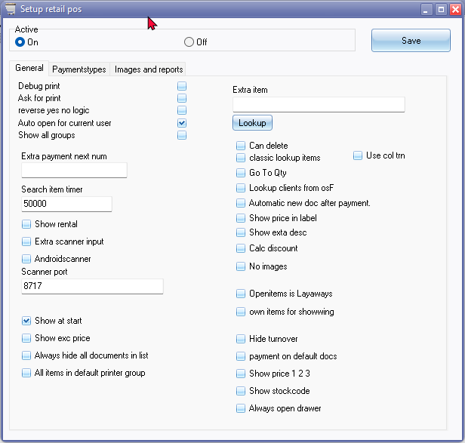

Activate

On

Off

Save 726

Tabs and all options

***RetailPOS - Setup - Payment types***

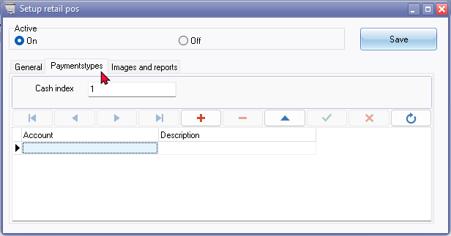

***RetailPOS - Setup - Images and reports***

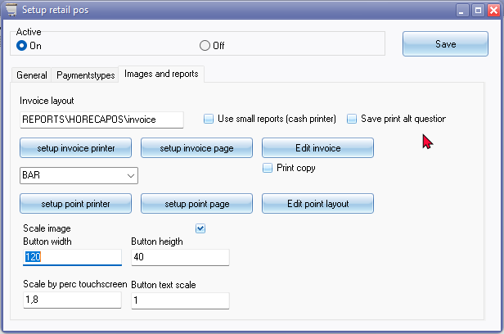

**RetailPOS - Access - Plugins menu**

RETAILPOS - Also see Tools -> Activate Plugins

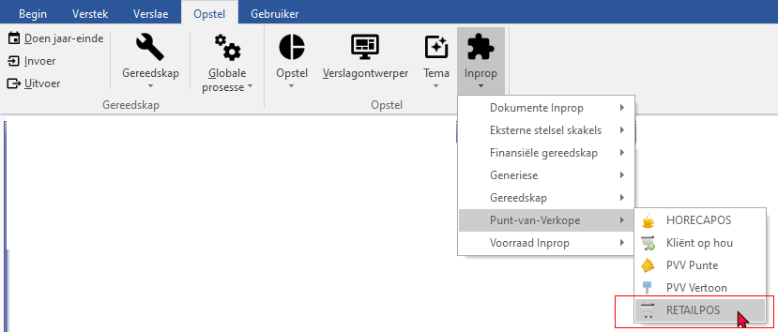

**RetailPOS - Default ribbon**

Also see Titlebar captions in Retail POS screens

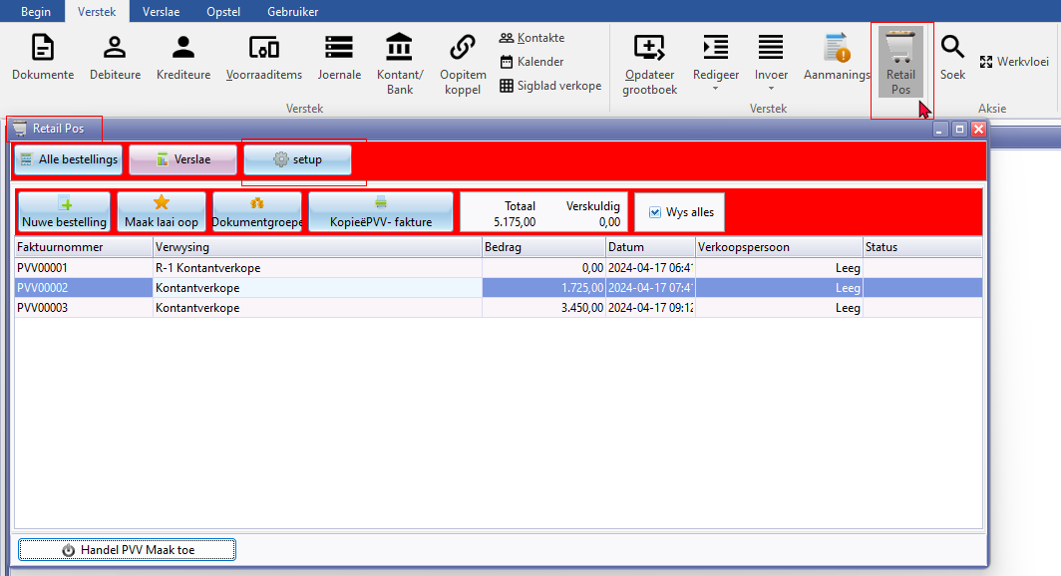

**RetailPOS - Invoice - All orders**

***RetailPOS - Invoice - New order***

Reference 1708

Lookup / barcode

* Click here to show/hide/move columns (Mouse over)

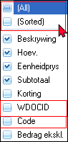

(All) 20055

(Sorted) 20056

WDOCID

Code 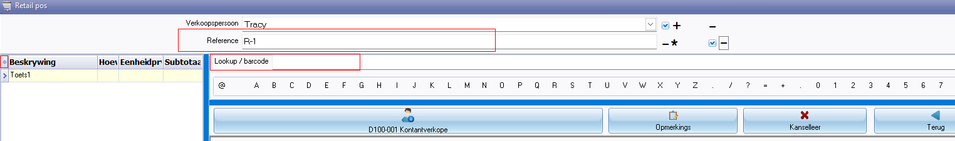

Scan will be negative (Mouse over)

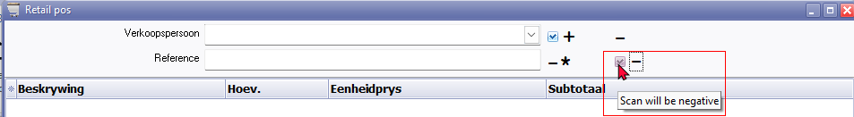

Delete message

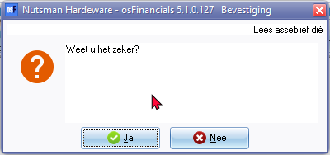

***Document groups button - Documents***

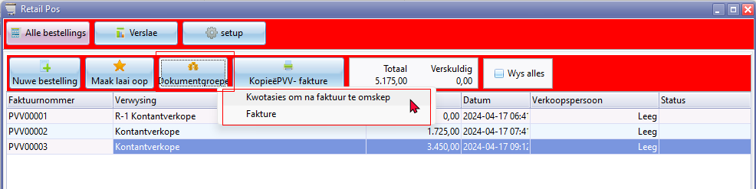

Document groups button - Documents

Lookup titlebar caption - Document groups

* Quotes a to convert to an invoice - Lists Quote documents
* Invoices - Lists POS invoice documents

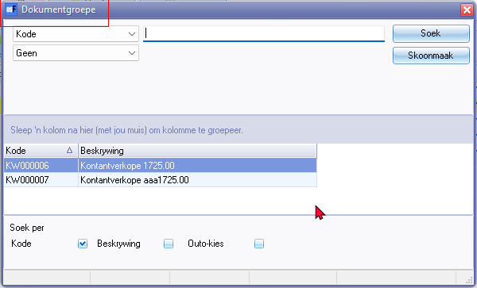

***RetailPOS - Invoice - Context menu***

Get dish value F6

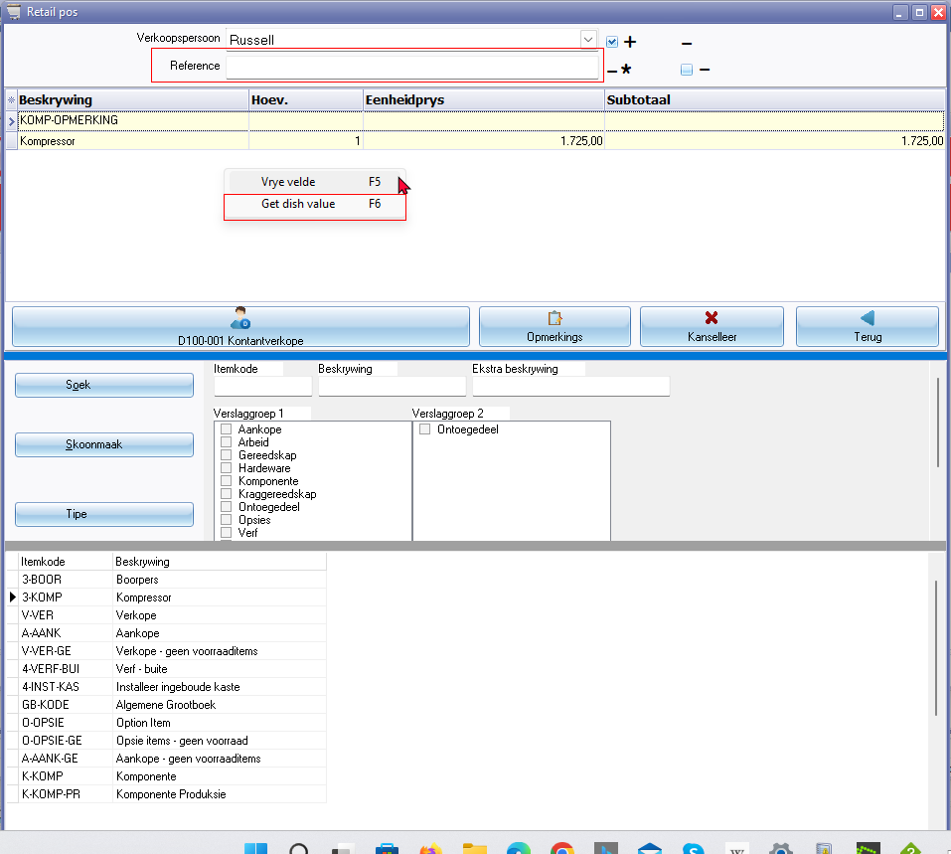

***RetailPOS - Invoice - Select account***

Select account (Titlebar caption)

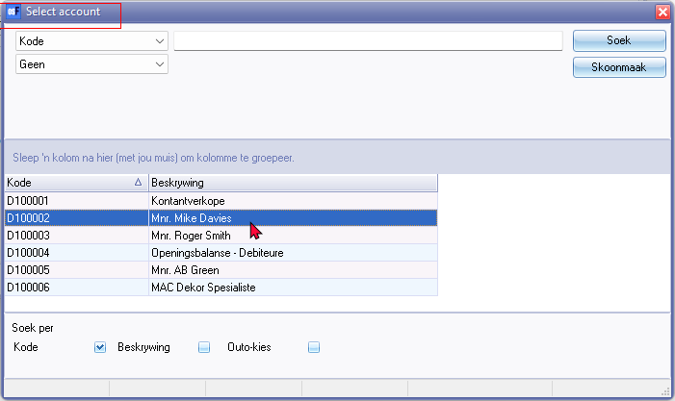

**RetailPOS - Quotes**

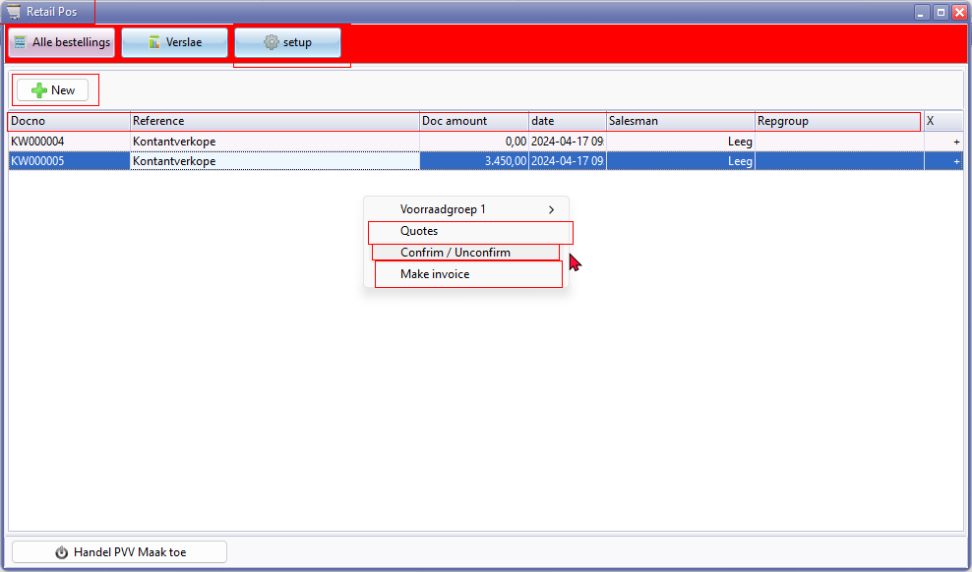

New button

**Column headings**

* Docno
* Reference 1708
* Doc amount
* date 238
* Salesman
* Repgroup

**Context menu**

* Quotes
* Confirm / Unconfirm
* Make invoice

***Stock group 1 refers to Document groups***

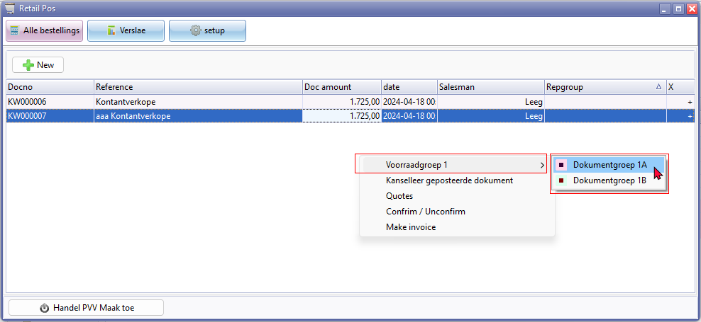

**RetailPOS - Reports**

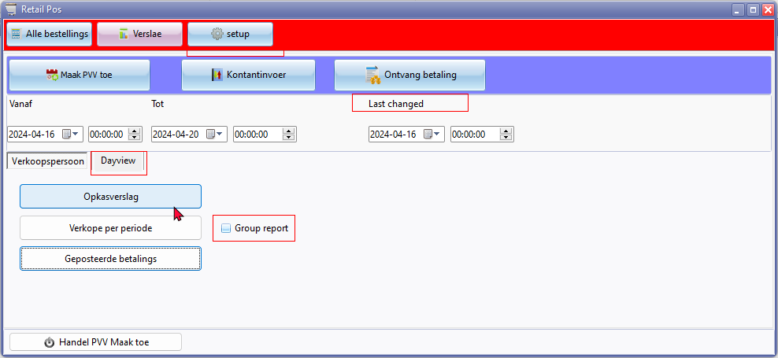

Last changed

Group report

Dayview

**RetailPOS - Receive payment**

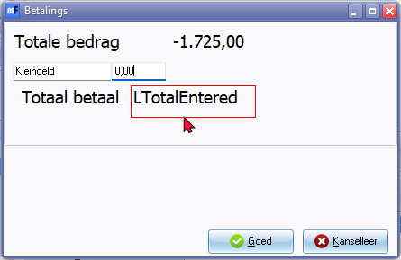

Openamount

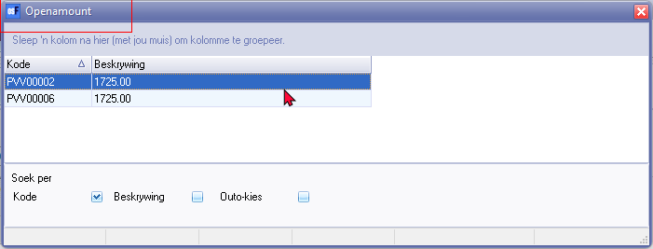

**RetailPOS - Invoice - Setup**

**Launch** - **RetaiPOS** icon on **Default** ribbon

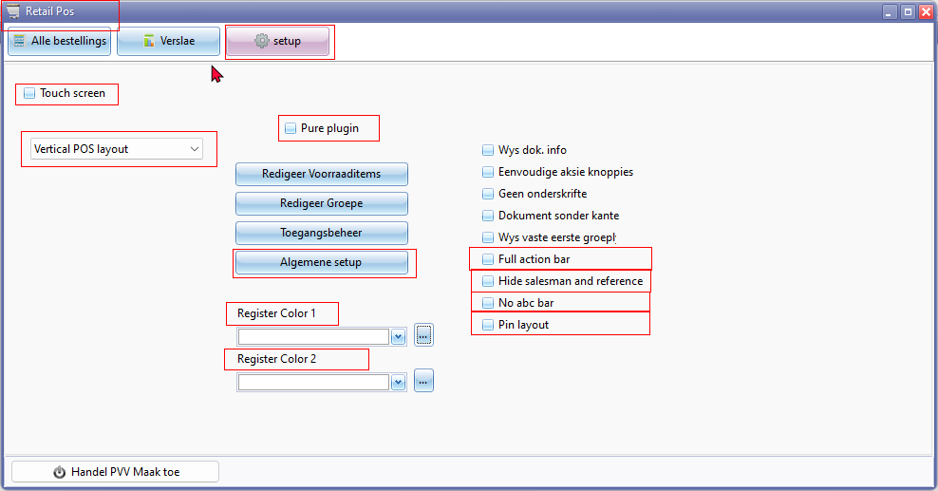

Vertical POS layout

Horizontal POS layout

Color Editor - Not translatable via Windows operating system

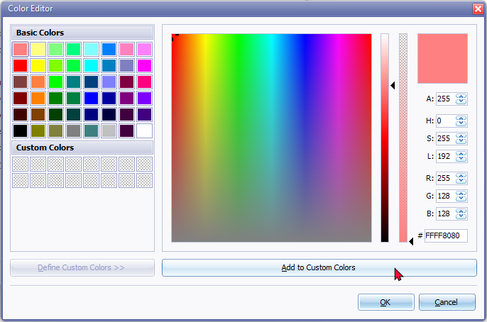

**RetailPOS - Reports**



**Notes on reports**

* These reports may not fully translatable
* Report names may need to be added to the print-outs to show if it is Cashup report, Sales per period or Posted payments report
* Address will be displayed Address1 / Postal code / Address 2 / Address 3 for the Nederlands basetype 0

for international base type 1 - Address will be displayed Address1 / Address 2 / Address 3 / Postal code

* Printed from Salesperson tab options and when Close POS option prints automatically.

**Location** : ...\plug_ins\reports\REPORTS\HORECAPOS\DAYVIEW

***Cashup report***

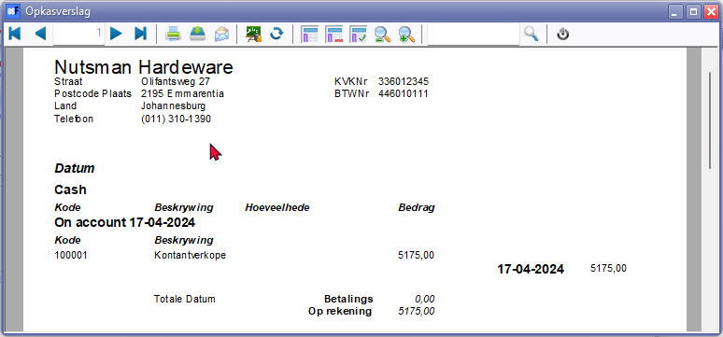

***Sales per period***

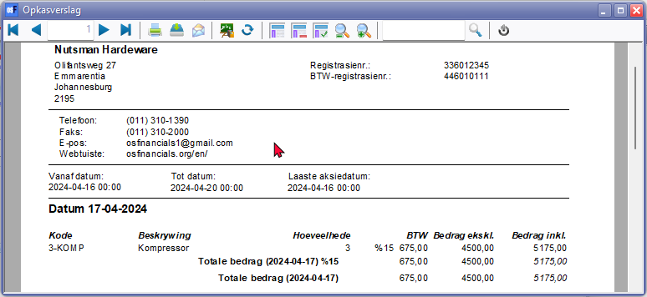

***Posted payments***

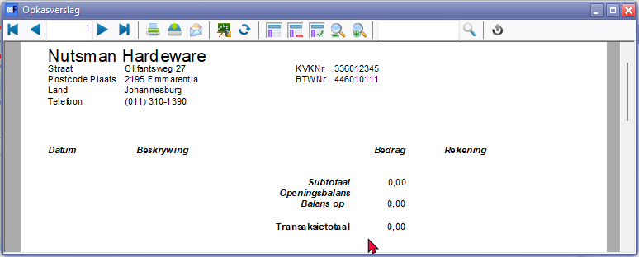

***Dayview***

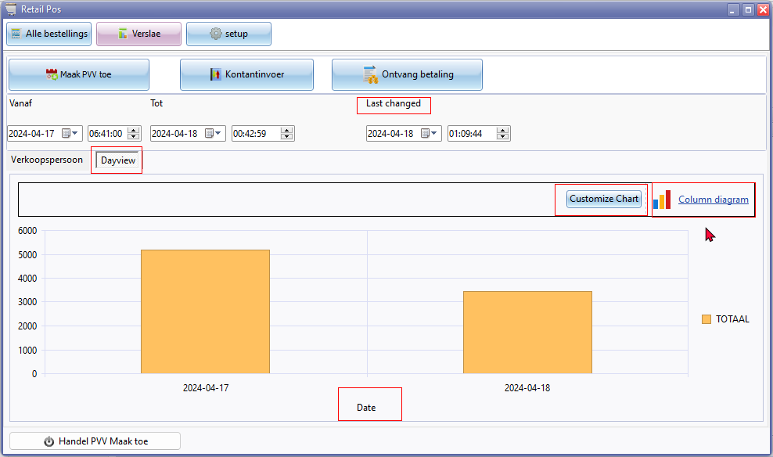

**POS Document type**

Most document number prefixes starts with PVV in Afrikaans or POS in English (8-digit document numbers)

PY00001 (7-digit document number) number prefix generated for 0.00 document

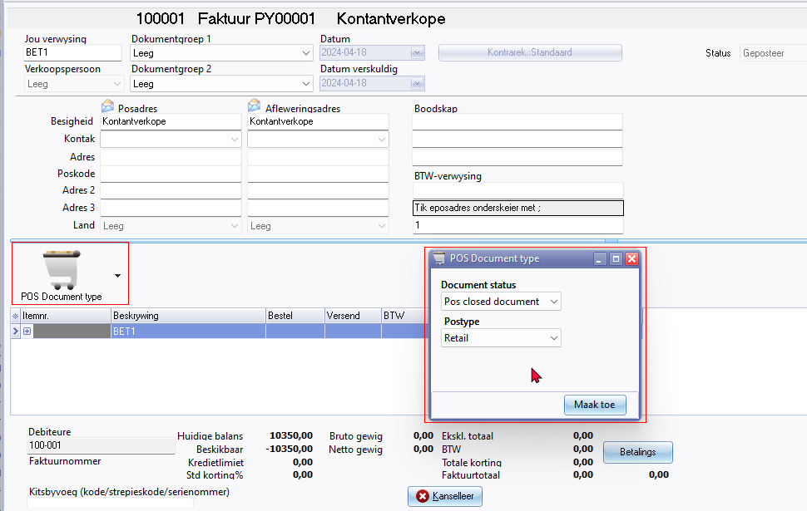

Document status

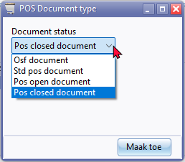

Postype - Select Retail / Horeca