Table of Contents

**SQLBrowser Plugin - Translations** 1

**Menus** 1

Context menus 2

Columns / Grid 2

**SQLBrowser Plugin - Translations**

|  |  |
| --- | --- |
|  | ***SQLBrowser*** *- Manual - Shop -* ***Licence*** *: Once-off*  ***Documentation*** *: Help documentation* |

**Menu**: **Plugins → Tools → SQLBrowser** (**Setup** ribbon).

**Menus**

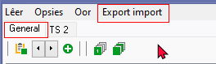

General 1367 / 3205

Export import (Maybe JSON can be added - Already have Export option on File menu

Export to JSON

Create from JSON

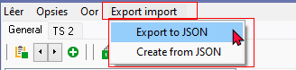

Set path

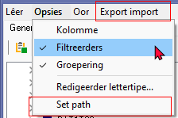

# Context menus

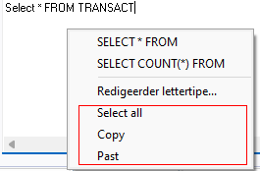

Select all

Copy 3293 / 21010

Past (Paste) 21011

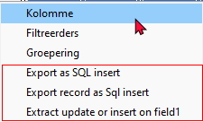

Export as SQL insert

Export record as Sql insert

Extract update or insert on field1

# Columns / Grid

* Click here to show/hide/move columns (Mouse over)

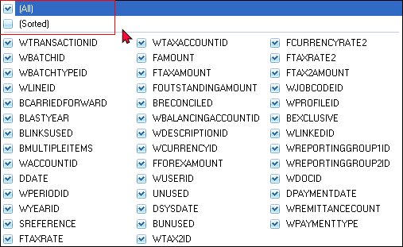

(All) 20055

(Sorted) 20056