Table of Contents

**Stock check** 1

***Stock check / Stock correction plugin*** 1

**Activation** 1

**Default ribbon icon** 2

**Stock check tabs** 2

***List*** 2

***Correctie tab*** 3

***Bulkcheck tab*** 4

**Documents Credit notes** 5

**Stock check**

**Menu**: **Plugins → Stock → StockCheck** (**Setup** ribbon).

***Stock check / Stock correction plugin***

|  |  |
| --- | --- |
|  | ***Stock check / Stock correction*** *- Manual - Shop -* ***Licence****: Once-off*  ***Documentation*** *: Help documentation* |

**Activation**

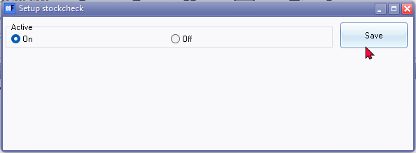

Entire setup screen

Save button 726

**Default ribbon icon**

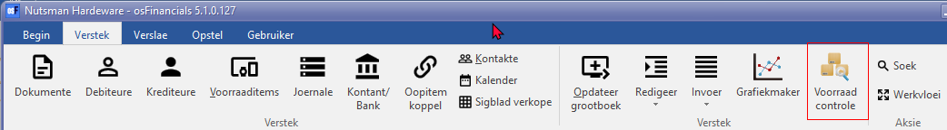

Voorraad controle - Stock control 225 used in titlebar captions and on Plugins menu

**Stock check tabs**

***List***

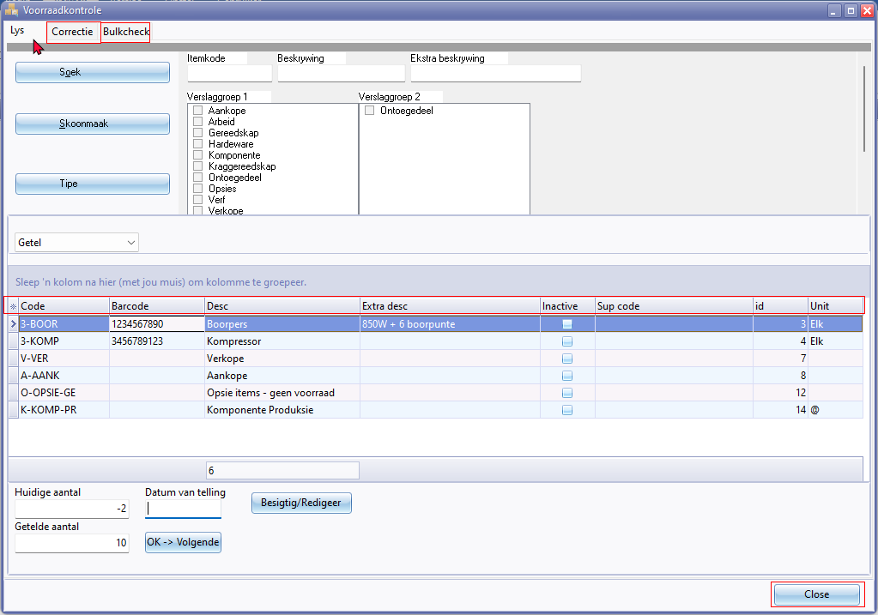

**Columns**

* Code 605
* Barcode 990 / 991 / 1774 / 1801
* Desc 1708
* Extra desc 2919
* Inactive
* Supplier code
* id 906446
* Unit 1131 / 1775

Close button 828

***Correctie tab***

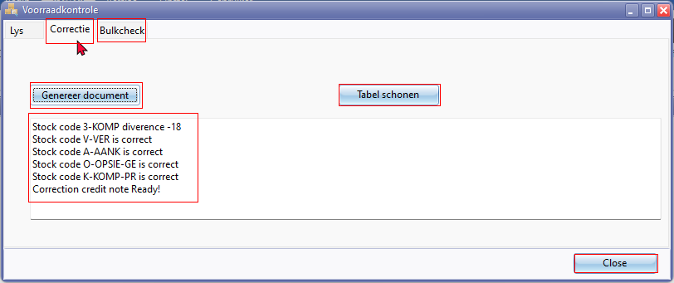

Correctie tab

Example text for generated document.

*Genereer document   
Stock code 3-BOOR diverence 8  
Stock code 3-KOMP diverence 12  
Correction credit note Ready!*

Tabel schonen - Clear table

Confirmation message

*Delete all stock checks? Warning this cannnot be reversed!*

Confirmation message

*Are you sure you want to post the new inventory data?*

***Bulkcheck tab***

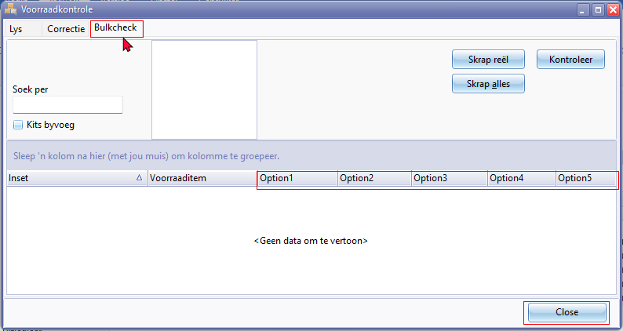

Delete line - No Confirmation message

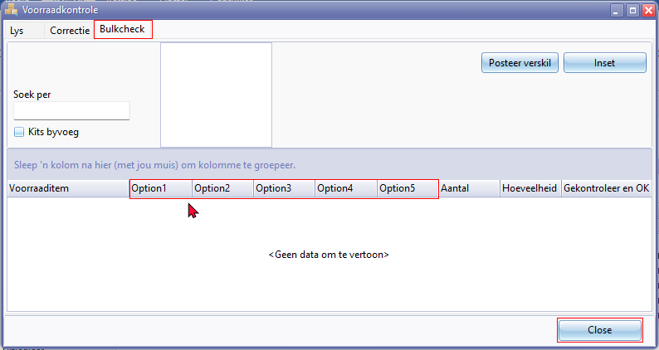

Confirmation message **Post difference** button.

*Are you sure you want to post the new inventory data?*

Post difference button - Access violation error on Bulk check tab

*violation of FOREIGN KEY constraint "FK_DOCLINE_STOCK" on table "DOCLINE"  
Foreign key reference target does not exist*

**Documents Credit notes**

Your reference - Text - Correction

Document lines description - Text - Stock count correction.

