Table of Contents

**Subscriptions Plugin** 2

**Setup Subscription** 2

**Debtors - Subscription tab** 3

**Process warnings** 5

**Process subscriptions** 5

**Search** 6

**Subscriptions - Reports** 6

**Error message in Processing - Process warnings** 8

**Subscriptions Next run / Transaction dates 1900 year** 8

***Subscriptions to process*** 8

***Debtors - Subscriptions tab*** 8

***Quote*** 9

***Invoice*** 9

**Subscriptions Plugin**

|  |  |
| --- | --- |
|  | ***Subscriptions*** *- Manual - Shop -* ***Licence*** *: Annual license -*  ***Documentation*** *: Help documentation* |

Reminders - Email Setup - See EmailPro plugin

**Setup Subscription**

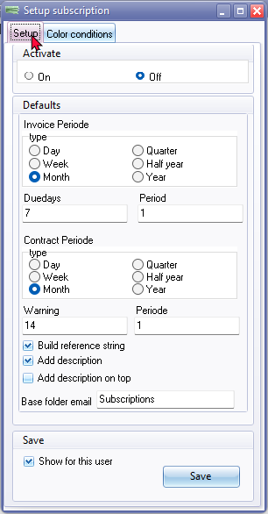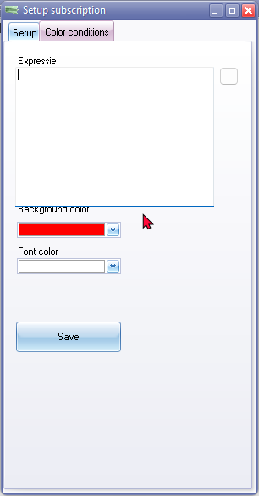

Tabs

Setup 124

Activate (Enabled 1322) to be consistent with other plugins)

On 3256

Off 3257

Invoice Periode

type 1079

Day 901017

Week 901018

Month 901019

Quarter 901020

Half year 901021

Year 901022

Due days 2221 / 2241

Period 600

Build reference string

Add description

Add description on op

Base folder email

Show for this user 3521

Save 726

Color conditions 903107

Expression 903175

Background color 3337

Font color 3338

**Debtors - Subscription tab**

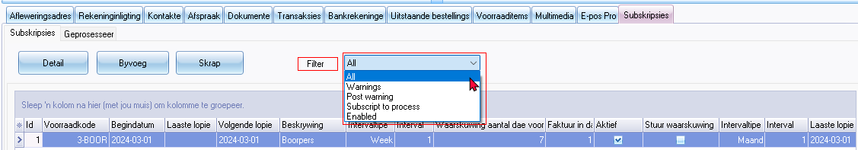

Filter 20097

All 21019

Warnings 901002

Post warning

Subscript to process 901003

Enabled 1322

Column headings

* (All) 20055
* (Sorted)
* Id 906446

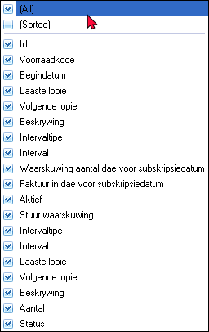

Double-click on Post warnings per invoice

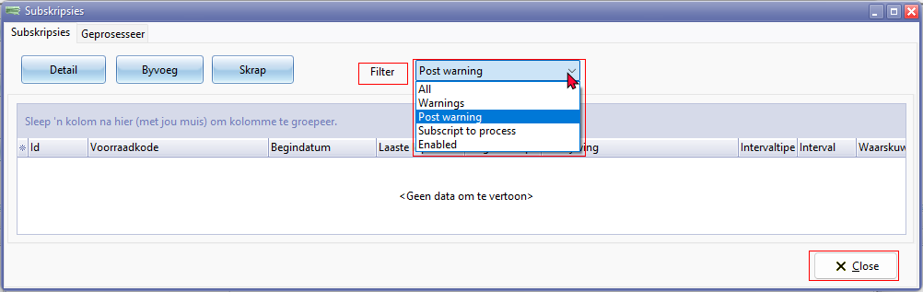

Close button 828

**Process warnings**

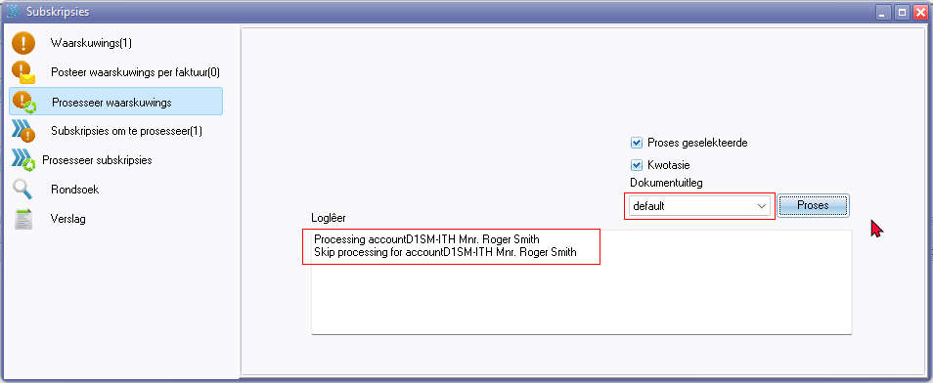

default 1341

Log file entries e.g. "*Processing account xxxxxxxxxxx*" / "*Skip processing account xxxxxxxxxxx*" , etc.

**Process subscriptions**

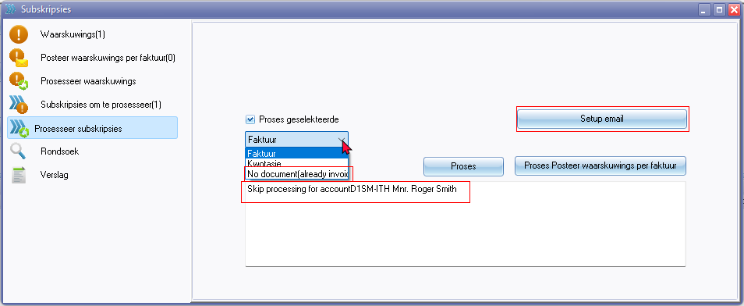

Setup email

No document (already invoiced) No document 2992

Log file entries e.g. "*Processing account xxxxxxxxxxx*" / "*Skip processing account xxxxxxxxxxx*" , etc.

**Search**

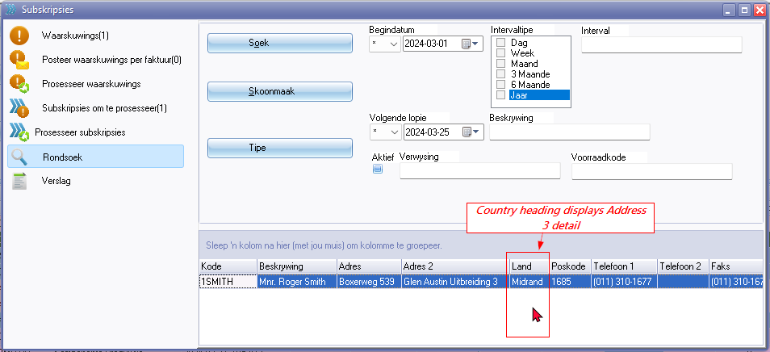

The Country column heading "*Land*" should be Address 3 since the data entered in Address 3 field is displayed in thee Country column.

Address 3 (2420)

**Subscriptions - Reports**

Parameters

* From date 286 / 2108
* To date 287

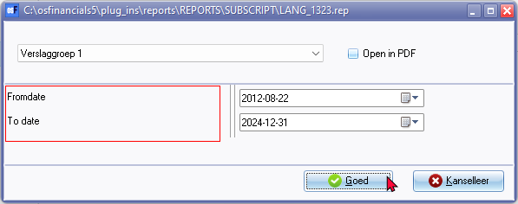

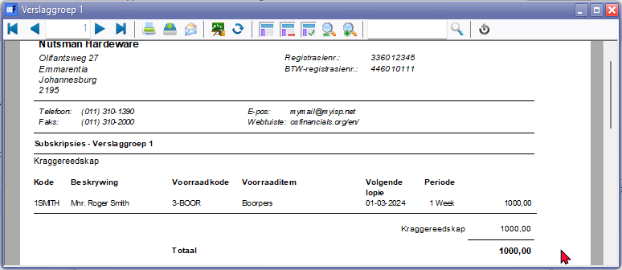

Need to add a heading for last column Amount exclusive (translatable expression in Report designer.

Amount excl. 650 added

**Location** : " ... \plug_ins\reports\REPORTS\SUBSCRIPT\

|  |  |  |
| --- | --- | --- |
| ***Language ID*** | ***Report name*** | ***Report name on printed report*** |
| *LANG_1323.rep* | *Reporting group 1* | *Subscriptions - Reporting group 1* |
| *LANG_1325.rep* | *Reporting group 2* | *Subscriptions - Reporting group 2* |
| *LANG_901000.rep* | *Subscriptions* | *Subscriptions* |
| *LANG_901001.rep* | *Subscriptions list* | *Subscriptions list* |

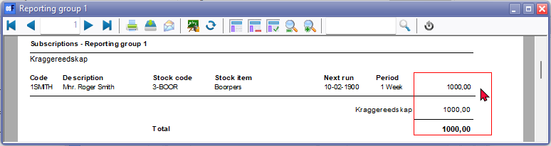

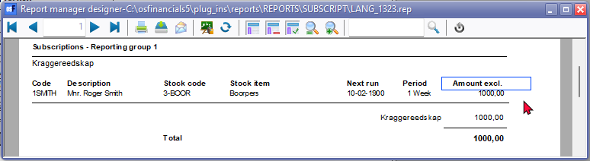

**Error message in Processing - Process warnings**

Logfile -entry - "*Processing accountD1SM-ITH Mnr. Roger Smith*" produces error message

*ZQWarnings: Cannot perform this operation on a closed dataset*

**Subscriptions Next run / Transaction dates 1900 year**

***Subscriptions to process***

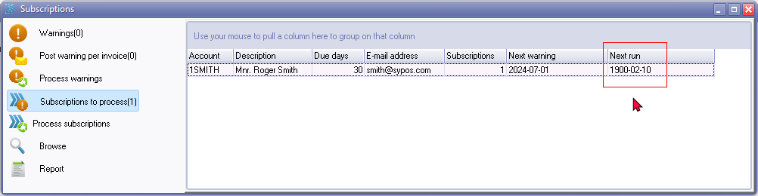

***Debtors - Subscriptions tab***

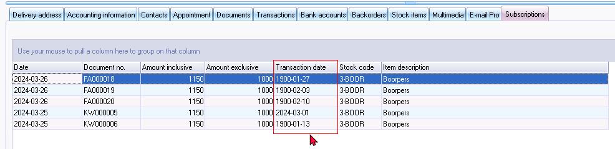

***Quote***

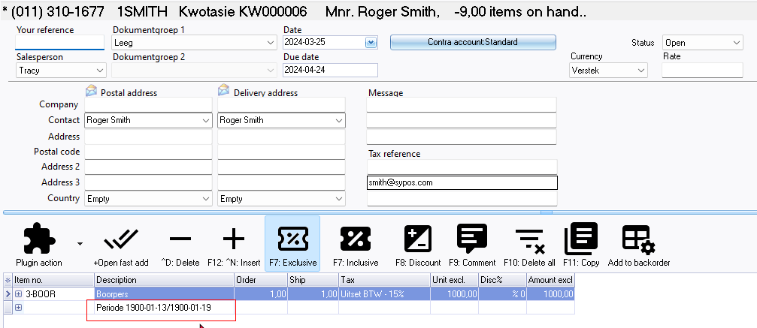

***Invoice***

