Table of Contents

**Graphs per week - Graphs per week - X and Y axis values labels (titles)** 1

***MSSQL - X-axis and Y-axis - fixed*** 1

***MSSQL - X-axis and Y-axis - incorrect*** 2

***Firebird database types*** 3

***MSSQL database types*** 5

***Existing SQL - DOCUMENTLINE DATASET*** 6

**Updated DOCUMENTLINE SQL** 8

**Changelog - File names - Graphs per week (TRN_906558)** 9

**Graphs per week - Graphs per week - X and Y axis values labels (titles)**

***MSSQL - X-axis and Y-axis - fixed***

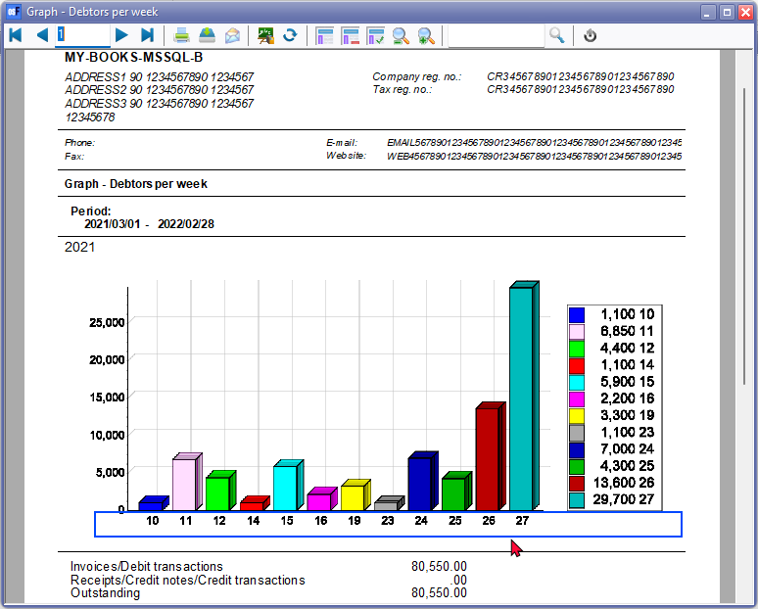

***MSSQL - X-axis and Y-axis - incorrect***

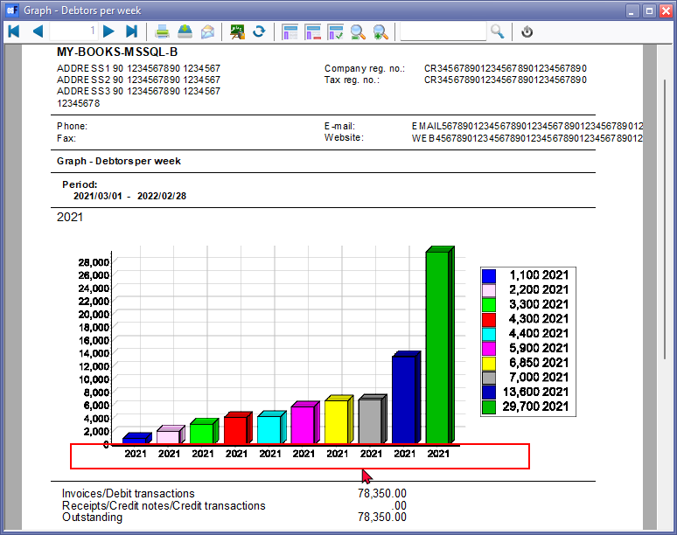

DOCUMENTLINE Dataset SQL - DATEPART - It s the line 3 DATEPART in SQL and related lines

*{if interbase}extract(week from ddate){else}datepart(week,ddate){endif} week,*

***Firebird database types***

In Firebird database types, the Graph - Profit / Loss per week - displays the week number on the x-axis - correctly

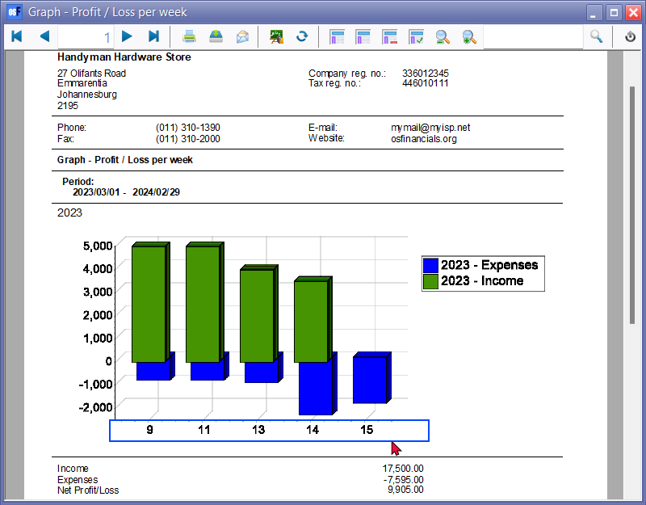

**Firebird - DOCUMENTLINE Dataset - Show Data - correct**

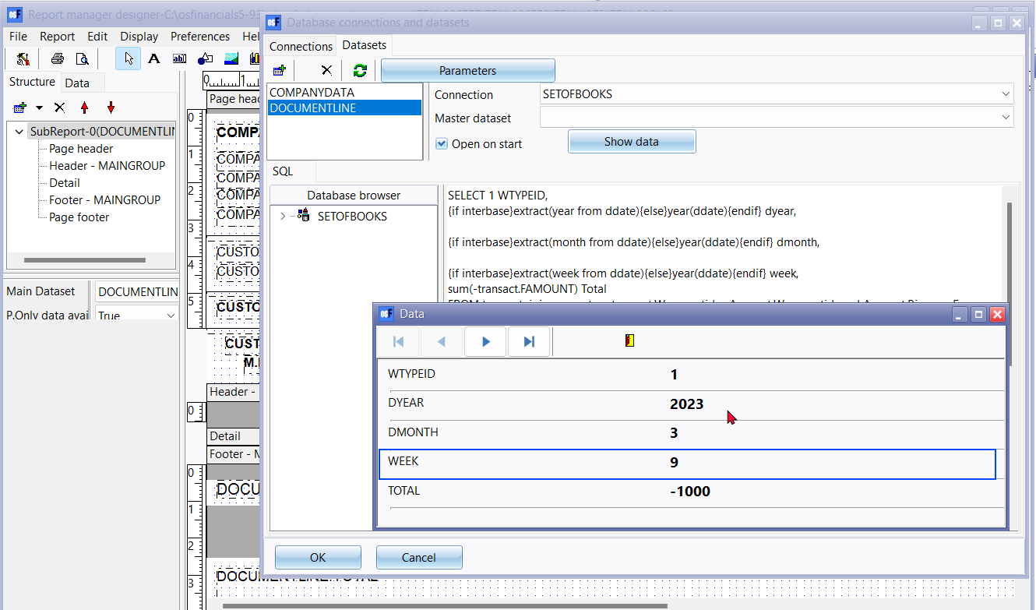

***MSSQL database types***

In MSSQL database types, the Graph - Profit / Loss per week - displays the Year instead of the week number on the x-axis - incorrectly

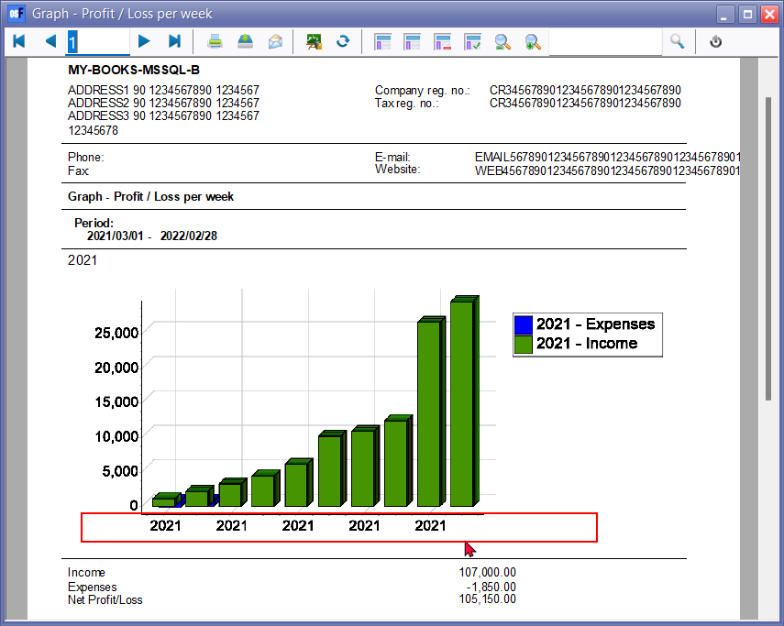

***Existing SQL - DOCUMENTLINE DATASET***

|  |
| --- |
| SELECT 1 WTYPEID,  {if interbase}extract(year from ddate){else}year(ddate){endif} dyear,  {if interbase}extract(month from ddate){else}year(ddate){endif} dmonth,  {if interbase}extract(week from ddate){else}year(ddate){endif} week,  sum(-transact.FAMOUNT) Total  FROM transact join account on transact.Waccountid = Account.Waccountid and Account.BincomeExpense = 1  where  (transact.ddate >= :DDATEFROMFL and transact.ddate <= :DDATETOFL)  and transact.FAMOUNT > 0  group by  {if interbase}extract(year from ddate){else}year(ddate){endif} ,  {if interbase}extract(month from ddate){else}month(ddate){endif} ,  {if interbase}extract(week from ddate){else}datepart(week,ddate){endif}  union  SELECT 2 WTYPEID,  {if interbase}extract(year from ddate){else}year(ddate){endif} dyear,  {if interbase}extract(month from ddate){else}year(ddate){endif} dmonth,  {if interbase}extract(week from ddate){else}year(ddate){endif} week,  sum(-transact.FAMOUNT) Total  FROM transact join account on transact.Waccountid = Account.Waccountid and Account.BincomeExpense = 1  where  (transact.ddate >= :DDATEFROMFL and transact.ddate <= :DDATETOFL)  and transact.FAMOUNT < 0  group by  {if interbase}extract(year from ddate){else}year(ddate){endif} ,  {if interbase}extract(month from ddate){else}month(ddate){endif} ,  {if interbase}extract(week from ddate){else}datepart(week,ddate){endif}  order by 1,2,3 |

**MSSQL - DOCUMENTLINE Dataset - Show Data - incorrect**

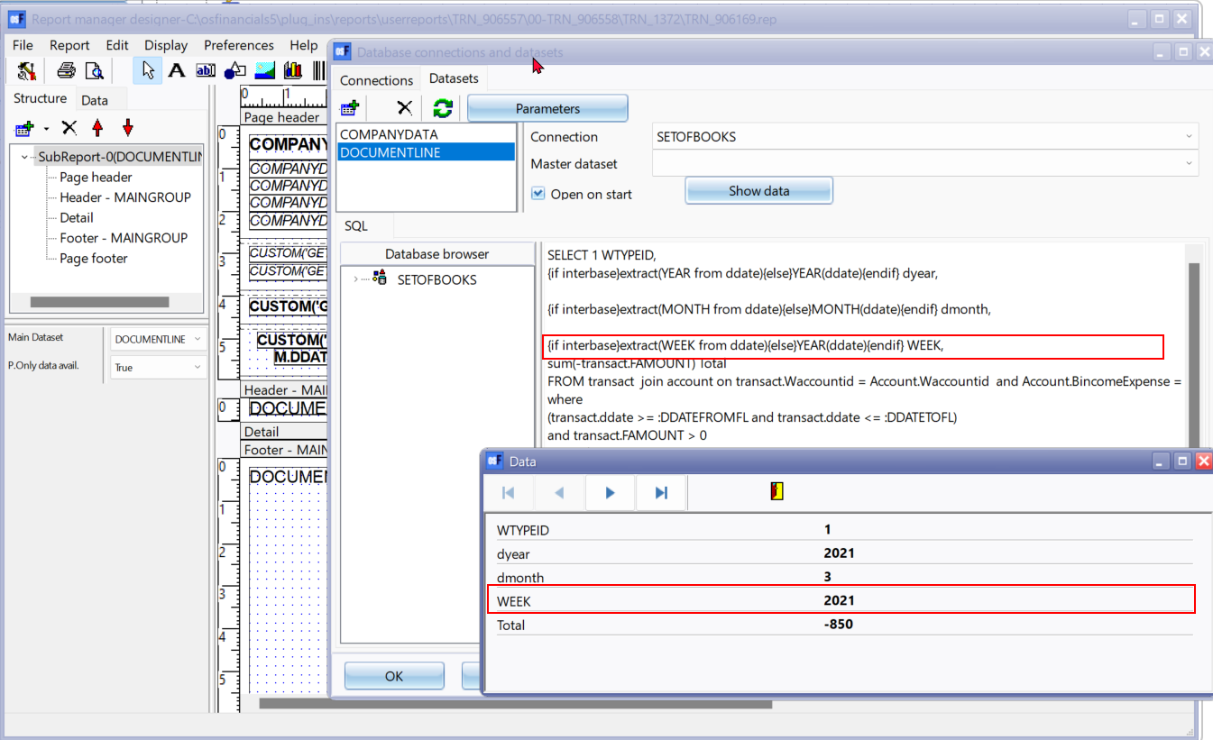

**MONTH** (Originally "dmonth" was showing the Year value "2021")

Changing YEAR to MONTH (2nd line)

*{if interbase}extract(MONTH from ddate){else}YEAR(ddate){endif} dmonth,*

to

*{if interbase}extract(MONTH from ddate){else}MONTH(ddate){endif} dmonth,*

After changes - displays "dmonth" was showing the Month value "03" for March, etc.)

**WEEK**

Changing YEAR to WEEK + add datepart (3rd line)

*{if interbase}extract(week from ddate){else}year(ddate){endif} week,*

to

{if interbase}extract(week from ddate){else}datepart(week,ddate){endif} week,

**Updated DOCUMENTLINE SQL**

**NOTE** - For year, month, datepart week UPPERCASE / lowercase no effect on results in SQL foe Firebird database types and MSSQL database types

|  |
| --- |
| SELECT 1 WTYPEID,  {if interbase}extract(year from ddate){else}year(ddate){endif} dyear,  {if interbase}extract(month from ddate){else}month(ddate){endif} dmonth,  {if interbase}extract(week from ddate){else}datepart(week,ddate){endif} week,  sum(-transact.FAMOUNT) Total  FROM transact join account on transact.Waccountid = Account.Waccountid and Account.BincomeExpense = 1  where  (transact.ddate >= :DDATEFROMFL and transact.ddate <= :DDATETOFL)  and transact.FAMOUNT > 0  group by  {if interbase}extract(year from ddate){else}year(ddate){endif} ,  {if interbase}extract(month from ddate){else}month(ddate){endif} ,  {if interbase}extract(week from ddate){else}datepart(week,ddate){endif}  union  SELECT 2 WTYPEID,  {if interbase}extract(year from ddate){else}year(ddate){endif} dyear,  {if interbase}extract(month from ddate){else}year(ddate){endif} dmonth,  {if interbase}extract(week from ddate){else}datepart(week,ddate){endif} week,  sum(-transact.FAMOUNT) Total  FROM transact join account on transact.Waccountid = Account.Waccountid and Account.BincomeExpense = 1  where  (transact.ddate >= :DDATEFROMFL and transact.ddate <= :DDATETOFL)  and transact.FAMOUNT < 0  group by  {if interbase}extract(year from ddate){else}year(ddate){endif} ,  {if interbase}extract(month from ddate){else}month(ddate){endif} ,  {if interbase}extract(week from ddate){else}datepart(week,ddate){endif}  order by 1,2,3 |

**Changelog - File names - Graphs per week (TRN_906558)**

| ***Menu item*** | ***Sub-menu item 1*** | ***Internal folder name /***  ***Report name*** | ***Internal report name*** |
| --- | --- | --- | --- |
| ***Ledger*** | ***TRN_1372*** |  |  |
|  |  | *Graph - Profit Loss per week* | *TRN_906169.rep* |
| ***Debtors*** | ***TRN_160*** |  |  |
|  |  | *Graph - Debtors per week* | *TRN_906168.rep* |
| ***Creditors*** | ***TRN_161*** |  |  |
|  |  | *Graph - Creditors per week* | *TRN_906167.rep* |
| ***Sales*** | ***TRN_1792*** |  |  |
|  | ***Quotes per period*** | ***TRN_3568*** |  |
|  |  | *Graph - Quotes per week - Quantities* | *TRN_906323.rep* |
|  |  | *Graph - Quotes per week - Amount* | *TRN_906324.rep* |
|  | ***Credit notes per period*** | ***TRN_3569*** |  |
|  |  | *Graph - Credit notes per week - Quantities* | *TRN_906319.rep* |
|  |  | *Graph - Credit notes per week - Amount* | *TRN_906320.rep* |
|  | ***Invoices per period*** | ***TRN-3570*** |  |
|  |  | *Graph - Invoices per week - Quantities* | *TRN_906170.rep* |
|  |  | *Graph - Invoices per week - Amount* | *TRN_906171.rep* |
|  | ***Sales per period*** | ***TRN_906122*** |  |
|  |  | *Graph - Invoices - Credit notes per week - Quantities* | *TRN_906579.rep* |
|  |  | *Graph - Invoices - Credit notes per week - Amount* | *TRN_906580.rep* |
| ***Purchases*** |  | ***TRN_302*** |  |
|  | ***Purchases*** |  |  |
|  |  | *Graph - Purchases - Supplier returns per week - Quantities* | *TRN_906581* |
|  |  | *Graph - Purchases - Supplier returns per week - Amount* | *TRN_906582* |
|  | ***Orders per period*** |  |  |
|  |  | *Graph - Orders per week - Quantities* | *TRN_906325.rep* |
|  |  | *Graph - Orders per week - Amount* | *TRN_906326.rep* |
|  | ***Supplier returns per period*** |  |  |
|  |  | *Graph - Supplier returns per week - Quantities* | *TRN_906321.rep* |
|  |  | *Graph - Supplier returns per week - Amount* | *TRN_906322.rep* |
|  | ***Purchases per period*** |  |  |
|  |  | *Graph - Purchases per week - Quantities* | *TRN_906289.rep* |
|  |  | *Graph - Purchases per week - Amount* | *TRN_906290.rep* |