Table of Contents

**Graphs per week - Graphs per week - X and Y axis values labels (titles)** 1

**TESTS - AFTER FIXES in DATABASES - Graphs per month** 1

**TESTS - AFTER FIXES in DATABASES - Graphs per week** 3

***MSSQL – Graphs per week*** 3

***Graph - Profit /Loss per week*** 3

***Graph - Creditors per week*** 6

***Graph - Sales per week / Graph - Sales per week (Invoices - credit notes)*** 7

***FIREBIRD – Graph Creditors per week*** 8

**Graphs per week - Graphs per week - X and Y axis values labels (titles)**

Could these be something missing in

**TESTS - AFTER FIXES in DATABASES - Graphs per month**

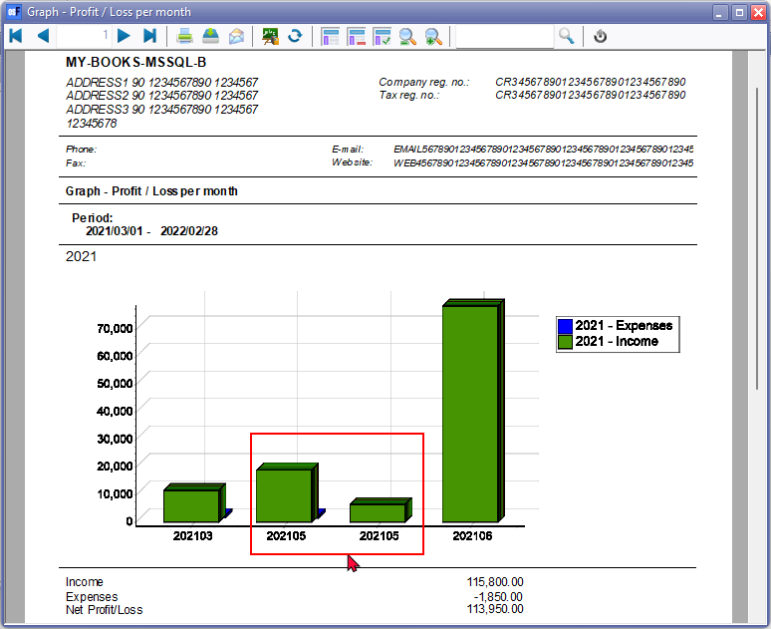

Order by 1,2,3 (Type, Year Month) or 2,1,3 (Year, Type, Month)

If order is set to 2,3,1 (Year, Month. Type) it prints as follows:

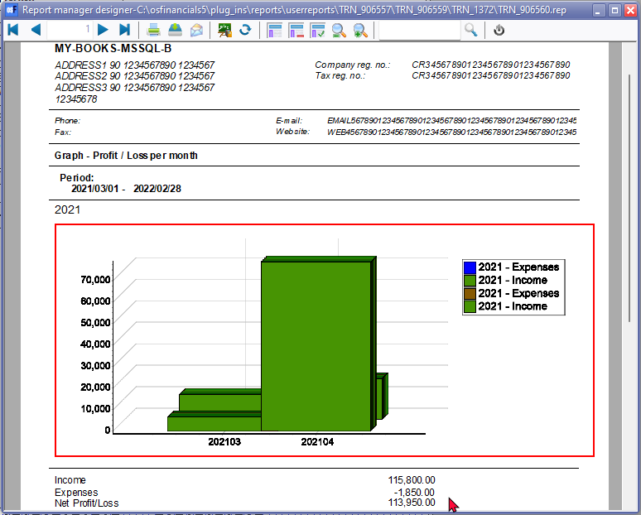

**TESTS - AFTER FIXES in DATABASES - Graphs per week**

***MSSQL – Graphs per week***

Database MY-BOOKS-MSSQL-B

***Graph - Profit /Loss per week***

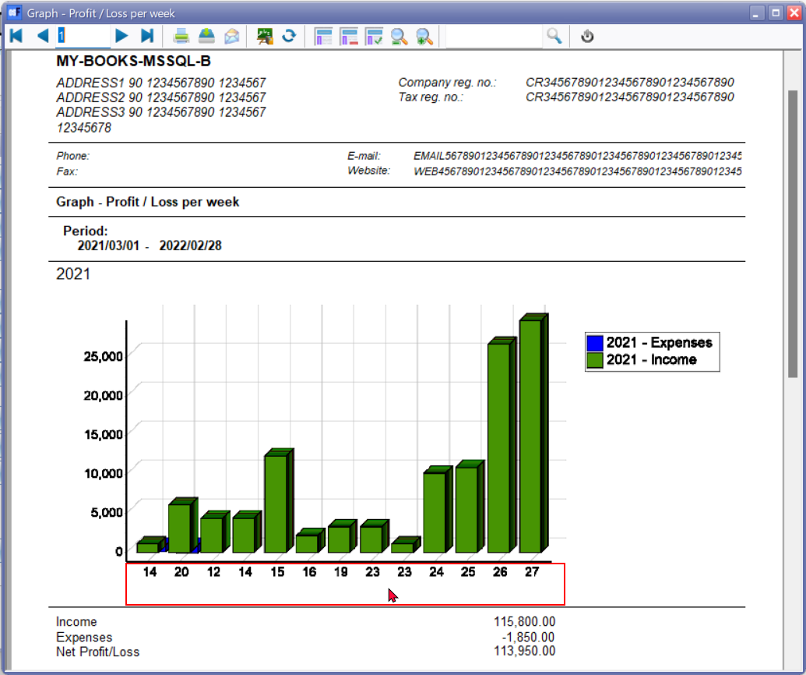

It probably has to do with SELECT 1 WTYPEID, and SELECT 2 WTYPEID, or Order by

It probably has to do with SELECT 1 WTYPEID, and SELECT 2 WTYPEID,

year , month , week, type

order by 2,3,4,1

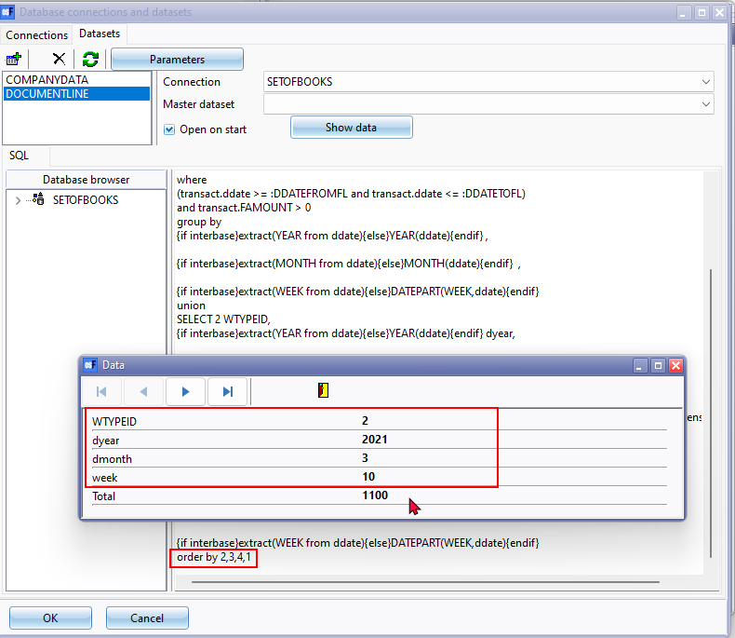

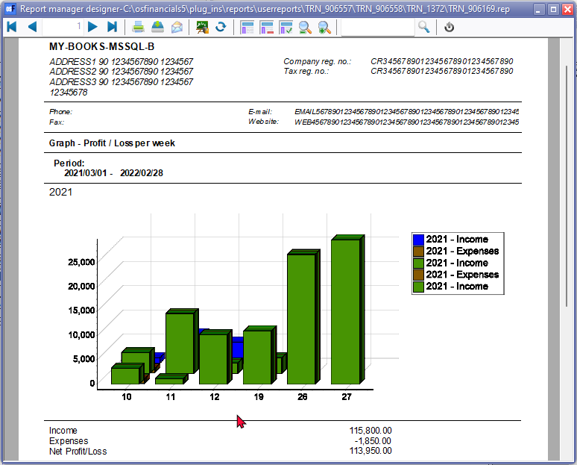

***Graph - Creditors per week***

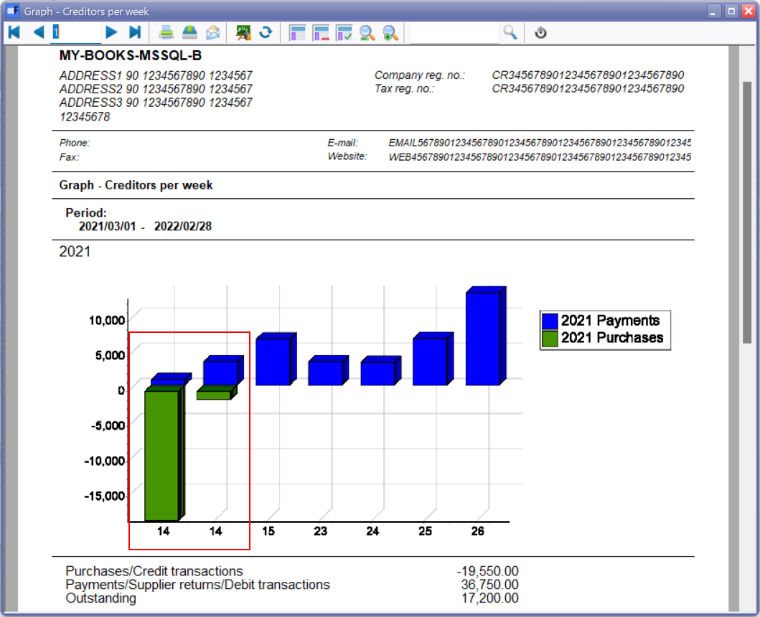

***Graph - Sales per week / Graph - Sales per week (Invoices - credit notes)***

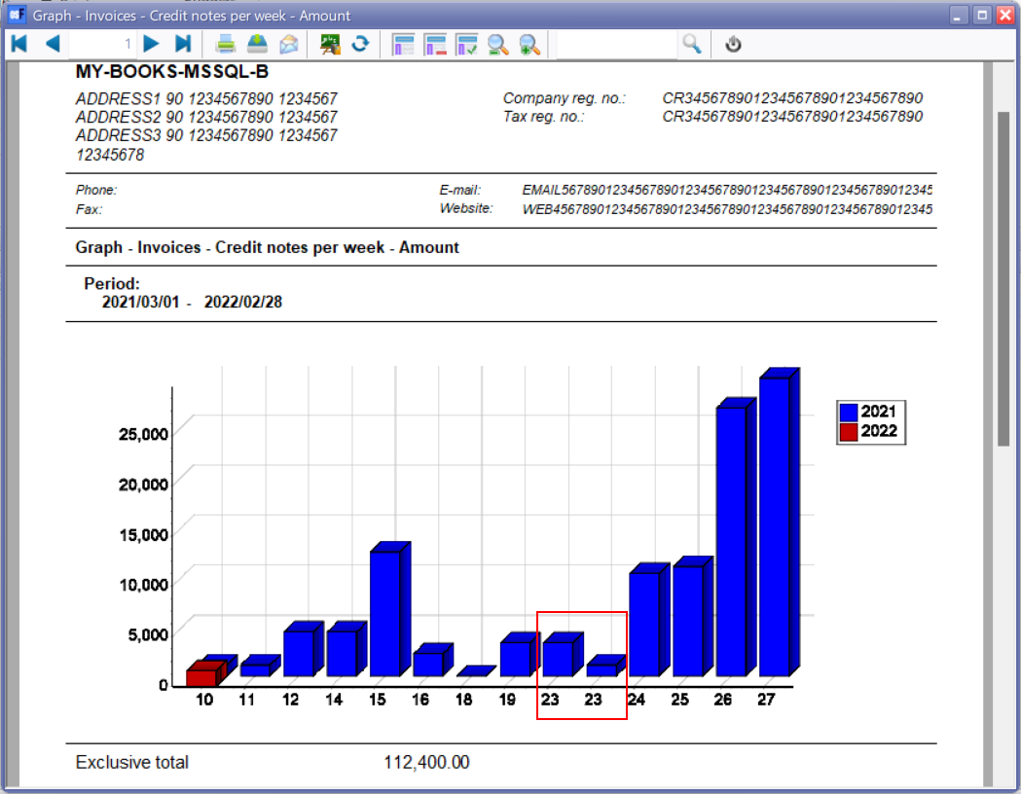

***FIREBIRD – Graph Creditors per week***

**Database** : HELPDEMO

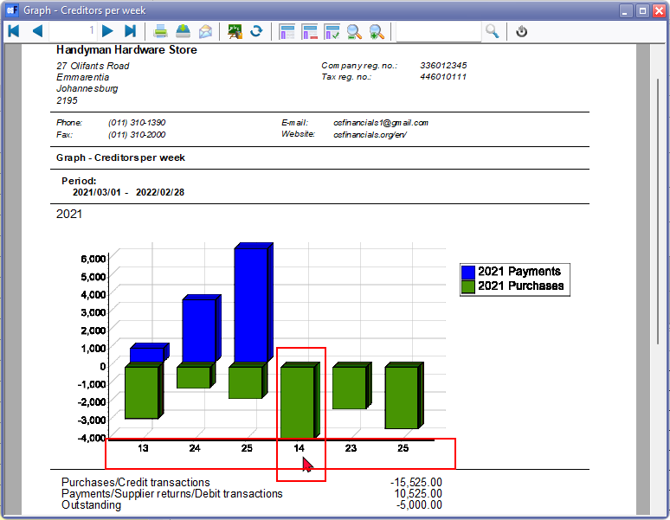

**Database HULP-AFR**

