Table of Contents

**Firebird Errors** 1

**MSSQL Errors** 1

***Stock In/Out*** Cannot change or Set the Properties such as word wrap, cut text, etc.

Debtor transactions - Extra details - **Location** : ...\plug_ins\reports\systemreports\TRN_160\TRN_74\TRN_906107.rep

Creditor transactions - Extra details - **Location** : ...\plug_ins\reports\systemreports\TRN_161\TRN_74\TRN_906109.rep

Long Debtor / Creditor account names or descriptions may overlap 1

***Outstanding at date reports*** 2

***MSSQL Graphs per Week / Graphs per Month MSSQL- Axis labels (Axis titles)*** 2

**Firebird Errors**

Ledger - Transactions

Prints in most databases in Firebird and MSSQL without errors –

Error only replicated in 1 Firebird Database

Set of Books = TEST-REPORTS-4-DIGIT-DESCRIPTION-1234567890123456

**Location** : ...\plug_ins\reports\systemreports\TRN_1372\TRN_74\TRN_74.rep

*TRANSACTION_DETAIL:arithmetic exception, numeric overflow, or string truncation*

**MSSQL Errors**

***SUM MSSQL ERRORS***

***systemreports - MSSQL ERRORS - Stock - Stock In / Out***

**Location** : ...\plug_ins\reports\systemreports\TRN_1999\TRN_906112\TRN_906112.rep

*Unknown identifier: :END.SUM 'END.SUM':Expression TRpExpression2*

***STOCK - MSSQL ERRORS - Sidebar reports - Historical value***

**Location** : ...\plug_ins\reports\REPORTS\STOCK\TRN_906031.rep - Historical value

*Unknown identifier: VERKOOP.SUM 'VERKOOP.SUM':Expression TRpExpression12*

***Stock In/Out***

**Location** : ...\plug_ins\reports\systemreports\TRN_1999\TRN_906112\TRN_906112.rep

*Unknown identifier: :END.SUM 'END.SUM':Expression TRpExpression2*

***Outstanding at date reports***

Debtors outstanding at date

**Location** : ...\plug_ins\reports\userreports\TRN_160\TRN_947\TRN_906104.rep

Creditors outstanding at date

**Location** : ...\plug_ins\reports\userreports\TRN_161\TRN_947\TRN_906103.rep

*TRANSACTION_DETAIL:ACCLIST:Parameter 'DDATETOFL' not found*

***userreports - MSSQL ERRORS***

Prints in Firebird database types, but produces error in MSSQL database types.

***Debtors outstanding at date***

**User reports → Debtors → Outstanding → Debtors outstanding at date**

**Location** : ...\plug_ins\reports\userreports\TRN_160\TRN_947\TRN_906104.rep

*TRANSACTION_DETAIL:ACCLIST:Parameter 'DDATETOFL' not found*

***Creditors outstanding at date***

**User reports → Creditors → Outstanding → Creditors outstanding at date**

**Location** : ...\plug_ins\reports\userreports\TRN_161\TRN_947\TRN_906103.rep

*TRANSACTION_DETAIL:ACCLIST:Parameter 'DDATETOFL' not found*

# *Plugin – Remittance layouts*

***Firebird Error - default.rep in English and Nederland***

**English**

**Location** : ...\plug_ins\reports\remittance\en\layouts\default.rep

**Nederlands**

**Location** : ...\plug_ins\reports\remittance\nl\layouts\default.rep

*Could not convert variant of type (UnicodeString) into type (Double)*

and within Reportman

*Could not convert variant of type (UnicodeString) into type (Double)  
TODATE=11-10-2006*

The error message "*Could not convert variant of type (UnicodeString) into type (Double*)" in Firebird databases suggests that there is an issue with data conversion, particularly involving a Unicode string and a Double data type.

In your provided information, you also mentioned "*TODATE=11-10-2006*." It seems like there might be an attempt to convert a string ("*11-10-2006*") to a Double data type using the TODATE function in Firebird.

Here are a few steps you can take to troubleshoot and resolve the issue:

1. **Check the Data Type Compatibility**: Ensure that the data types used in your expressions are compatible. If you are using the TODATE function, make sure that the input is a valid date format.

Example: sql

*SELECT TODATE('11-10-2006', 'DD-MM-YYYY') FROM YourTable;*

1. **Verify Data Formats**: Double-check the format of the date string. In the example above, the format is 'DD-MM-YYYY'. If your date string follows a different format, adjust the format accordingly.
2. **Handle NULL Values**: If your data might contain NULL values, consider adding conditions to handle them appropriately. For instance, use the COALESCE function to replace NULL values with a default or handle them in another way.
3. **Explicit Type Conversion**: If you're dealing with mixed data types, explicitly convert the data types using appropriate functions. For example, you can use the CAST or CONVERT function to explicitly convert a string to a Double if needed.

Example: sql

*SELECT CAST('11-10-2006' AS DOUBLE PRECISION) FROM YourTable;*

1. **Review the SQL Statement**: Check the entire SQL statement or query for any other potential issues. Look for areas where data types might conflict.

Without seeing the full query or knowing more about the database structure, these are general suggestions. If the issue persists, providing more details about the relevant part of your SQL query and the database schema would be helpful for further assistance.

*Plugin – CRM*

CRM plugin - **Location** : ...\plug_ins\reports\CRM\ - Not updated - Need to activate and configure the CRM plugin before any reports could be printed. - MSSQL Errors in

*"DOCUMENTHEAD:Incorrect syntax near '|'."*

***FIXED -NEED TO RECHECK MSSQL Graphs per Week / Graphs per Month MSSQL- Axis labels (Axis titles)***

Example Graphs per month - 204121 Should display the month and year e.g. 202103, 202104 , 202105, 202106, etc. like in Firebird databases

Example Graphs per month - 204121 Should display the week and year e.g. 09 for first week March , etc. like in Firebird databases

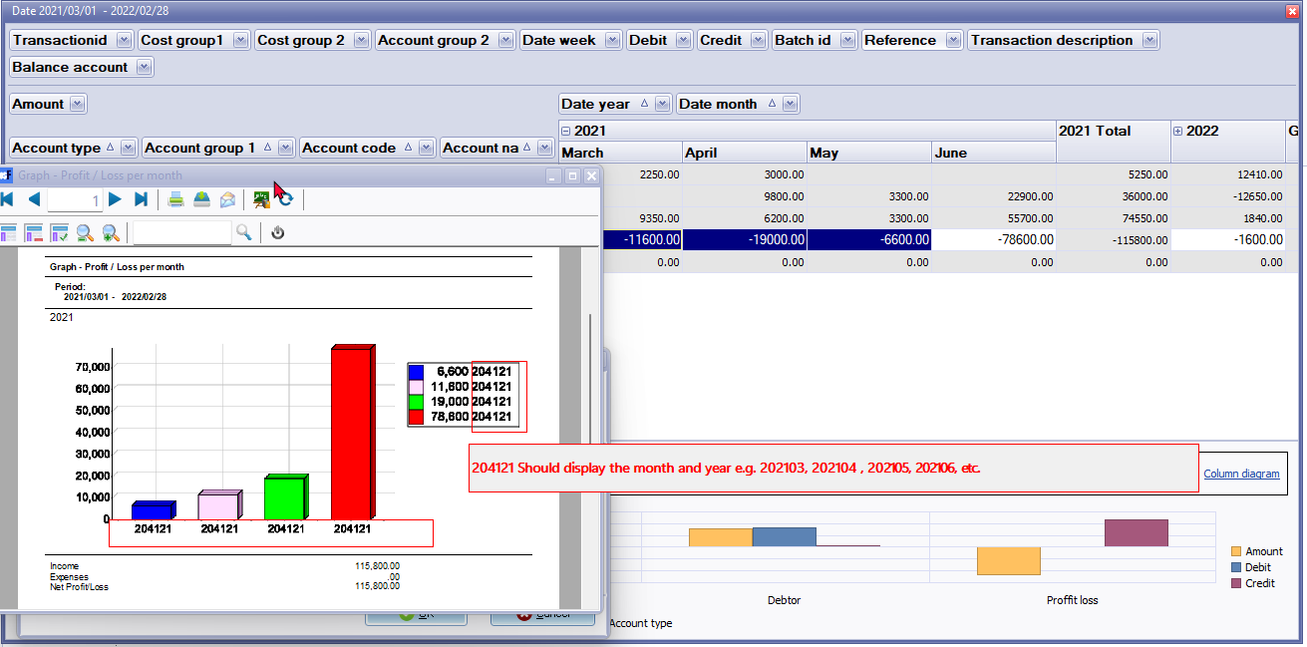

DOCUMENTLINE SQL Graphs per month -> Graph - Profit / Loss per month

|  |
| --- |
| SELECT 1 WTYPEID,  {if interbase}extract(year from ddate){else}year(ddate){endif} dyear,  {if interbase}extract(month from ddate){else}year(ddate){endif} dmonth,  sum(-transact.FAMOUNT) Total  FROM transact join account on transact.Waccountid = Account.Waccountid and Account.BincomeExpense = 1  where  (transact.ddate >= :DDATEFROMFL and transact.ddate <= :DDATETOFL)  and transact.FAMOUNT > 0  group by  {if interbase}extract(year from ddate){else}year(ddate){endif} ,  {if interbase}extract(month from ddate){else}month(ddate){endif}  union  SELECT 2 WTYPEID,  {if interbase}extract(year from ddate){else}year(ddate){endif} dyear,  {if interbase}extract(month from ddate){else}year(ddate){endif} dmonth,  sum(-transact.FAMOUNT) Total  FROM transact join account on transact.Waccountid = Account.Waccountid and Account.BincomeExpense = 1  where  (transact.ddate >= :DDATEFROMFL and transact.ddate <= :DDATETOFL)  and transact.FAMOUNT < 0  group by  {if interbase}extract(year from ddate){else}year(ddate){endif} ,  {if interbase}extract(month from ddate){else}month(ddate){endif}  order by 2,1,3 |

***Tidy report errors***

Cannot change or Set the Properties such as word wrap, cut text, etc. Long Debtor / Creditor account names or descriptions may overlap

Debtor transactions - Extra details-**Location**: ...\plug_ins\reports\systemreports\TRN_160\TRN_74\TRN_906107.rep

Creditor transactions - Extra details-**Location**:...\plug_ins\reports\systemreports\TRN_161\TRN_74\TRN_906109.rep

