Table of Contents

**Price Agreement Plugin** 1

**Price Agreement - Translatable reports** 1

**Price agreement setup** 1

**Tabs** 2

***Tabs - Stock item*** 2

***Tabs - Debtor / Creditor*** 3

**Price Agreement Plugin**

|  |  |
| --- | --- |
|  | ***Price Agreement Plugin*** *- Manual - Shop -* ***Licence*** *: Once-off -*  ***Documentation*** *: Help documentation* |

**Price Agreement - Translatable reports**

Reports is translatable **Reports → Plugins → Price agreement**. (**Reports** ribbon).

* Debtor price agreement
* Creditor price agreement

**Stock items** (**Default** ribbon) - **Reports** button on sidebar, or **Print single item** context menu option.

* Price list - Large retail - Sales
* Price list - Large retail - Purchases

**Price agreement setup**

All labels except the Activate for debrors on / off.

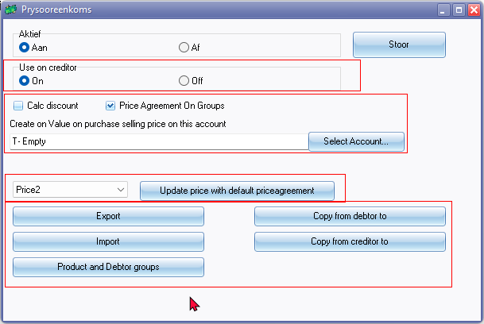

Select Account... button and Lookup title bar caption

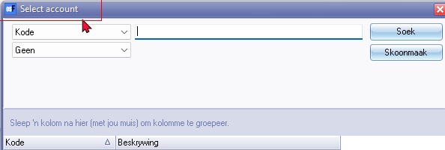

**Tabs**

***Tabs - Stock item***

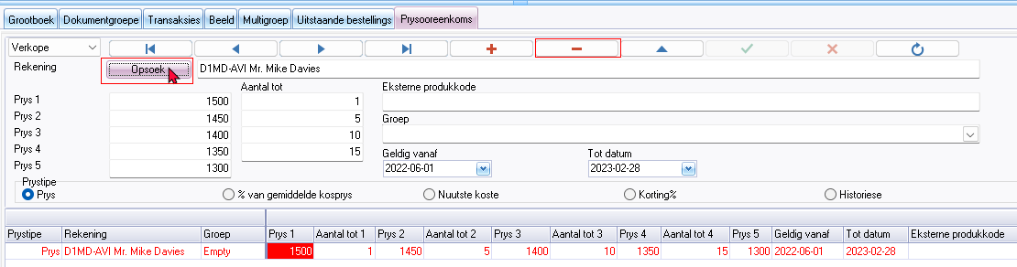

Add record - All accounts

Delete record?

Lookup button - Select Account Lookup title bar caption



***Tabs - Debtor / Creditor***

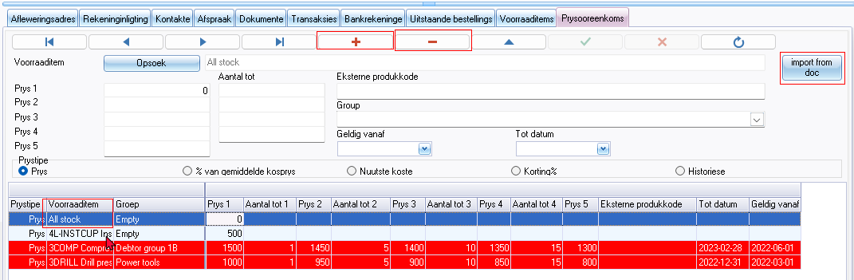

Add record - All stock

Delete record?

Lookup button - Select stock Lookup title bar caption

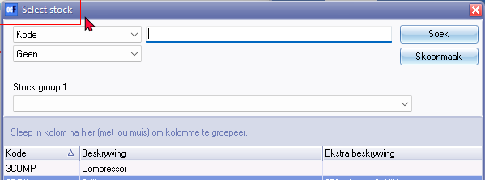

Import from doc button

Select document (Titlebar caption)

