Table of Contents

**CRM plugin** 1

***CRM - Setup*** 2

**CRM - Activity - Dashboard view tab** 2

**CRM - Leads tab** 3

***Search tab*** 3

***Import / Export tab*** 3

***Conversion tab*** 4

**CRM - Activity** 4

***Search tab*** 4

**CRM - Activity - Delete tab** 5

**CRM - All accounts tab** 6

***Search tab*** 6

***CRM - All accounts- Plugins - Multimedia tab*** 7

***All accounts - Mass tags*** 8

***All accounts - Mass activity*** 8

**CRM - Invoice matrix tab** 8

**CRM - Calendar tab** 8

**CRM reports** 10

***actlayout1 folder*** 10

***actlayout2 folder*** 10

***printouts folder*** 10

***Emails templates*** 10

***email1*** 10

***emailaction*** 10

**CRM plugin**

|  |  |
| --- | --- |
|  | ***CRM*** *-*  ***Customer Relations Management***  *- Manual -* Shop *-* ***Licence*** *: Annual license -*  ***Documentation : osFinancials website*** *- Manual* |

CRM Customer relations management plugin for osFinancials and TurboCASH.

**Menu**: **Plugins → External links → CRM** (**Setup** ribbon).

***CRM - Setup***

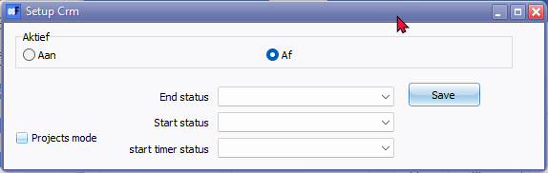

Save 726

Projects mode

End status

Start status

start timer status

**CRM - Activity - Dashboard view tab**

Refresh 3056

Totals 1360

Treeview 3147 = View as tree

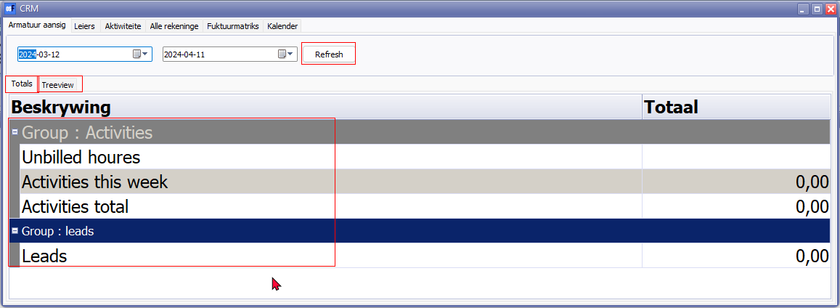

**CRM - Leads tab**

***Search tab***

Tag - marker alignment

Tabs

* Search 1204 / 1760 / 1763
* Import / Export
* Mass tag
* Conversion

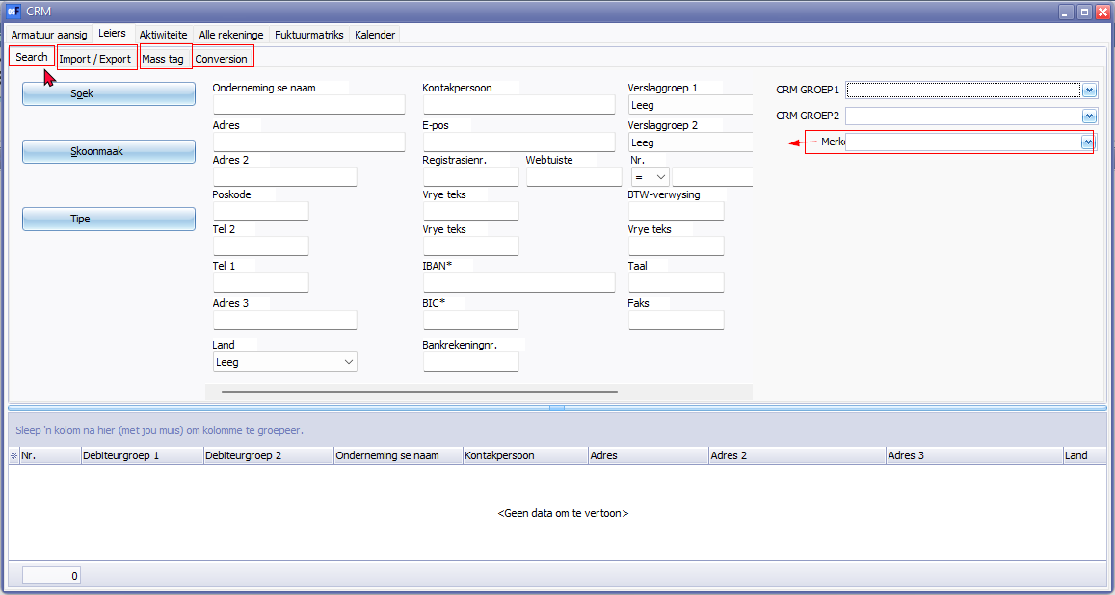

***Import / Export tab***

Pull from outlook

From date 286 / 1208

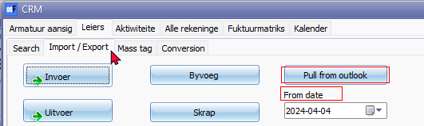

***Conversion tab***

Conversion tab

Filter sales conversion

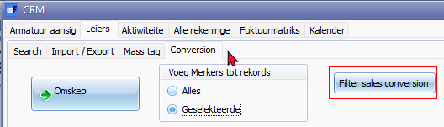

**CRM - Activity**

***Search tab***

CRM Activity status

Tag

Id

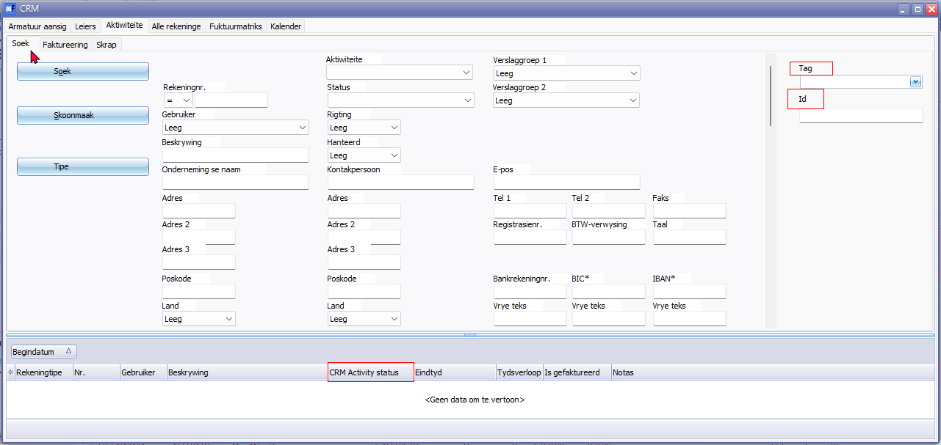

**Columns**

* Click here to show/hide/move columns (Mouse over)

(All) 20055

(Sorted) 20056

CRM Activity status

CRM Activity

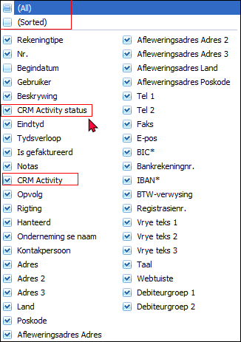

**CRM - Activity - Delete tab**

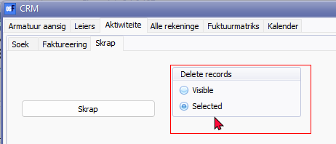

Delete records

Visible

Selected 1070

**CRM - All accounts tab**

Actions tab

***Search tab***

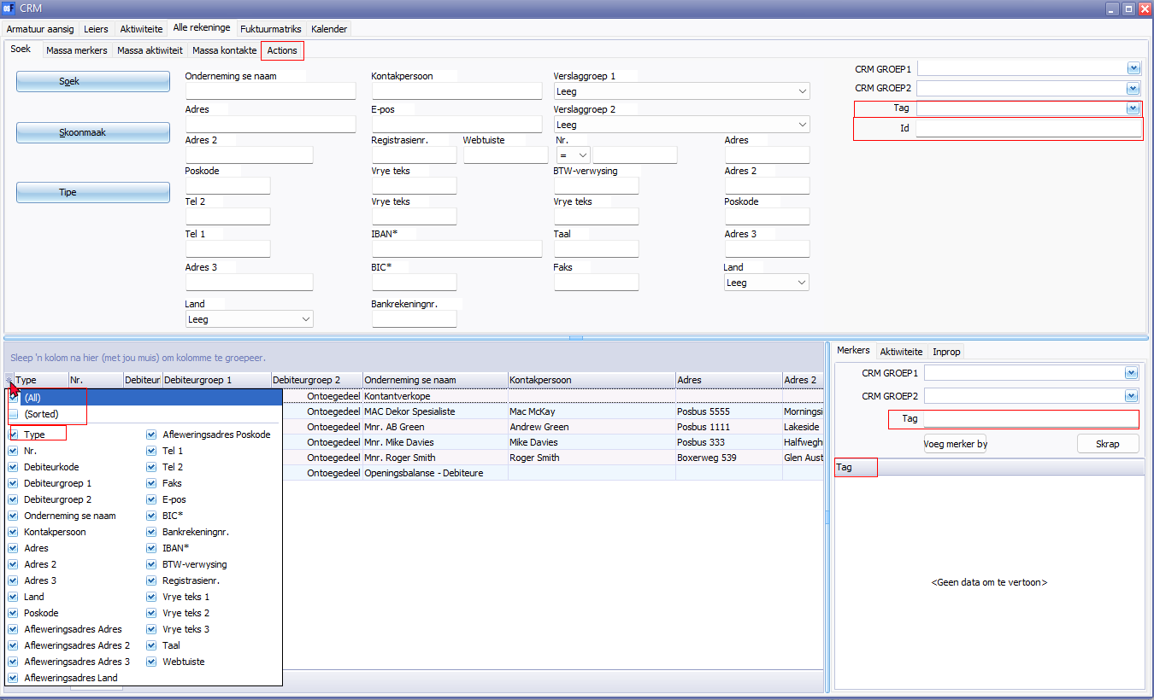

**Columns**

* Click here to show/hide/move columns (Mouse over)

(All) 20055

(Sorted) 20056

Type 1079

Changed Afrikaans label 3587 - Voeg merker toe - Changed label to + Merker - Afrikaans to fit in button CRM Plugin

***CRM - All accounts- Plugins - Multimedia tab***

Plugins - Multimedia (See Multimedia plugin)

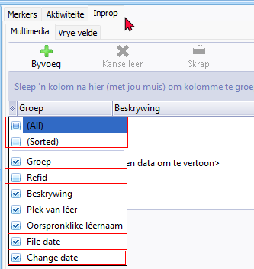

* Click here to show/hide/move columns (Mouse over)

(All) 20055

(Sorted) 20056

Refid

File date 903003

Change date 2352 / 2367

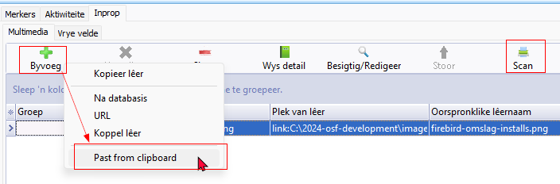

Past from clipboard 21014

Scan

***All accounts - Mass tags***

Tag

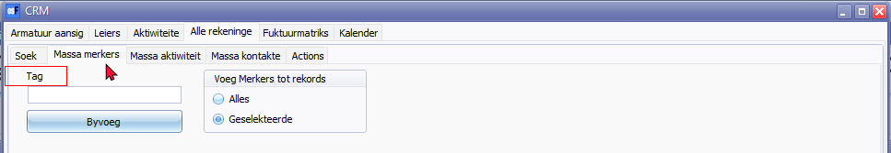

***All accounts - Mass activity***

Startdate time

End datetime

CRM Activity

CRM Activity status

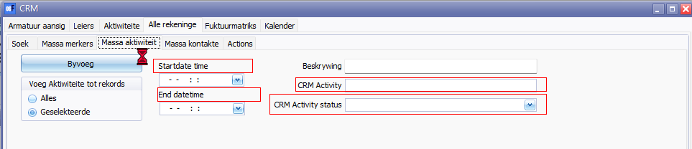

**CRM - Invoice matrix tab**

Username 1899 / 3671

User 0

CRM Activity

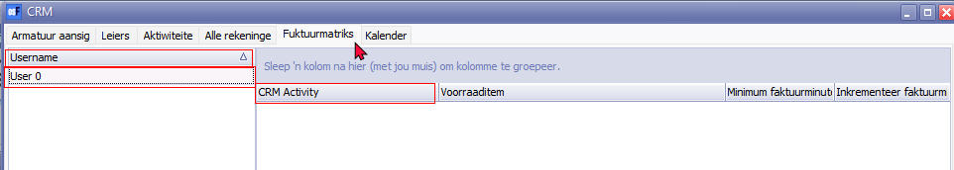

**CRM - Calendar tab**

All users

real use

Sync to outlook

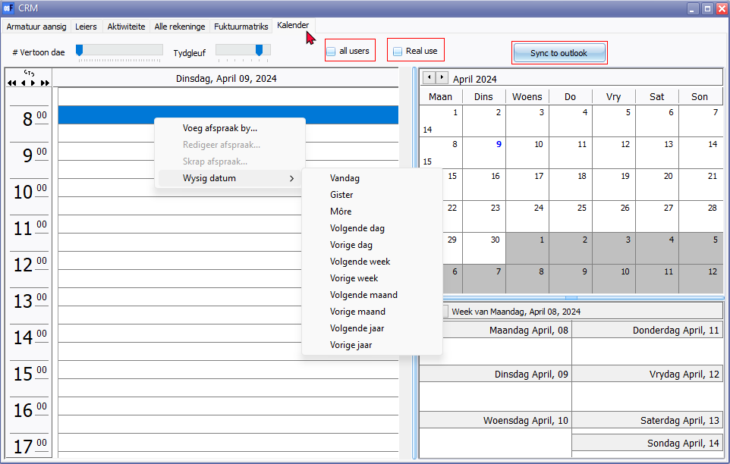

**CRM reports**

CRM Plugin in mostly translatable - but reports only in Nederlands. Need to add translatable reports.

These may be selected on All accounts - Mass contacts tab to print these files and to email these emailltemplates.

***actlayout1 folder***

Location : ...\plug_ins\reports\CRM\actlayout1

1. act 1.rep
2. act 2.rep
3. layout 1.rep
4. remote support.rep

These 4 reports replicates similar error

*Type conversion error 'Round':Expression TRpExpression27*

***actlayout2 folder***

**Location** : ...\plug_ins\reports\CRM\actlayout2

1. act 1.rep
2. act 2.rep
3. layout1.rep

Prints intern nummer and a barcode

***printouts folder***

**Location** : ...\plug_ins\reports\CRM\printouts

1. act 1.rep
2. act 2.rep
3. layout1.rep

Prints news letter in dutch

***Emails templates***

Emails templates only supports the Nederlands language.

***email1***

**Location** : ...\plug_ins\reports\CRM\emails\email1

***emailaction***

**Location** : ...\plug_ins\reports\CRM\emailaction\emailtemplates