Table of Contents

**TC Drill Down - Plugin** 1

**TC Drill Down - Transactions** 2

***TC Drill Down Transactions Filters*** 3

**TC Drill Down - Client invoice** 4

**TC Drill Down - Invoice stock item** 4

**TC Drill Down - Stock item invoice** 5

**TC Drill Down - Plugin**

|  |  |
| --- | --- |
|  | ***DrillDown plugin*** *- Shop -* ***Licence :*** *Once-off -*  ***Documentation : osFinancials website*** *- Manual*  ***Documentation*** *: Help documentation* |

Drill Down 3387

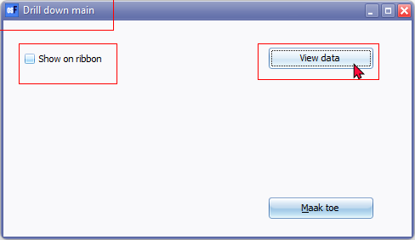

Drill down main (titlebar caption) Drill Down 3387

Show on ribbon

View data

TC Drill Down

**TC Drill Down - Transactions**

TC Drill Down (titlebar caption)

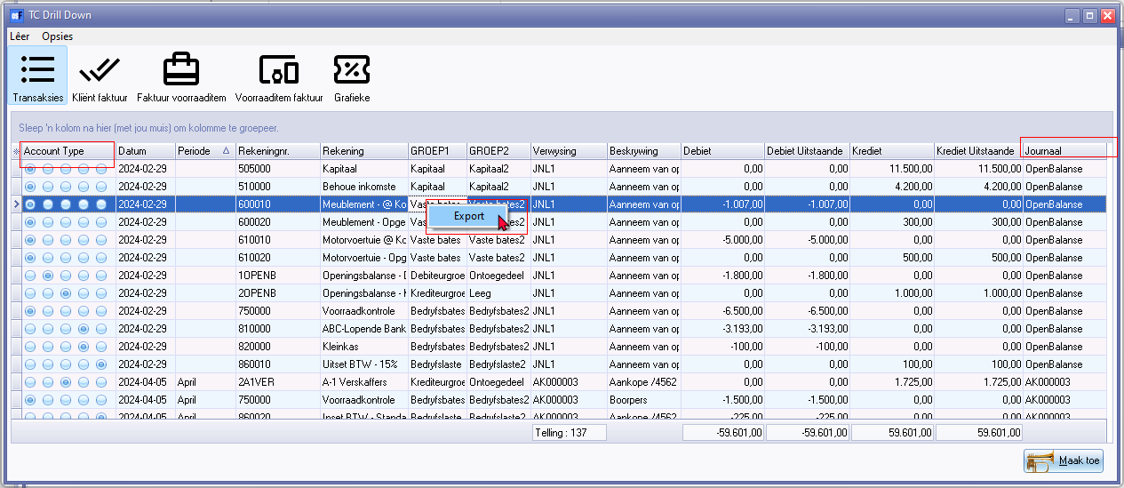

Account type 1109 / 1935

Journaal 906074

Export (context menu) 20063

***TC Drill Down Transactions Filters***

Columns * Click here to show/hide/move columns (Mouse over)

(All) 20055

(Sorted) 20056

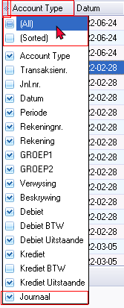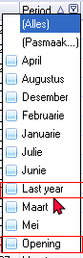

In the Periods column :

Last year 604

Opening for Opening balances

**TC Drill Down - Client invoice**

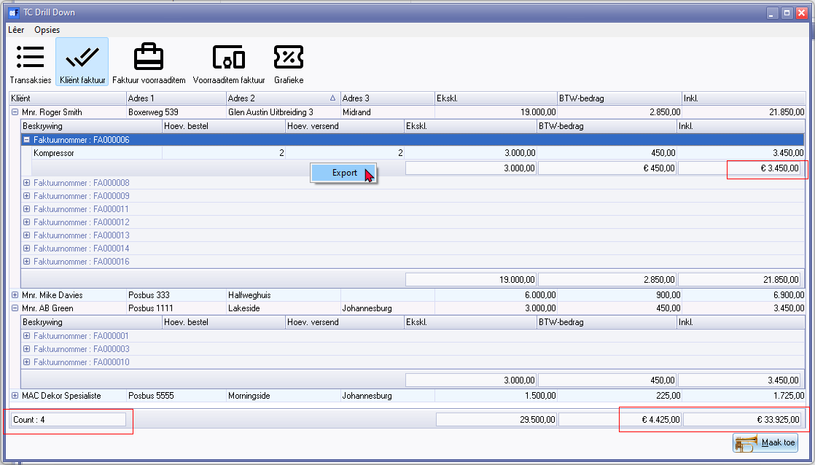

Euro sign

Count : ( 2143 Translated on Transactions option)

Export 20063 (context menu)

**TC Drill Down - Invoice stock item**

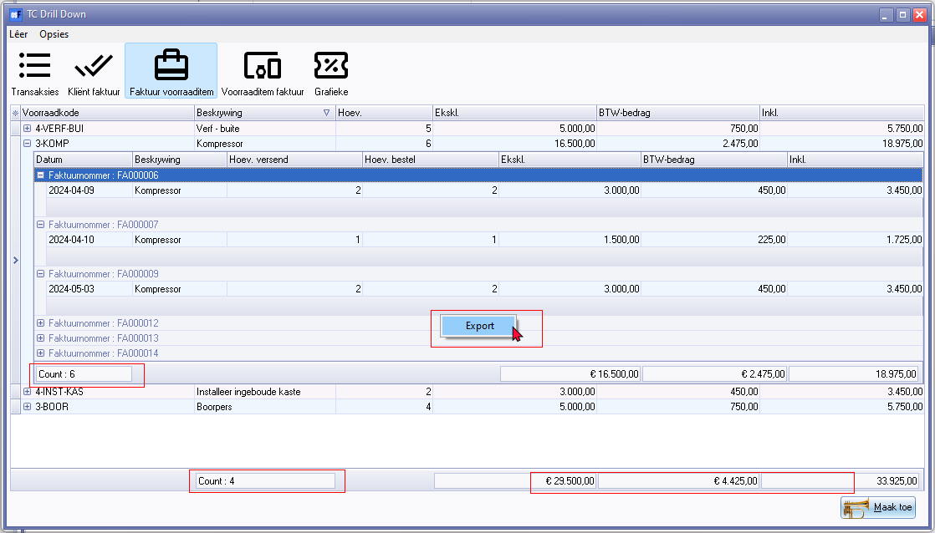

Euro sign

Count : ( 2143 Translated on Transactions option)

Export 20063 (context menu)

**TC Drill Down - Stock item invoice**

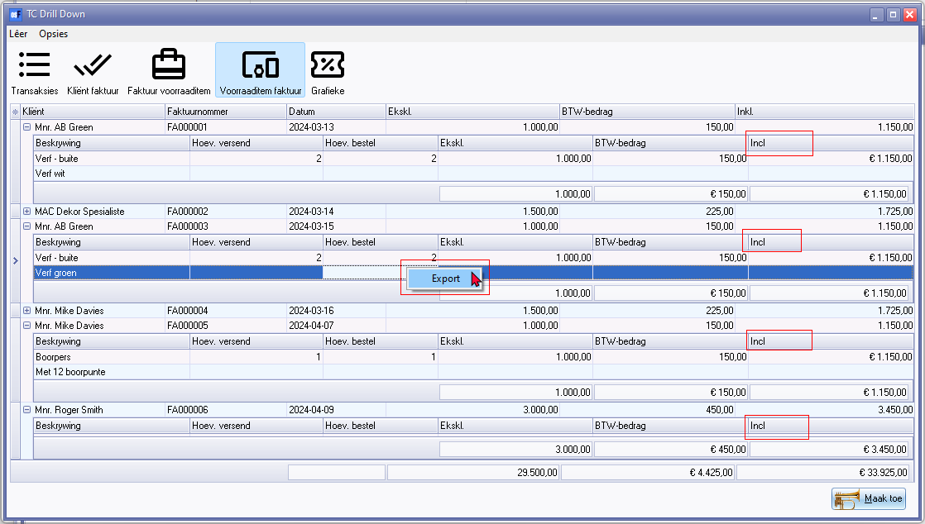

Euro sign

Incl. 1201

Export 20063 (context menu)