Table of Contents

**HandyTools Plugin** 1

Handytools tabs 1

*Remove tab* 2

*Run SQL tab* 3

*Countries tab* 4

*Stock tab* 4

*Import tab* 5

**HandyTools Plugin**

|  |  |
| --- | --- |
|  | ***HandyTools*** *-* ***Licence*** *: Free.*  ***Caution****: Make backups of your Set of Books before use* |

HandyTools 3402 (titlebar caption)

# Handytools tabs

Countries 3691

## *Remove tab*

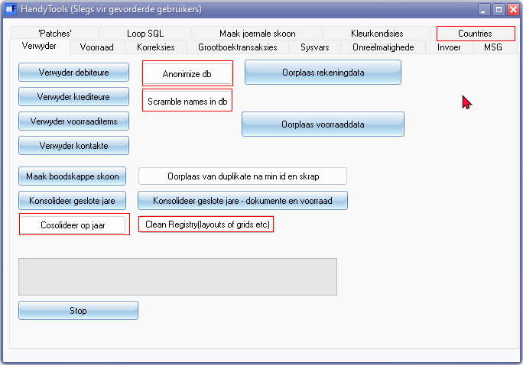

## *Run SQL tab*

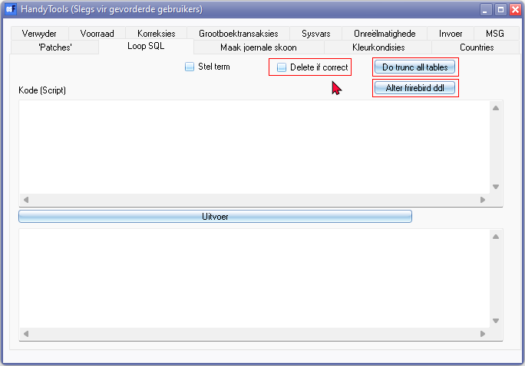

## *Countries tab*

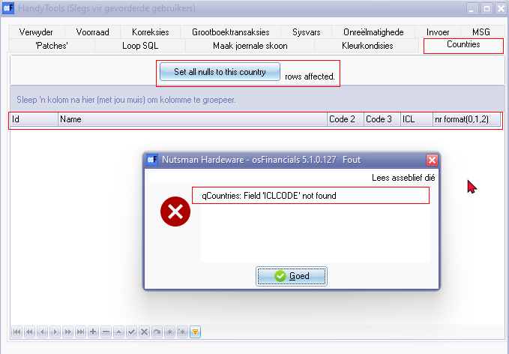

## *Stock tab*

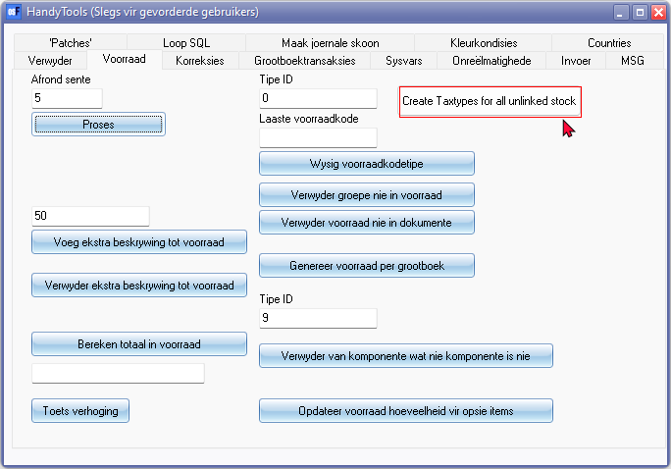

## *Import tab*

