Table of Contents

**Localisation-Batches-Serials Plugin** 1

**Translatable output files** 1

**Stock items Location / Serial / Batch tab** 2

***Fast mode selected*** 2

***Fast mode not selected*** 2

***Context menu*** 3

***Documents select*** 3

**Localisation-Batches-Serials Plugin**

|  |  |
| --- | --- |
|  | ***Localisation-Batches-Serials*** *- Manual - Shop -* ***Licence****: Once-off*  ***Documentation*** *: Help documentation* |

**Translatable output files**

Document layout files will print Serials / Batches and Locations in the Italic font.

Reports is translatable **Reports → Plugins → Locations-Batches-Serials**. (**Reports** ribbon).

1. On hand report
2. Stock movement report
3. Outdated batch
4. Bought from supplier
5. Sold to customer

**Stock items Location / Serial / Batch tab**

***Fast mode selected***

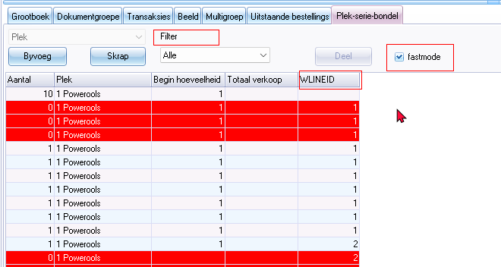

Filter

Fastmode

WLINEID

***Fast mode not selected***

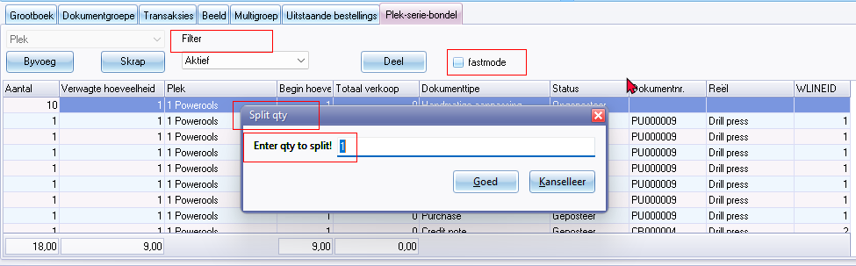

Filter

Fastmode

WLINEID

Split qty (title bar caption)

Enter qty to split

***Context menu***

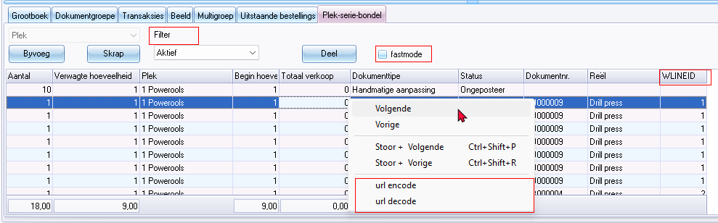

***Documents select***

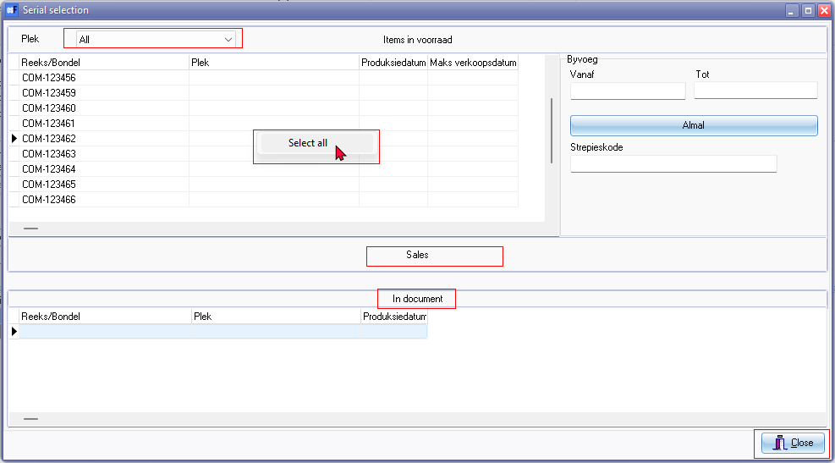

Serial selection (titlebar caption)

Select all (context menu option)

Sales

In document