Table of Contents

**Multi-user Calendar** 1

**Errors Multi-user Calendar** 1

***Calendar edit resource - error - Delete*** 1

***Add resource - error*** 1

***REPORTINGGROUP ROOT*** 2

**Calendar - Context menu** 3

**Calendar - Resources** 4

**Calendar - Special days** 5

**Calendar - Select colors** 5

**Multi-user Calendar**

|  |  |
| --- | --- |
|  | ***Multi-User Calendar (Agenda)*** *- Shop -* ***Licence*** *: Once-off -*  ***Documentation : osFinancials website*** *- Manual*  ***Documentation*** *: Help documentation* |

**Errors Multi-user Calendar**

***Calendar edit resource - error - Delete***

*Access violation at address 67DCE4D8 in module 'osfresource.bpl'. Read of address 00000054*

*Access violation at address 6B420082 in module 'rtl290.bpl'. Read of address 00000008*

***Add resource - error***

*Access violation at address 6B420082 in module 'rtl290.bpl'. Read of address 00000008*

Error 2

*List index out of bounds (2). TList range is 0..1*

***REPORTINGGROUP ROOT***

This Database PI-MULTI_USER-AGENDA was created when Groups was still using REPORTING GROUP ROOT in Setup -> Groups.

Since then it has changed to new group

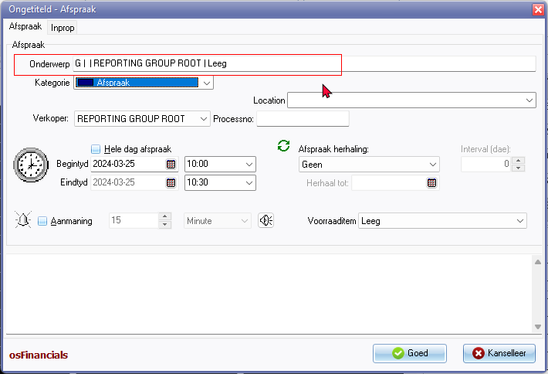

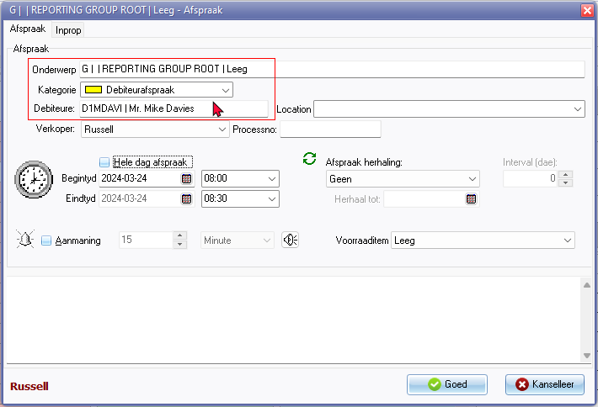

**Calendar - Context menu**

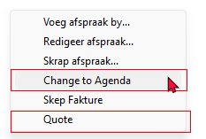

Change to Agenda

Quote

**Calendar - Resources**

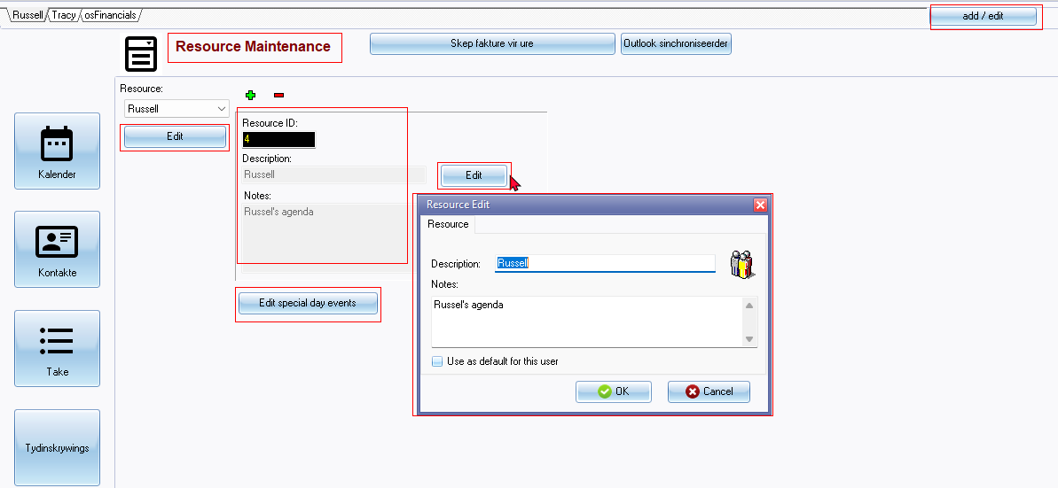

add / edit button

Resource Maintenance

Edit

Resource Edit (titlebar caption)

Resource tab

Description:

Notes: 2437

Use as default for this user

**Calendar - Special days**

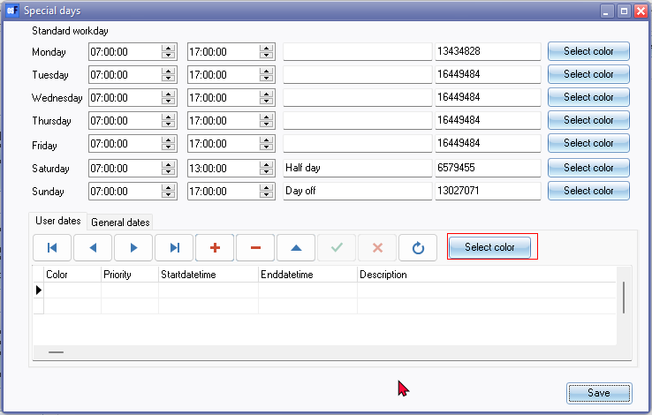

Select color 903164

Special days (entire screen)

**Calendar - Select colors**

Colors options translatable via Windows language settings

