Table of Contents

**Multimedia Plugin** 1

**Multimedia setup** 1

***General tab*** 1

***Image tab*** 3

**Stock / Debtors / Creditors tabs** 3

**Multimedia - Show detail** 4

**Multimedia context menu option on other tabs** 4

**Multimedia Plugin**

|  |  |
| --- | --- |
|  | ***Multimedia******plugin*** *- Shop - Licence : Once-off -*  ***Documentation*** *: osFinancials website - Manual*  ***Documentation*** *: Help documentation* |

**Multimedia setup**

***General tab***

Multimedia titlebar caption translated via label 3379

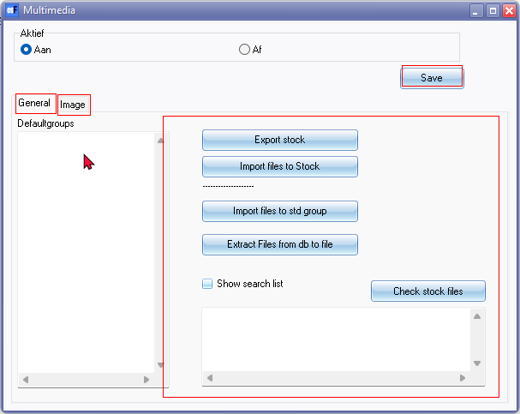

Save 726 button

General 3205

Image 3186

Default groups

Export stock

Import files to Stock

Import files to std group

Extract Files from db to file

Show search list

Check stock files button

***Image tab***

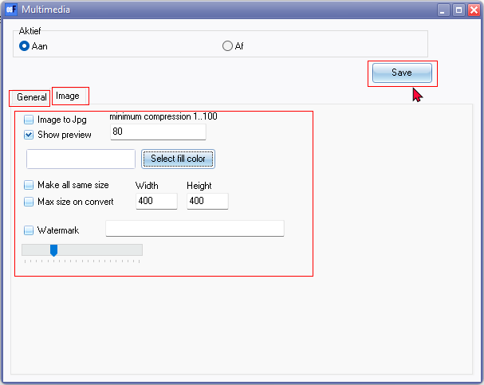

Image to Jpg

minimum compression1..100

Show preview

Make all same size

Max size on convert

Width 1340

Height 3545

Watermark

**Stock / Debtors / Creditors tabs**

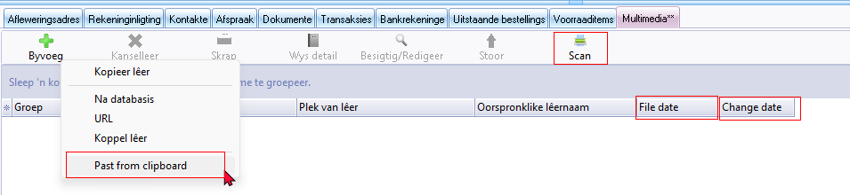

Multimedia tab translated via label 903000

URL 903007

Past from clipboard 21014 - Paste from clipboard

File date 903003

Change date 2352 / 2367

Messages paste from clipboard

No picture found!

Scan

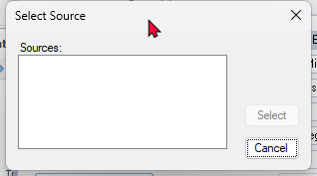

**Multimedia - Show detail**

Delete no confirmation message

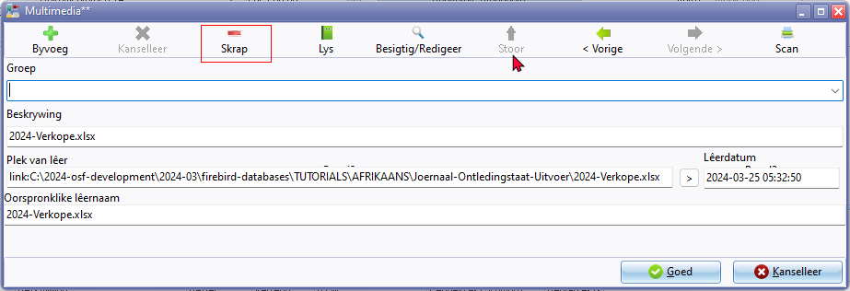

**Multimedia context menu option on other tabs**

Multimedia context menu on other tabs is not translatable

* **Stock** - Document groups / Transaction tabs
* **Debtors / Creditors** - Documents / Transaction tabs

