Table of Contents

**Reminders / Remittance plugin** 1

**Reminders - Email Setup** 1

**Reminders - Setup** 1

**Reminders - Setup - List** 2

**Reminders (Action ribbon)** 3

**Remittance - Email templates updated** 5

**Reminders / Remittance plugin**

|  |  |
| --- | --- |
|  | ***Remittance*** *- Shop -* ***Licence*** *: Once-off -*  ***Documentation : osFinancials website*** *- Manual*  ***Documentation*** *: Help documentation* |

**Reminders - Email Setup**

Reminders - Email Setup - See EmailPro plugin

**Reminders - Setup**

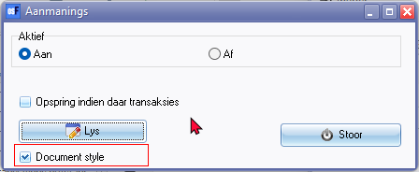

Document style

**Reminders - Setup - List**

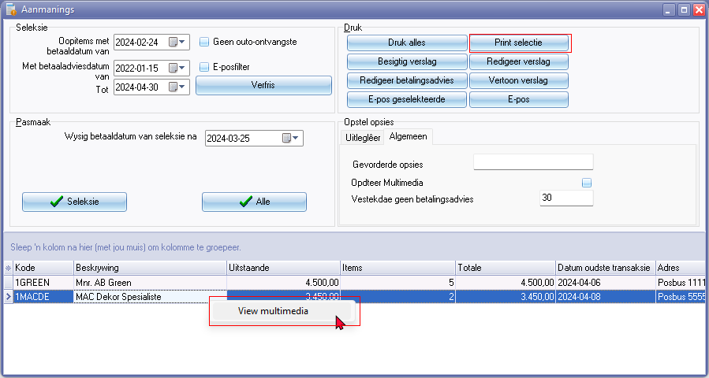

Print selectie

View multimedia (context menu)

Columns * Click here to show/hide/move columns (Mouse over) second asterisk

(All)

(Sorted)

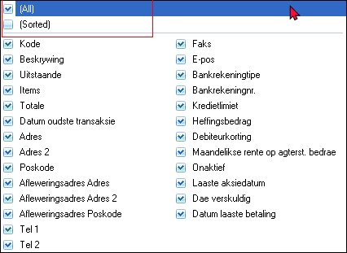

**Reminders (Action ribbon)**

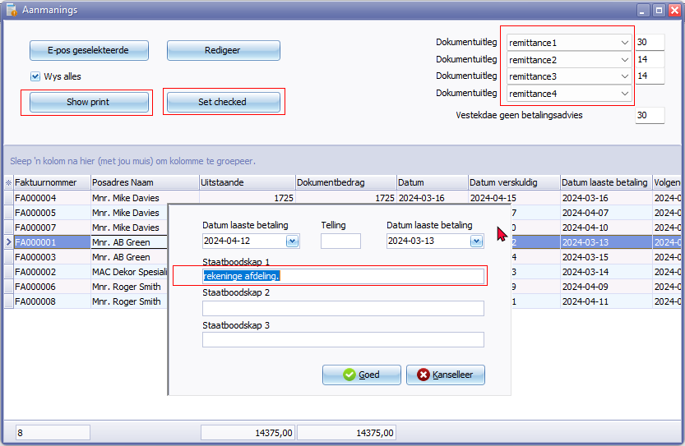

Show print

Set checked

**Edit - Messages**

Statement message 1 is populated as Statement message 1 on Debtors - Delivery address tab

Statement message is not included

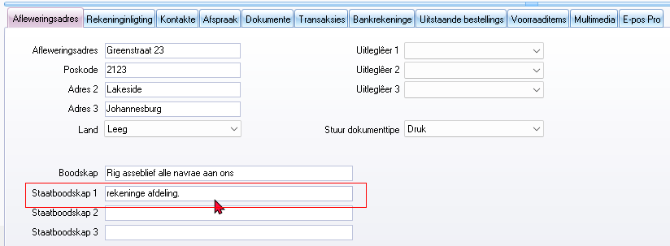

**Document layout**

remittance1/remittance2/remittance3/remittance4 report names not translatable via language files.

**Location** : "... \plug_ins\reports\remittance\doctype\layouts\

Show print - Print preview error if "Show all" box is not ticked and data list is empty - Open reportman screen produces error

*DOCUMENTKOP:Could not convert variant of type (UnicodeString) into type (Integer)*

Show print - Print preview error if "Show all" box is list and an debtor invoice is selected it prints the Open item selection layout

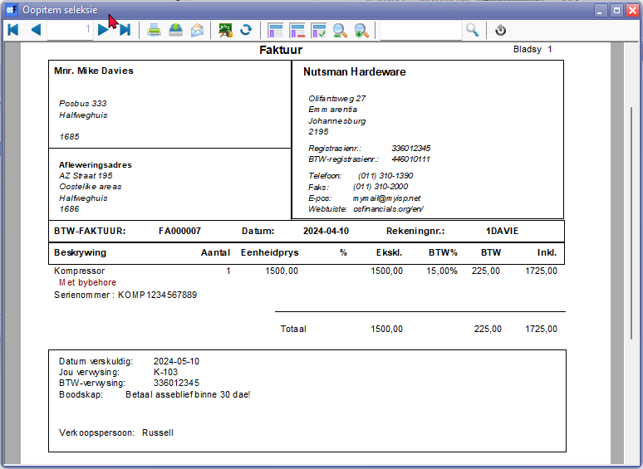

Does not support TRN_3400 or LANG_3400 for example.

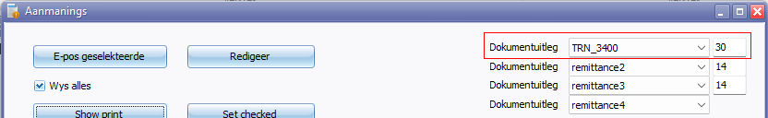

**Remittance - Email templates updated**

|  |  |  |
| --- | --- | --- |
| ***Language*** | ***Location*** | ***Changes*** |
| *Netherlands* | *\plug_ins\reports\remittance\doctype\nl\emailtemplates* | *No changes* |
| *English* | *\plug_ins\reports\remittance\doctype\en\emailtemplates* | *Translated from Netherlands to English* |
| *Afrikaans* | *\plug_ins\reports\remittance\doctype\af\emailtemplates* | *Added folder "af" for Afrikaans and translated from English to Afrikaans.* |

Each folder contains the osFinancials logo and 4 remittance-html files with 4 accompanying ini files:

1. " ... \plug_ins\reports\remittance\doctype\nl\emailtemplates\logo.jpg"
2. " ... \plug_ins\reports\remittance\doctype\nl\emailtemplates\remittance1.html"
3. " ... \plug_ins\reports\remittance\doctype\af\emailtemplates\remittance1.ini"
4. " ... \plug_ins\reports\remittance\doctype\nl\emailtemplates\remittance2.html"
5. " ... \plug_ins\reports\remittance\doctype\nl\emailtemplates\remittance2.ini"
6. " ... \plug_ins\reports\remittance\doctype\nl\emailtemplates\remittance3.html"
7. " ... \plug_ins\reports\remittance\doctype\nl\emailtemplates\remittance3.ini"
8. " ... \plug_ins\reports\remittance\doctype\nl\emailtemplates\remittance4.html"
9. " ... \plug_ins\reports\remittance\doctype\nl\emailtemplates\remittance4.ini"