Table of Contents

Setup - Access control 1

osFinancials program Statusbar 1

Standard security 2

Error message incorrect password 2

Batches access 3

Other options 4

Documents 5

Usertabs 6

# Setup - Access control

# osFinancials program Statusbar

Universal administrator (If NO users were setup in Access control)



User: Name (If users were setup in Access control)

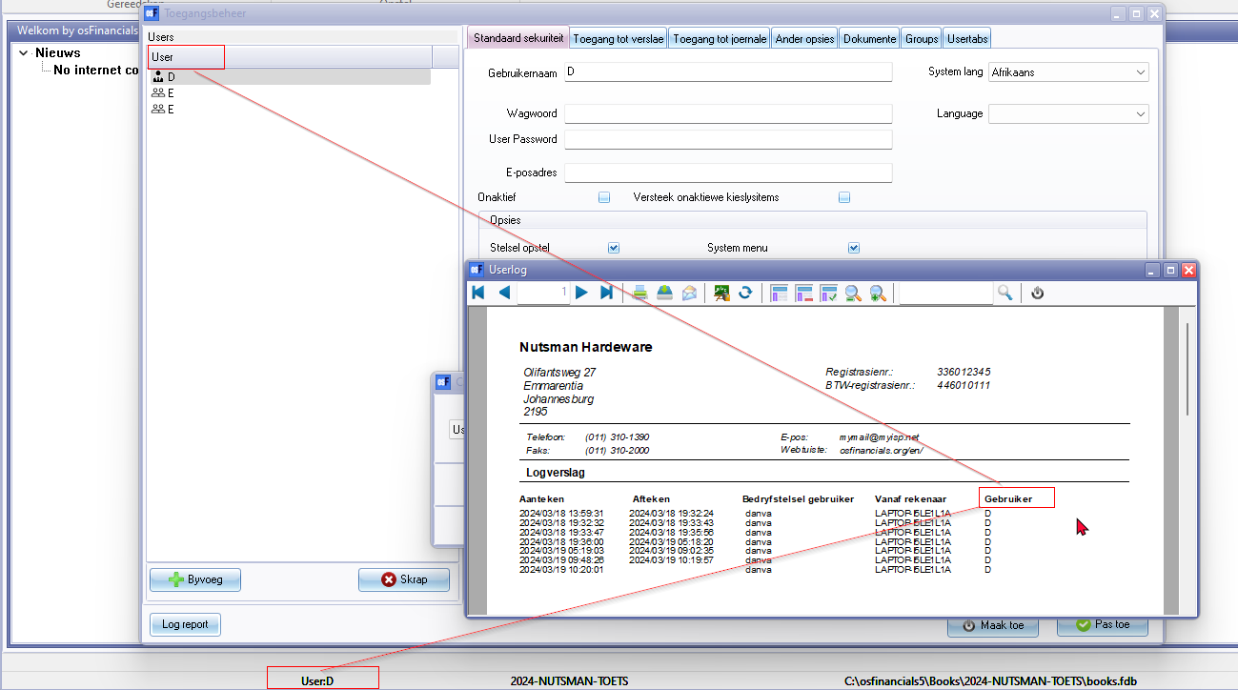

# Standard security

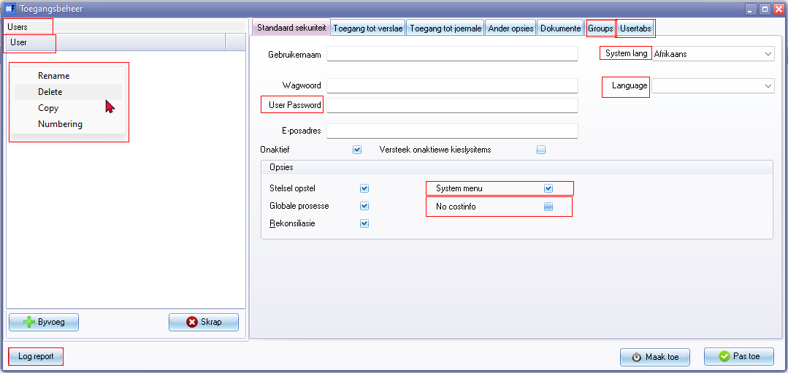

Tabs

* Groups 1846
* Usertabs 3563

Users

User 1072

System language

Language 3112

User Password 1972 / 1980 / Password confirmation 3204

System menu

No costinfo

# Error message incorrect password

*Password do not match*

# Batches access

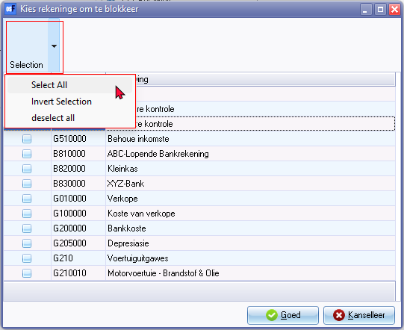

Selection - Also on context menu

* Select All
* Invert selection
* deselect all

# Other options

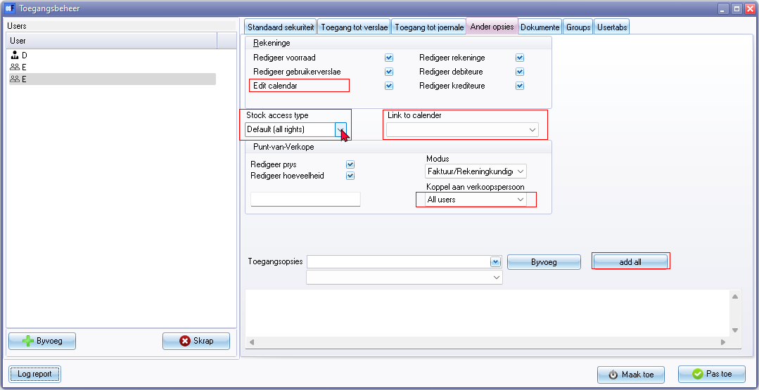

Edit calendar

Link to salesperson - All users (on list) the rest on the list will be populated for the Multiuser Agenda plugin Resource name added in the Calendar)

Stock access type

* Default (all rights)
* Wharehouse (Barcode / Weight dish) Typo => arehouse

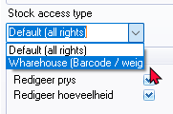

**Add all** button 1890

# Documents

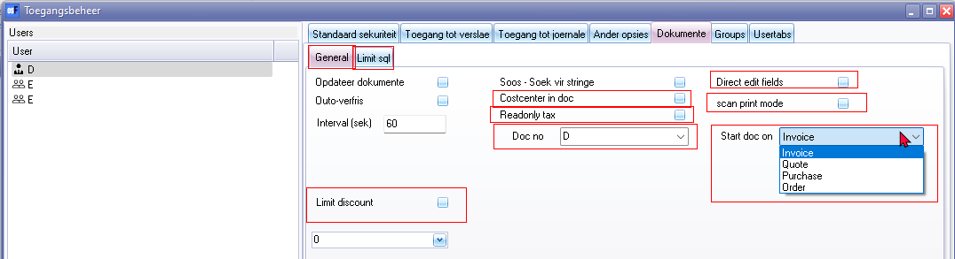

**General** tab 1367 / 3205

* Cost centre in doc
* Readonly tax
* Doc no 1120
* Direct edit fields
* scan print mode
* Start doc on (Invoice, Quote, Purchase, Order)

**Limit sql** tab

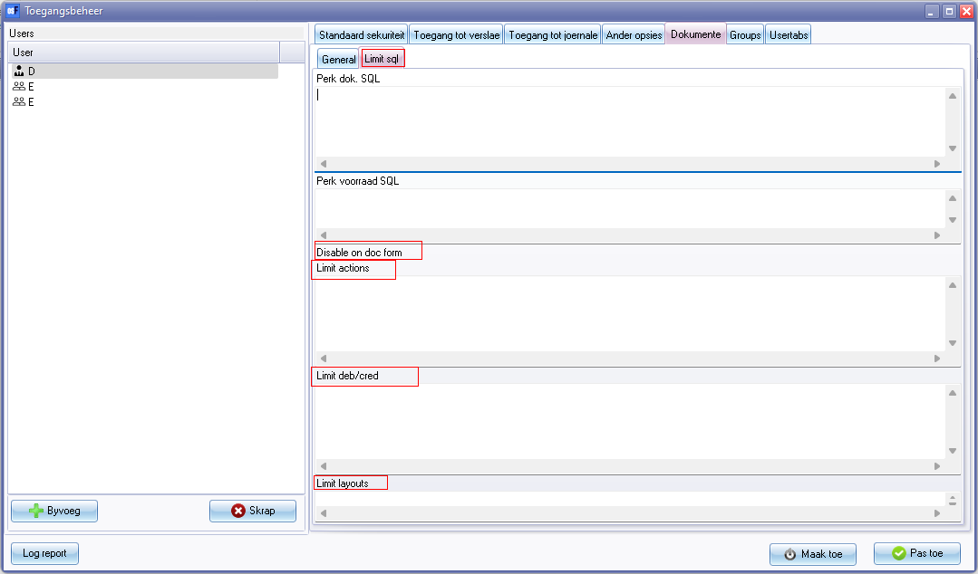

**Limit sql** tab

* Disable on doc form
  + Limit actions
* Limit deb/cred
* Limit layouts

# Usertabs

User ribbon

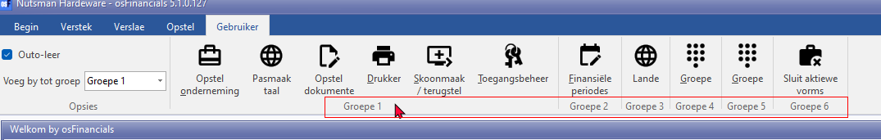

Groups Plural = LabelID 345 is used Set to singular Groepe => Groep

ID1072 - Gebruiker (User)

Usertabs 3563

