Table of Contents

Bank account recon options - Caption in titlebar - English language 1

**Bank statement options** 2

*Default Bank recon method* 2

*Bank import plugin (activated)* 3

Bank Import plugin – Outstanding labels 4

*Batch entry screen* 5

*Import bank statement* 6

*Toets (title bar caption)* 7

*Account bank references* 8

# Bank account recon options - Caption in titlebar - English language

Language label 2186 Bankrekonsiliasie verslagopsies / Bank account recon options => Bankstaat opsies - Bank statement options

The changed caption in the titlebar "*Bank statement options*" should then be fit to accommodate both options :

1. Bank import plugin where bank transactions is imported from bank statements, or;
2. Bank reconciliation default method (since reconciling the bank transactions with bank statements).

# **Bank statement options**

Click on **Cash / Bank entry** icon (**Default** ribbon). This will launch the "*Bank statement options*" screen.

## *Default Bank recon method*

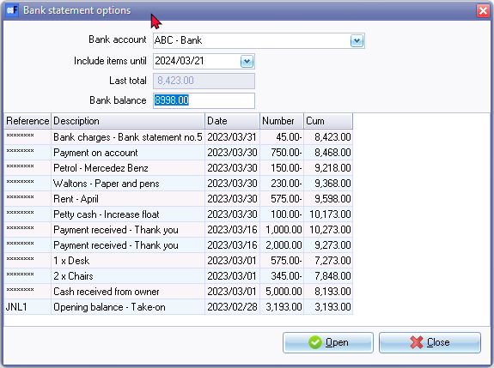

Open - Launch the "Reconcile bank account" screen. Reconcile bank statements with transactions already processed in separate payments and receipt batches.

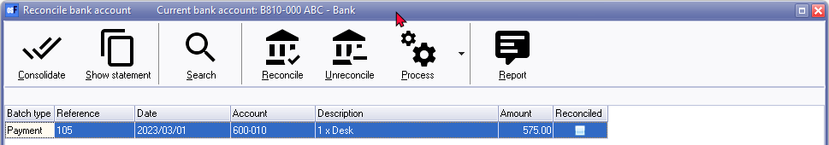

## *Bank import plugin (activated)*

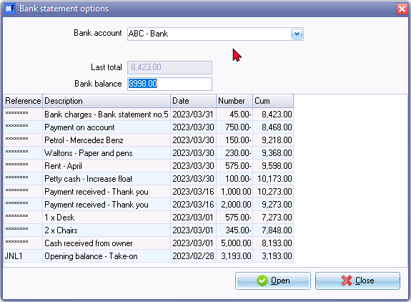

Open will launch the Bank import "Batch entry" screen linked to the payments batch. Import bank statements click on **Import bank statement** icon. Imported bank statements will import the transactions.

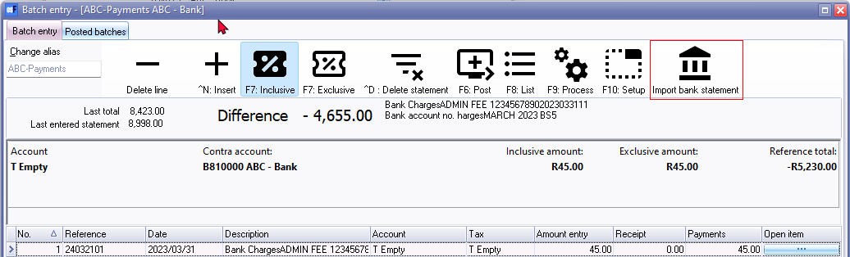

# Bank Import plugin – Outstanding labels

Bank account selection (from Cash / Bank on the Default ribbon)

Bank account "*Bankrekening*" label changes to Write6 (Sometimes to Read6 ) when a Bank account is selected (where 6 is the record name ACCOUNTID in the ACCOUNT Table of the selected bank account.

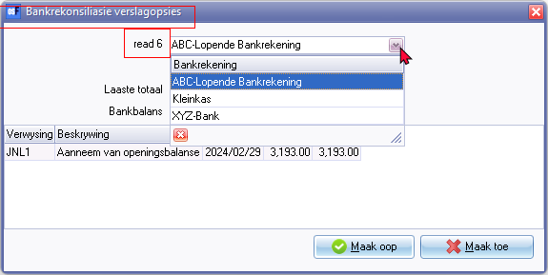

Language label 2186 Bankrekonsiliasie verslagopsies / Bank account recon options

Screen caption could read Bankstaat opsies - Bank statement options

Should then be fit to accommodate the Bank import plugin

And Bank reconciliation default method (since reconciling the bank transactions with bank statements

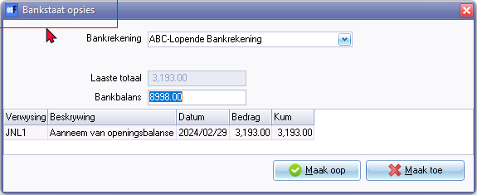

## *Batch entry screen*

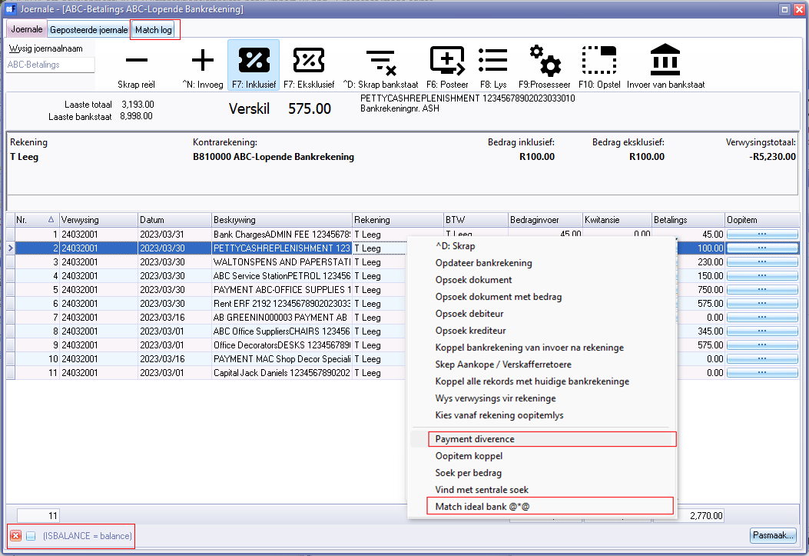

Match log tab

Context menu

* Payment diverence 3473
* Match ideal bank @*@

Balance = balance - Filter

## *Import bank statement*

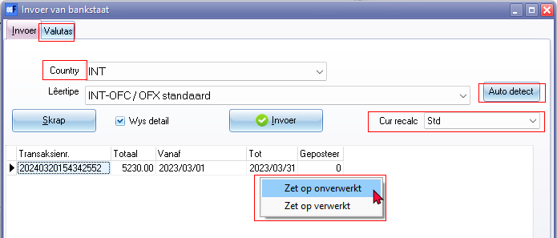

Country 2207 / 2388 / 2421

Auto detect

Cur recalc - Std / Default

Valutas tab - 3470 Currencies

Context menu

* Zet op onverwerkt
* Zet Zet op verwerkt

## *Toets (title bar caption)*

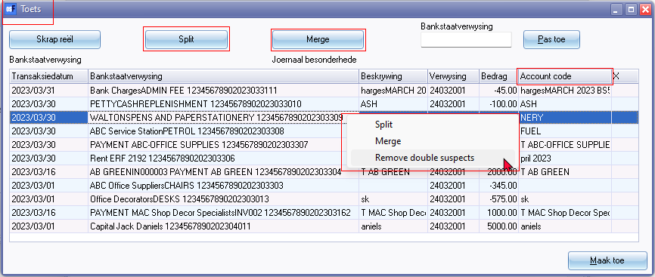

Toets / Check 897 (title bar caption) Translating this changes the Test button on Tools -> Data integrity check. In Afrikaans changed to Kontroleer.

* Account code
* Split (901500 Probably in different context as this is used for HORECAPOS Plugin)
* Merge 3629
* Remove double suspects

Split amount

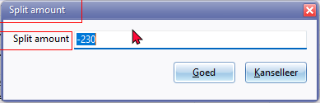

## *Account bank references*

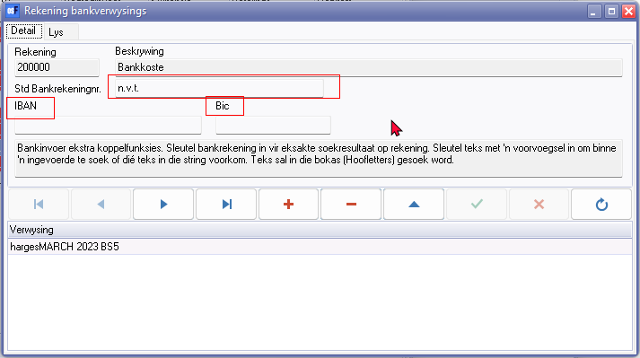

Std Bankrekeningnr. + n.v.t.

* Language label = 906016 - BIC*
* Language label = 906016 - IBAN*

Delete record conformation message

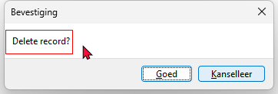

LabelID 20002 - Delete record?