Table of Contents

**Bank Recon Default** 1

***FIXED - Bank reconciliation report as at*** 2

**MSSQL Error - Bank reconciliation report** 4

**Bank Recon Default**

Bank account "*Bankrekening*" label changes to Write6 (Sometimes to Read6 ) when a Bank account is selected (where 6 is the record name ACCOUNTID in the ACCOUNT Table of the selected bank account.

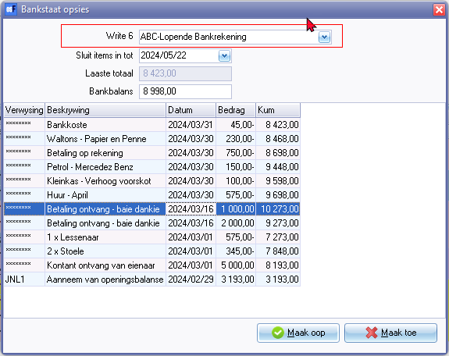

Process

* Apply reconciled
* Transfer Unreconciled to Batches

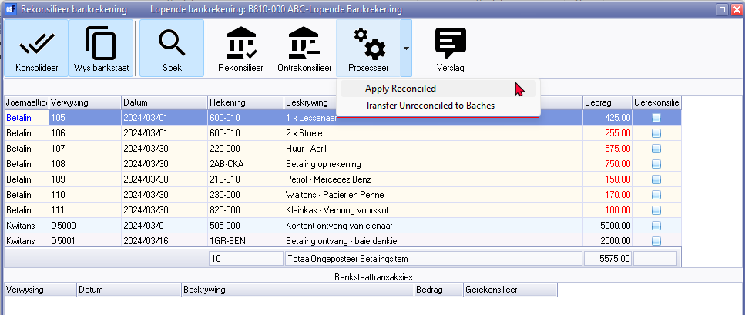

***FIXED - Bank reconciliation report as at***

**Location**: " ... \plug_ins\reports\GENERAL\documents\recon

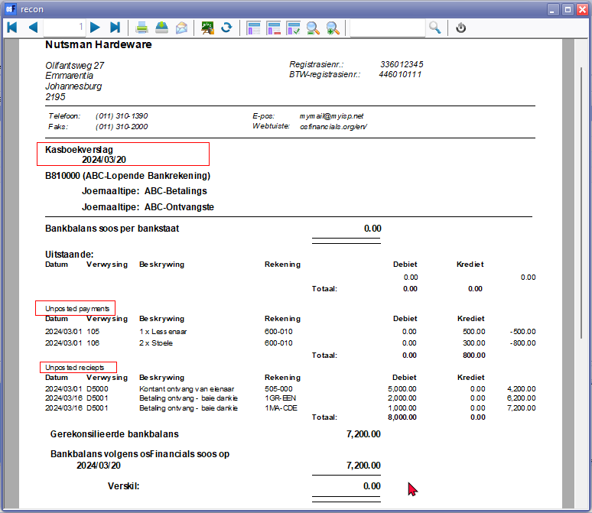

Unposted payments 906447

Unposted receipts 906448

**Language** : Kasboekverslag LabelID3014 changed in Afrikaans => Bankrekonsiliasie verslag soos op

**Expressions changed** :

TRpExpression55 CUSTOM('GETTEXTLANG',906447,'Unposted payments',0,0,0)

TRpExpression56 CUSTOM('GETTEXTLANG',906448,'Unposted receipts',0,0,0)

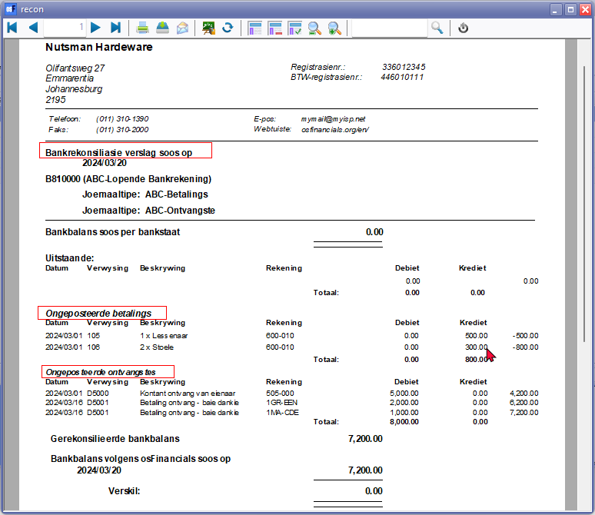

If the setting Print only if data available - Set to True for the following unposted subreports.

(SubReport-1UNPOSTEDPAYMENTS)

(SubReport-2UNPOSTEDRECEIPTS)

the Difference column will display a value as a result of the Reconciled balance

For this reason this setting is not applied.

**MSSQL Error - Bank reconciliation report**

**Location** : " ...\ plug_ins \ reports \GENERAL \documents \ recon

Prints in Firebird databases

In MSSQL databases produces error:

*OPREPORT:Incorrect syntax near '|'.*

OPREPORT Dataset SQL

*select * from OPREPORT where STROPTION like :BANKACCOUNT || 'BankBal%'*

Tried to change SQL to accommodate the CONVAT Function (concatenate):

*SELECT * FROM OPREPORT WHERE STROPTION LIKE CONCAT(:BANKACCOUNT, 'BankBal%')*

Then it produces Error in MSSQL databases:

*Type conversion error 'Val':Expression TRpExpression11*

Could not did not fix the error in MSSQL at this stage