Table of Contents

Bank account recon options - Caption in titlebar - English language 1

**Bank statement options** 1

*Default Bank recon method* 1

*Bank import plugin (activated)* 2

Bank Recon Default – Outstanding labels 3

FIXED - Bank reconciliation report as at 4

# Bank account recon options - Caption in titlebar - English language

Language label 2186 Bankrekonsiliasie verslagopsies / Bank account recon options => Bankstaat opsies - Bank statement options

The changed caption in the titlebar "*Bank statement options*" should then be fit to accommodate both options :

1. Bank import plugin where bank transactions is imported from bank statements, or;
2. Bank reconciliation default method (since reconciling the bank transactions with bank statements).

# **Bank statement options**

Click on **Cash / Bank entry** icon (**Default** ribbon). This will launch the "*Bank statement options*" screen.

## *Default Bank recon method*

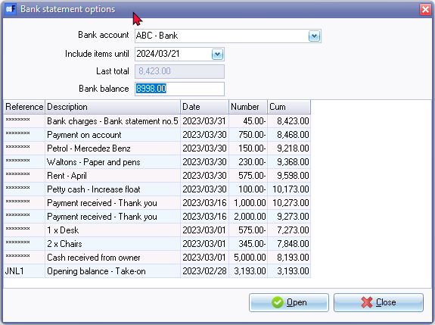

Open - Launch the "Reconcile bank account" screen. Reconcile bank statements with transactions already processed in separate payments and receipt batches.

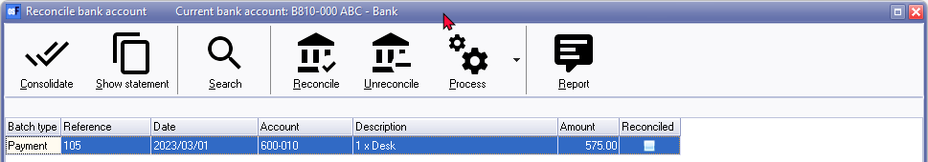

## *Bank import plugin (activated)*

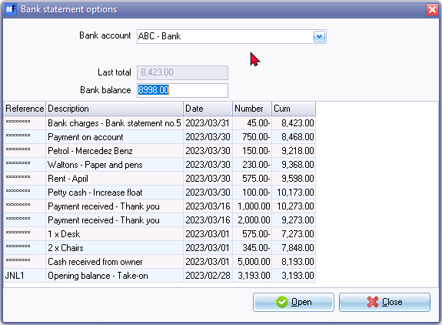

Open will launch the Bank import "Batch entry" screen linked to the payments batch. Import bank statements click on **Import bank statement** icon. Imported bank statements will import the transactions.

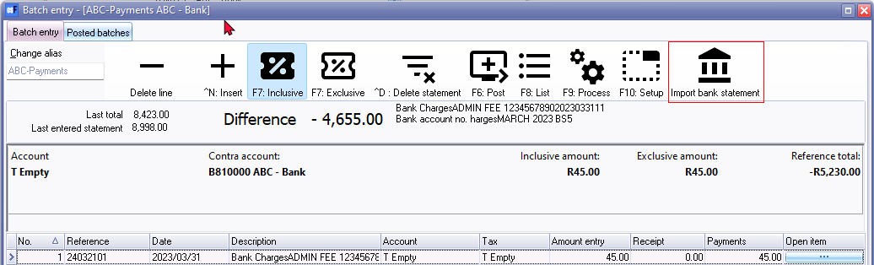

# Bank Recon Default – Outstanding labels

Bank account "*Bankrekening*" label changes to Write6 (Sometimes to Read6 ) when a Bank account is selected (where 6 is the record name ACCOUNTID in the ACCOUNT Table of the selected bank account.

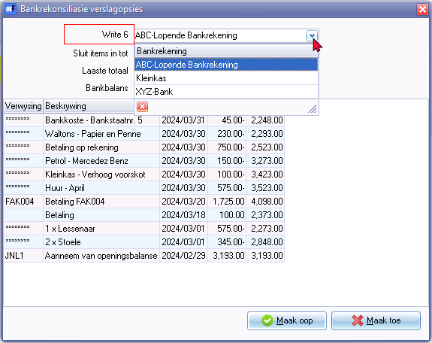

Process

* Apply reconciled
* Transfer Unreconciled to Batches

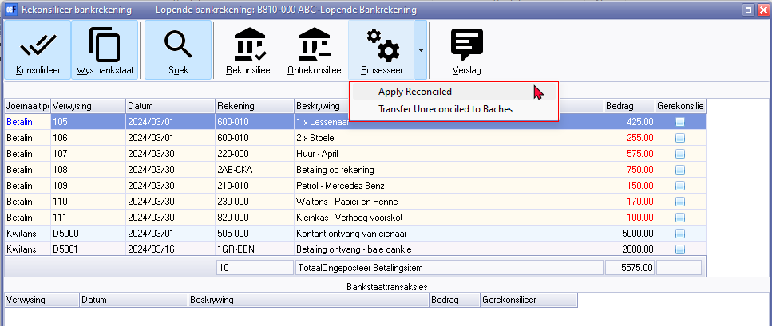

# FIXED - Bank reconciliation report as at

**Location**: " ... \plug_ins\reports\GENERAL\documents\recon.dfm

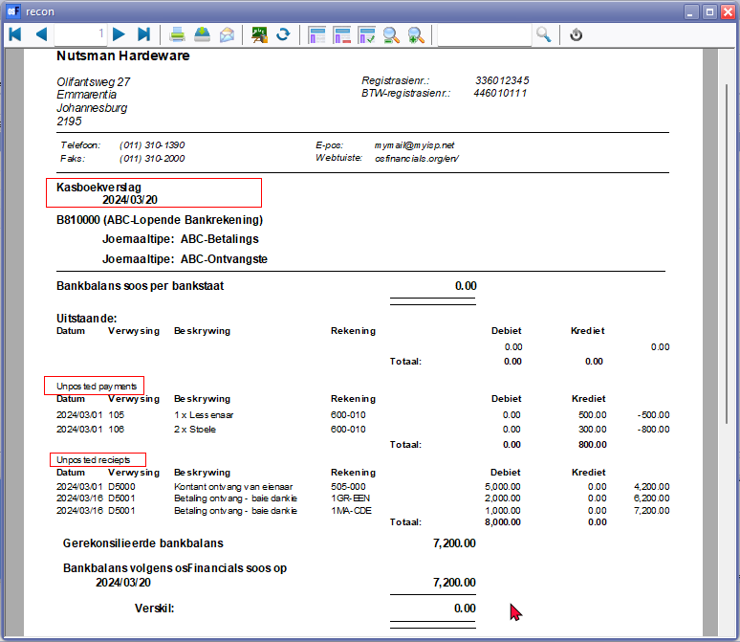

Unposted payments 906447

Unposted receipts 906448

**Language** : Kasboekverslag LabelID3014 changed in Afrikaans => Bankrekonsiliasie verslag soos op

**Expressions changed** :

TRpExpression55 CUSTOM('GETTEXTLANG',906447,'Unposted payments',0,0,0)

TRpExpression56 CUSTOM('GETTEXTLANG',906448,'Unposted receipts',0,0,0)

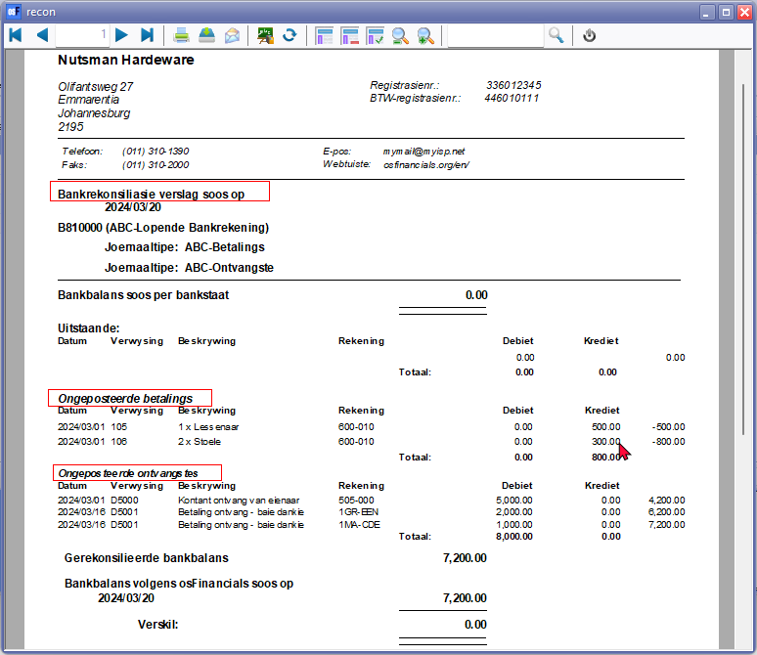

If the setting Print only if data available - Set to True for the following unposted subreports.

(SubReport-1UNPOSTEDPAYMENTS)

(SubReport-2UNPOSTEDRECEIPTS)

the Difference column will display a value as a result of the Reconciled balance.

For this reason, this setting is not applied.