Table of Contents

**Batches** 1

***Batch setup*** 1

***Batches - icon spreadsheet*** 2

***Post to retained earnings account confirmation message*** 2

***Batch filter*** 2

***Batch open item - Copy to search*** 3

***Edit - Repeating transactions*** 3

**Posted batch report** 3

**F9:Batch Process options** 4

***Cancel Error message*** 4

***Automatic payments*** 5

***Automatic receipts*** 6

**Batches**

***Batch setup***

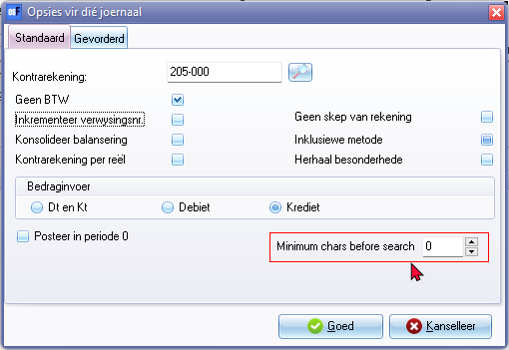

***Batches - icon spreadsheet***

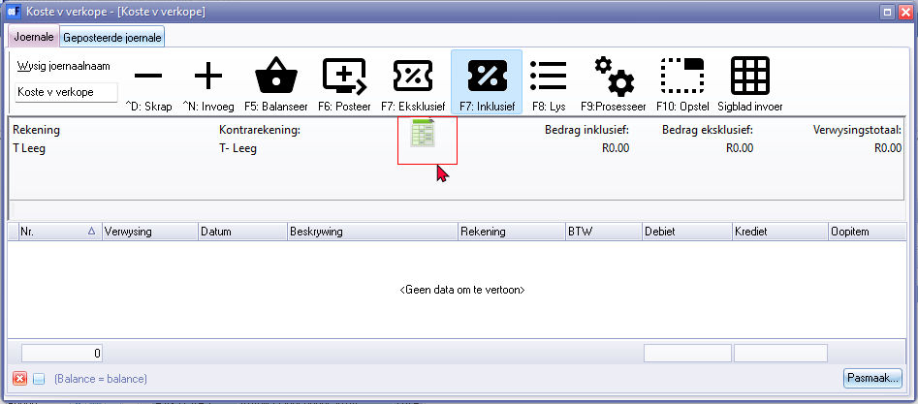

***Post to retained earnings account confirmation message***

*Do you wish to post on the retained earnings account?*

***Batch filter***

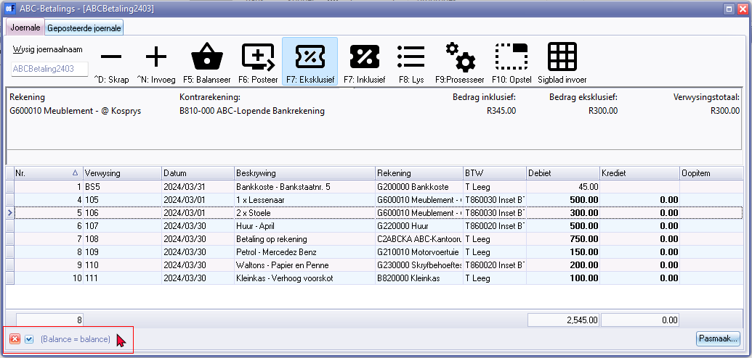

***Batch open item - Copy to search***

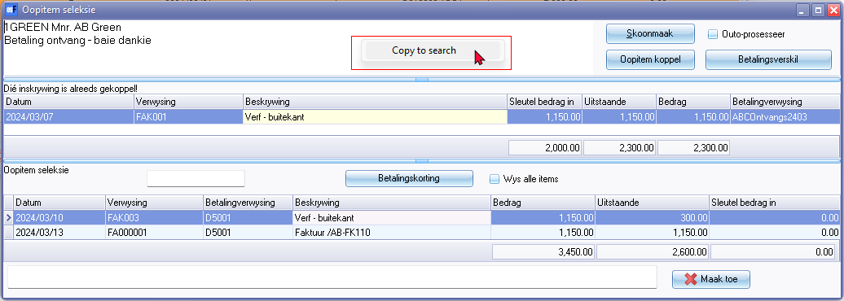

Copy to search

***Edit - Repeating transactions***

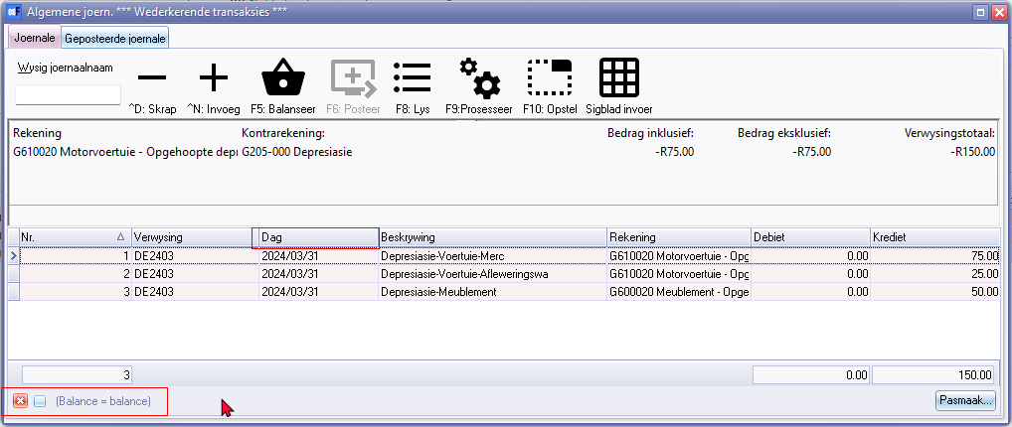

Day 2179 - Should be - Date 238

Balance = balance

**Posted batch report**

Fix unique id button

Filter options

* All
* Sorted

* Click here to show/hide/move columns (Mouse over)

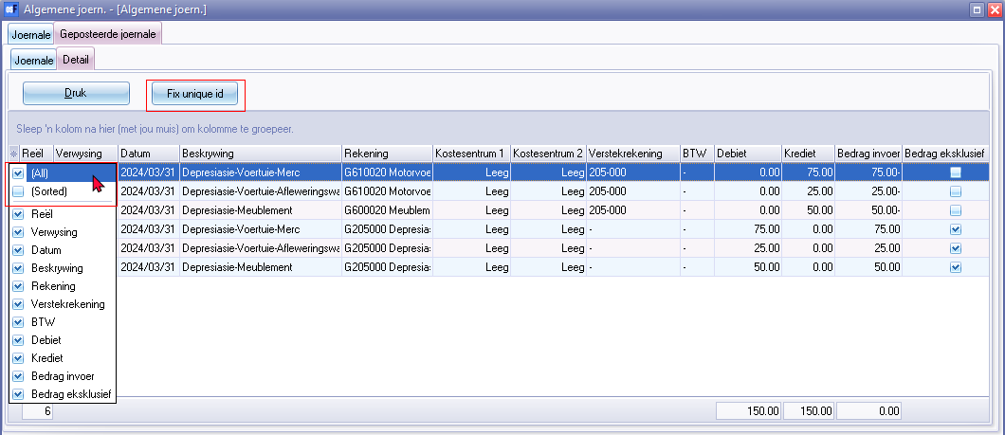

**F9:Batch Process options**

***Cancel Error message***

Creditor balances at date - click Cancel error message

*Operation aborted*

***Automatic payments***

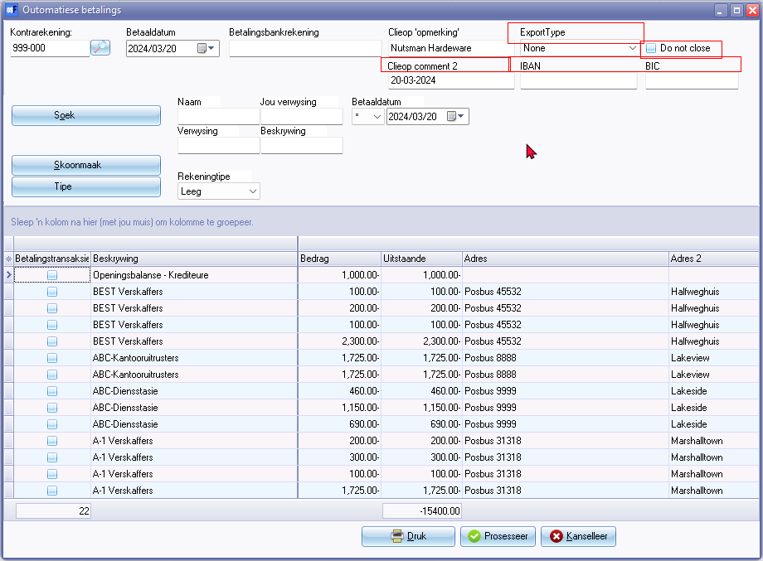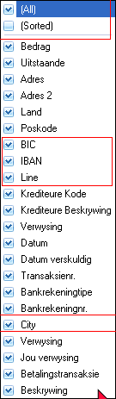

Language label = 906016 - BIC*

Language label = 906015 - IBAN*

***Automatic receipts***

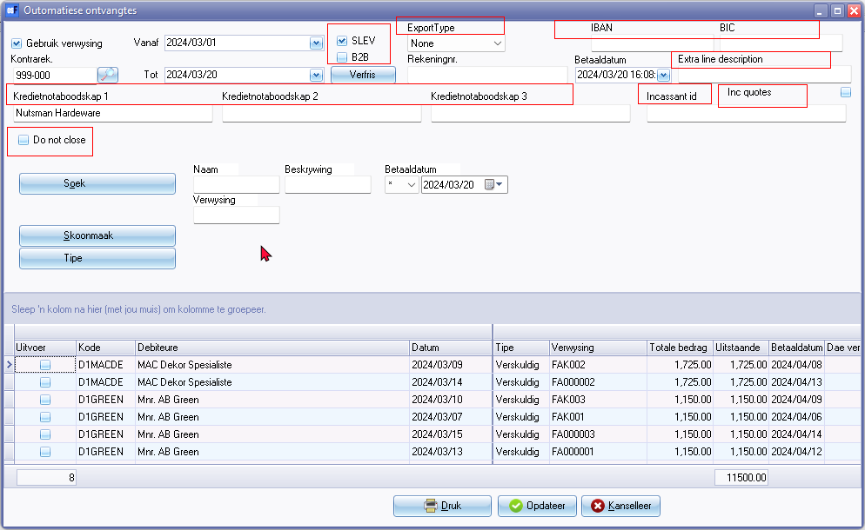

Language label = 906016 - BIC*

Language label = 906015 - IBAN*