Table of Contents

***Budgets (Reports ribbon)*** 1

***Messages*** 1

***Add amount - Confirmation message*** 1

***Delete all - Confirmation message*** 1

***Import Budget / Actual previous period - Confirmation message*** 1

***Budget grid*** 1

***Budget tab*** 1

***Transactions tab*** 2

***Pivot tab*** 3

**Setup - Accounts - Budget tab** 3

# Budgets (Reports ribbon)

Budget 1027 (Option on Reports ribbon)

***Messages***

***Add amount - Confirmation message***

*Add amount to selection?*

***Delete all - Confirmation message***

*Delete data for this period?*

***Import Budget / Actual previous period - Confirmation message***

*Delete data for this period?*

***Budget grid***

***Budget tab***

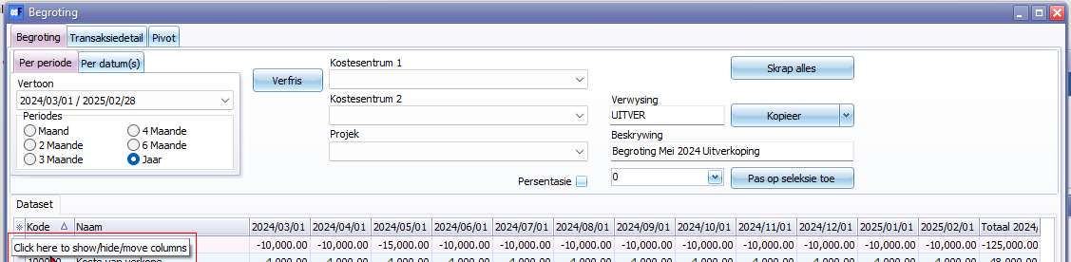

* Click here to show/hide/move columns (Mouse over)

Pivot tab

Dataset

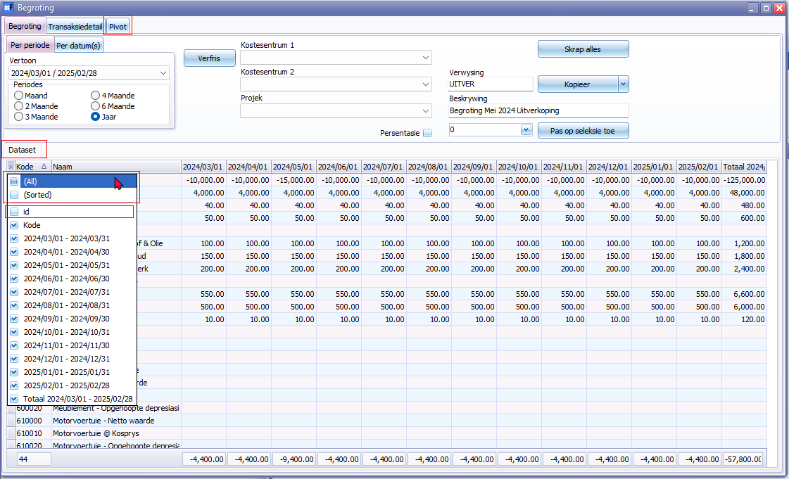

***Transactions tab***

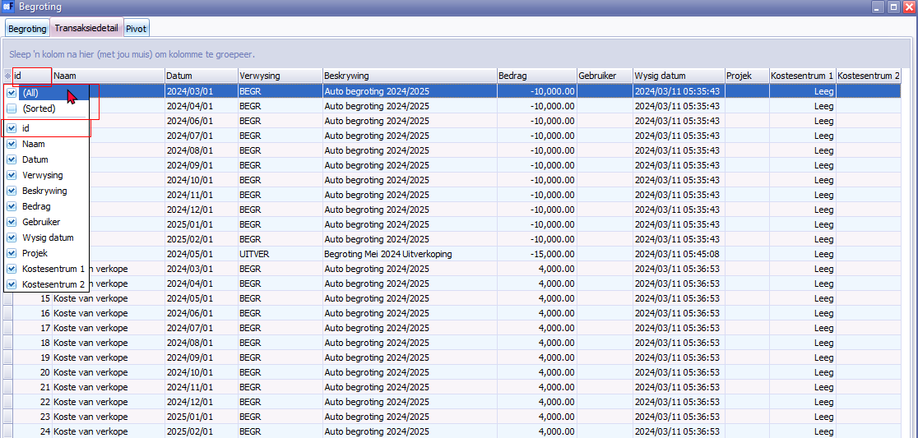

(All)

(Sorted)

id

***Pivot tab***

Entire Pivot tab + Columns + Context menus

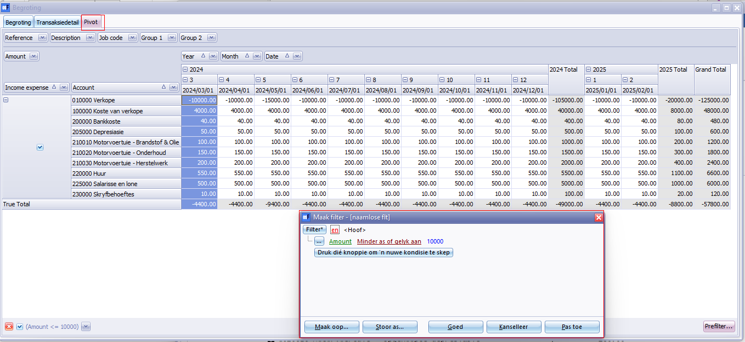

The Prefilter is translated except the column options

**Setup - Accounts - Budget tab**

## *Add new budget total*

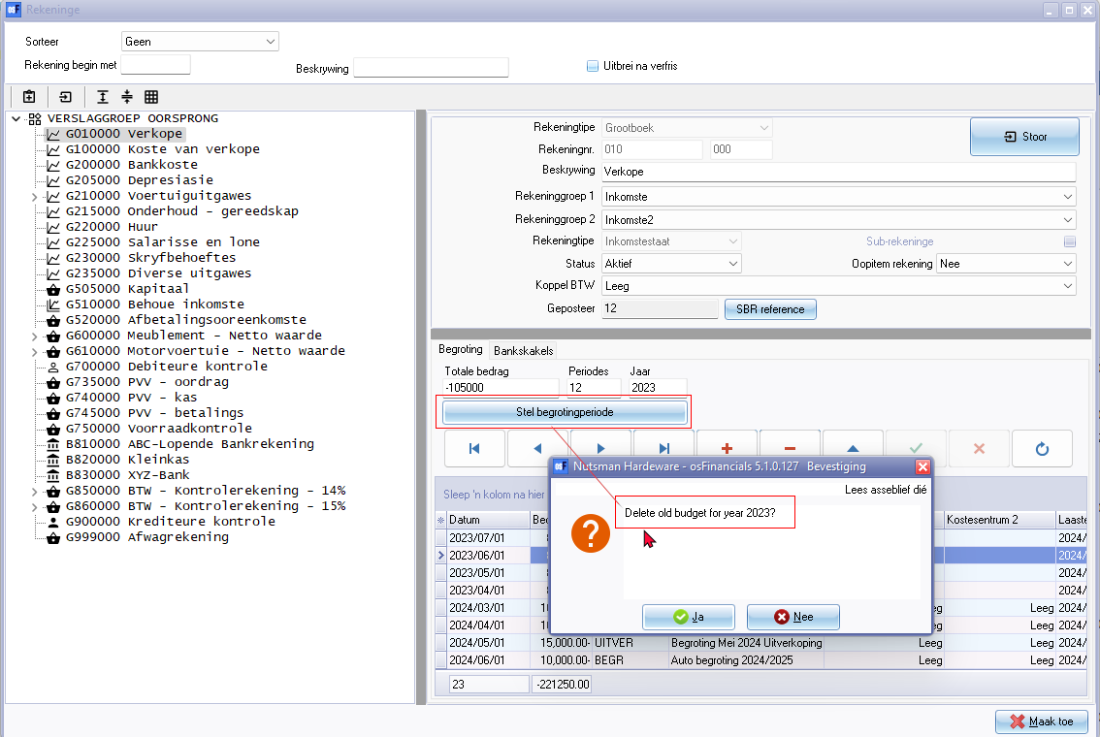

## *Delete budget record*

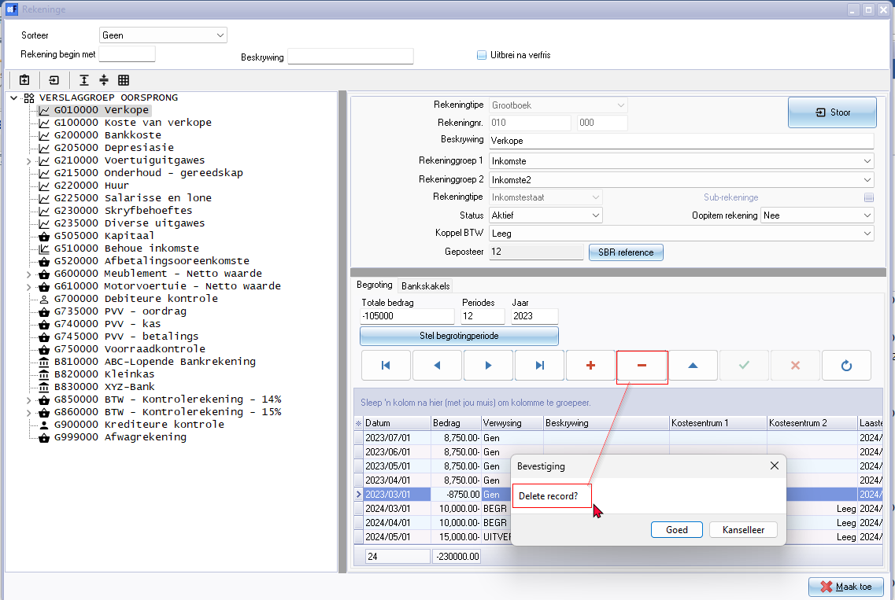

Delete record? 20002