Table of Contents

**Calendar** 1

**Appointment** 2

**Repeating invoice options** 2

**Tasks** 3

**Calendar**

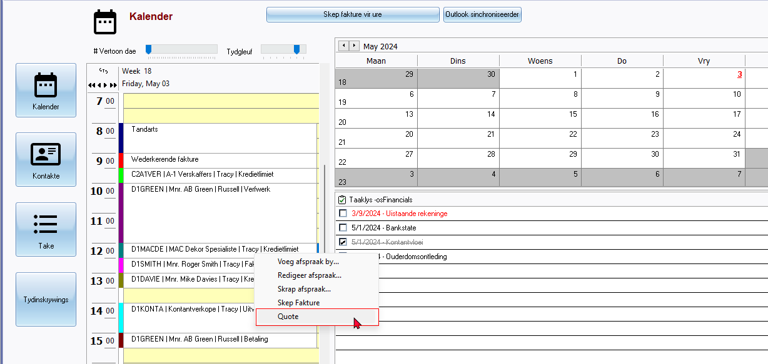

Quote

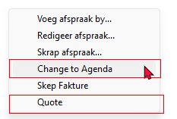

Change to Agenda This is applicable to the Multi-User Agenda Plugin - If activated and purchased should then be displayed as more resource names can be added.

**Appointment**

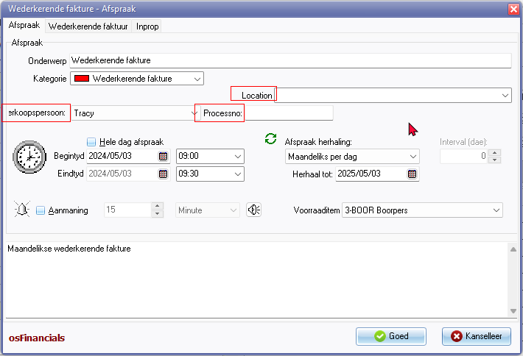

Location 3681 but for consistency on the Appointments screen it includes a colon : then 716 / 1829 includes a colon Location :

Processno:

Salesperson: - label cuts off in Afrikaans - LabelID1718 Verkoopspersoon => Verkoper:

**Repeating invoice options**

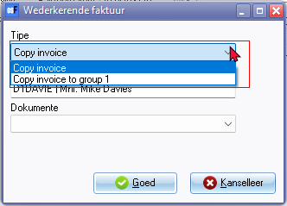

**Tasks**

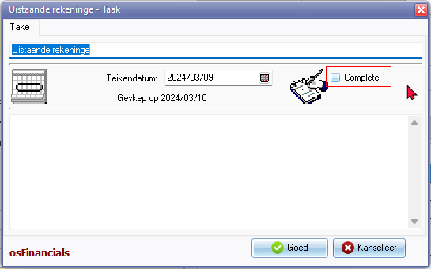

Complete