Table of Contents

**Debtors / Creditors** 1

***Debtors grid*** 1

***Creditors grid*** 2

***Debtor / Creditor tabs*** 2

***Accounting information*** 2

***Contacts form*** 3

**Debtors / Creditors**

***Debtors grid***

* Click here to show/hide/move bands (Mouse over) first asterisk

* Click here to show/hide/move columns (Mouse over) second asterisk

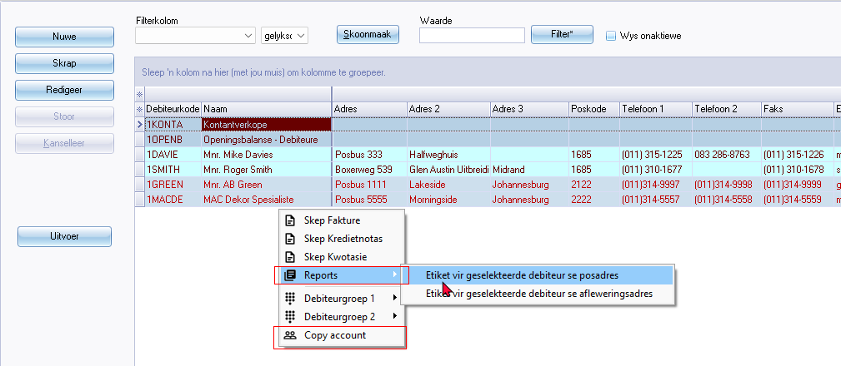

Reports 123

Copy account

Also on Debtor accounts when New document is created

***Creditors grid***

* Click here to show/hide/move bands (Mouse over) first asterisk

* Click here to show/hide/move columns (Mouse over) second asterisk

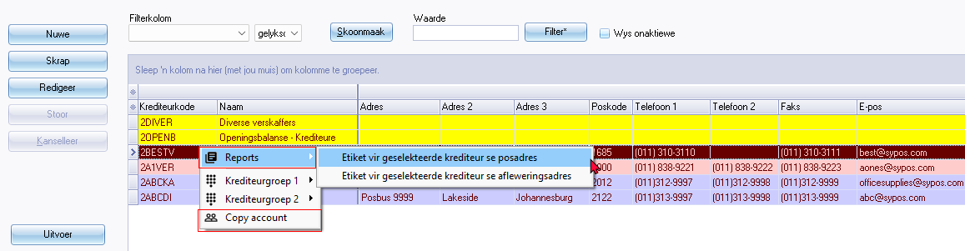

Reports 123

Copy account

Also on Creditor accounts when New document is created

***Debtor / Creditor tabs***

***Accounting information***

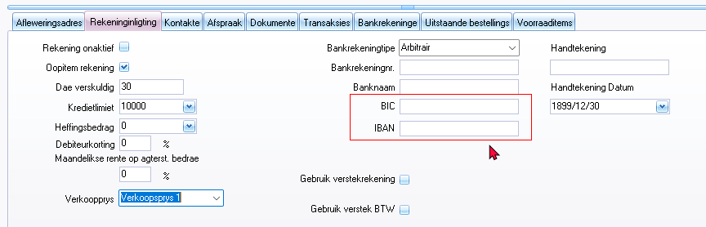

Language label = 906016 - BIC*

Language label = 906015 - IBAN*

***Contacts form***

Freefield7 field missing on Telephone tab

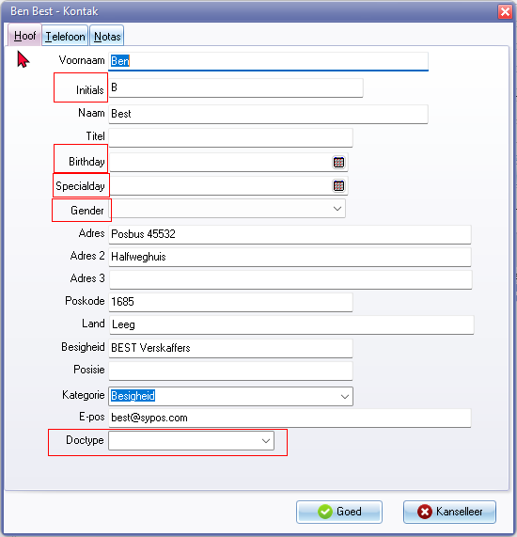

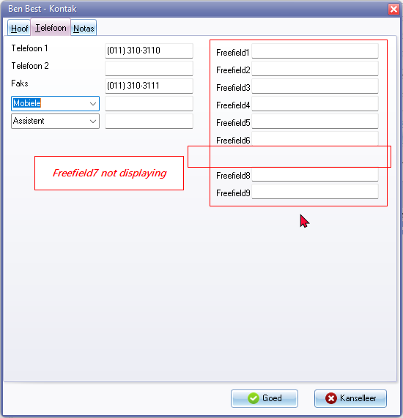

Birthday

Specialday

Gender 3198

Male 3199

Female 3200

Doctype (Document type) 1087 / 1869

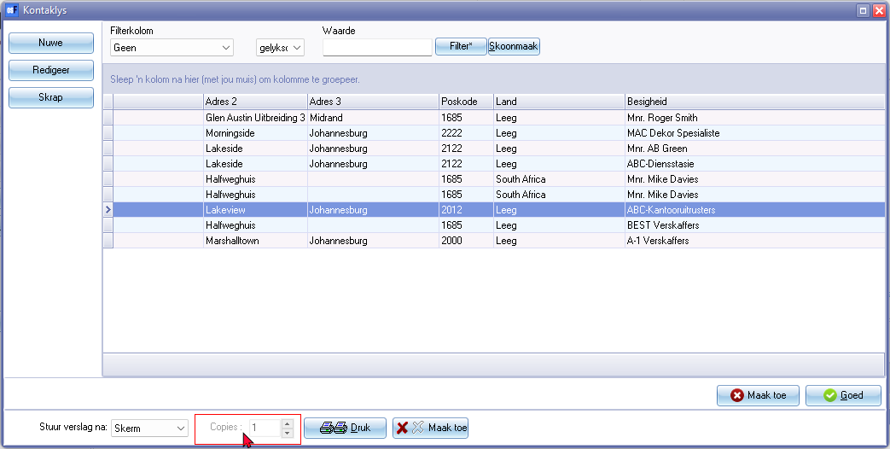

Copies 732