Table of Contents

**Documents** 1

*Reverse posted documents log* 1

*Document labels cuts-off* 2

*F8: Discount icon* 2

*Enter total* 2

***Document grid columns*** 3

***Documents grid - context menus*** 3

***Documents grid - context menu - Invoices*** 3

***Documents grid - context menu - Quotes*** 4

***Documents grid - context menu - Credit notes*** 4

***Documents grid - context menu - Purchases*** 5

***Documents grid - context menu - Orders*** 5

***Documents grid - context menu - Supplier returns*** 6

***Document grid - Graphs*** 6

**Document entry** 7

***Form - Header*** 7

***Document lines - Context menu*** 7

***Document - Footer - Context menu*** 7

***Documents - Contra account: Standard*** 8

**Input → Confirm Shift+F3** 9

**Documents context menu - XML import settings** 9

**Documents**

## *Reverse posted documents log*

*Reversing AK000001  
Reversing AK000002  
Reversing AK000003  
Reversing AK000004  
Done.*

## *Document labels cuts-off*

### *F8: Discount icon*

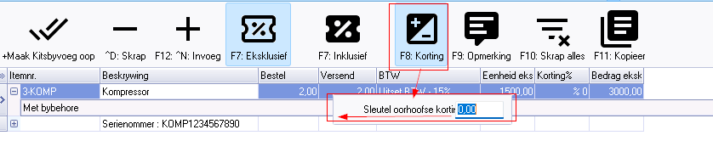

On the F8:Discount icon, the screen cuts the following label-off in both languages:

2151 - Sleutel oorhoofse korting in / Enter overall discount

*Enter total*

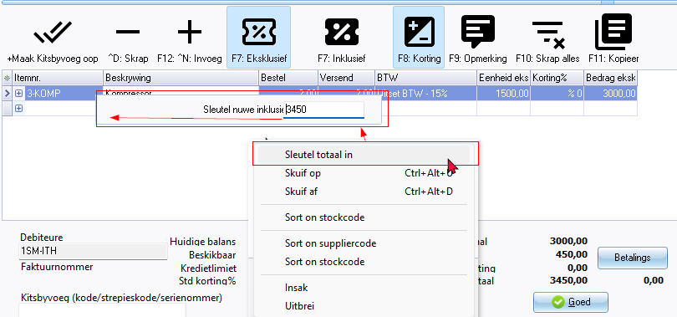

On the context menu, select "*Enter total*" / "*Sleutel totaal in*". The screen cuts the following label-off in both languages:

3322 Sleutel nuwe inklusiewe totaal in / Enter new inclusive total

***Document grid columns***

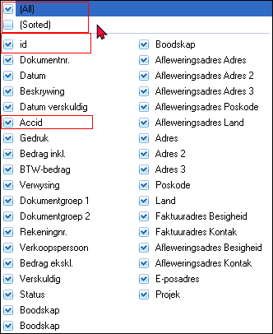

***Documents grid - context menus***

***Documents grid - context menu - Invoices***

* Click here to show/hide/move bands (Mouse over) first asterisk

* Click here to show/hide/move columns (Mouse over) second asterisk

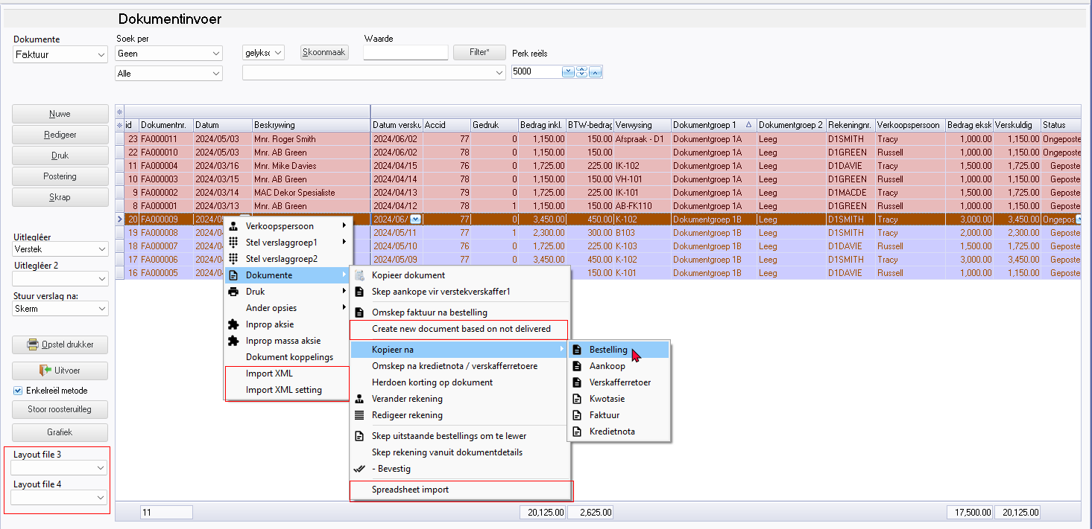

Layout file 3 - 3111

Layout file 4

Spreadsheet import 3720

***Documents grid - context menu - Quotes***

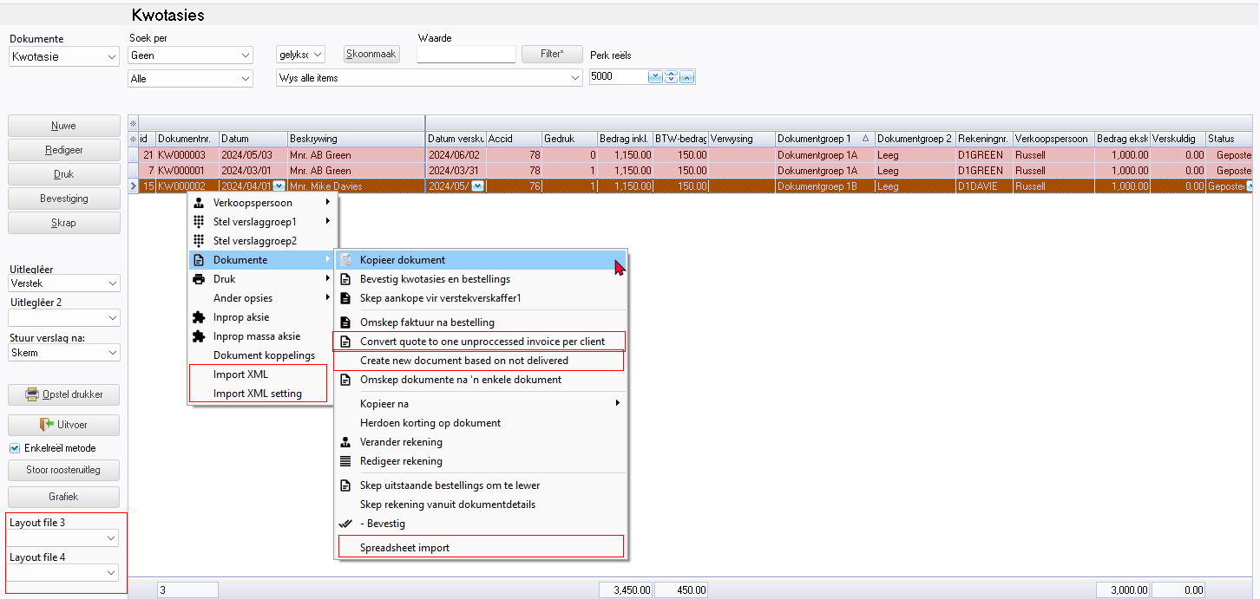

***Documents grid - context menu - Credit notes***

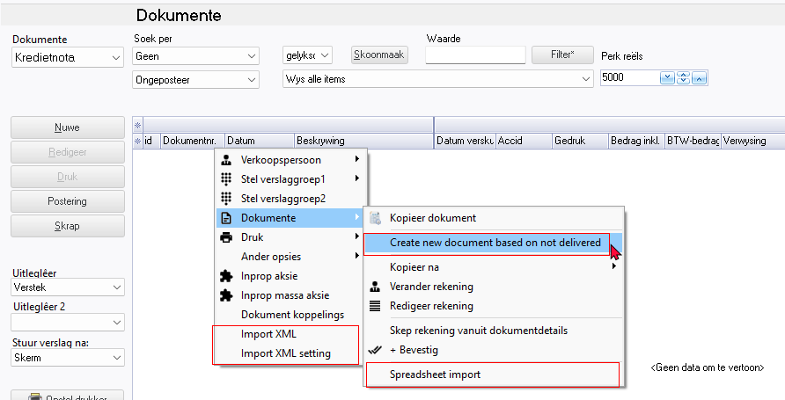

***Documents grid - context menu - Purchases***

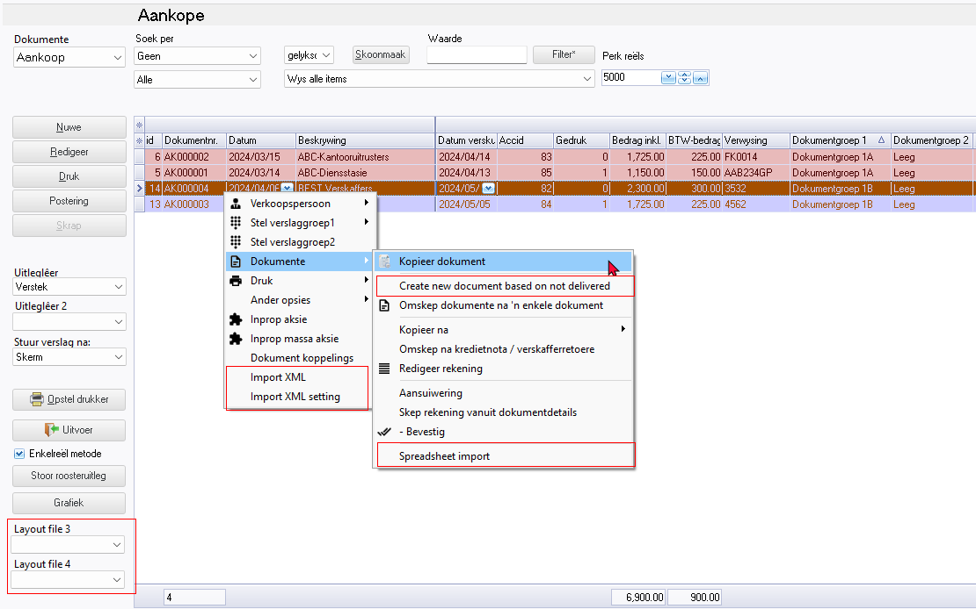

***Documents grid - context menu - Orders***

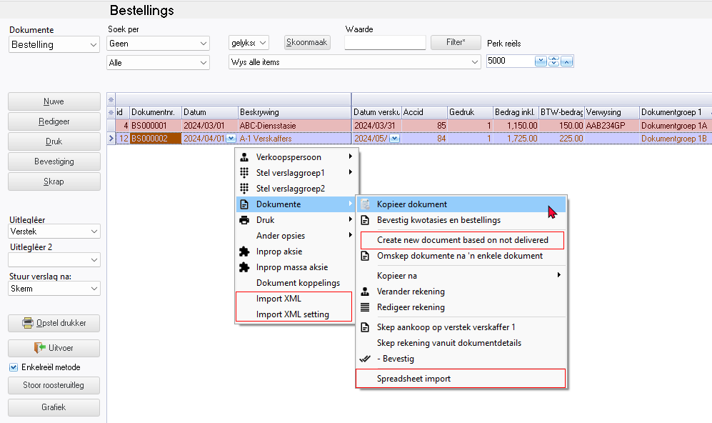

***Documents grid - context menu - Supplier returns***

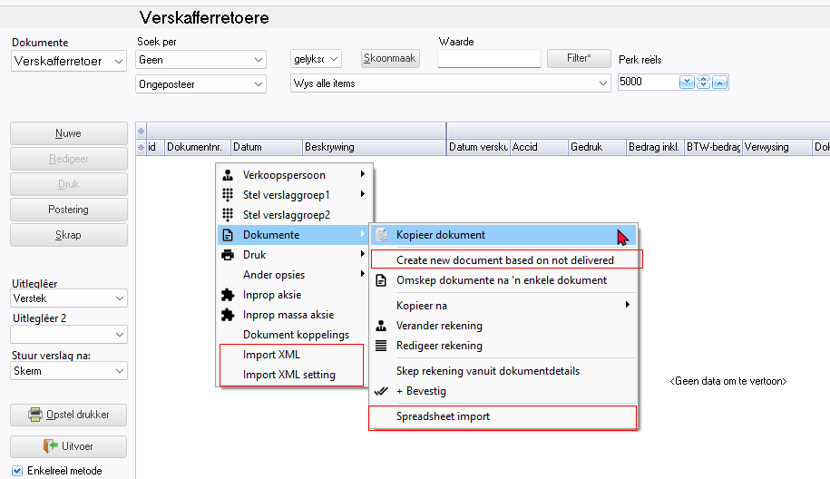

***Document grid - Graphs***

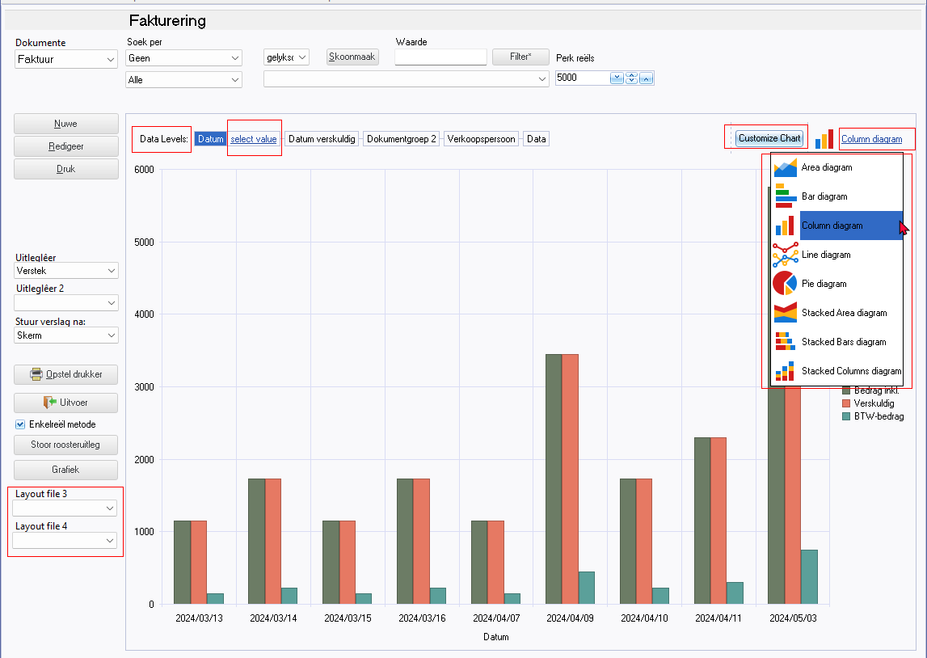

**Document entry**

***Form - Header***

Currency

Rate 3455

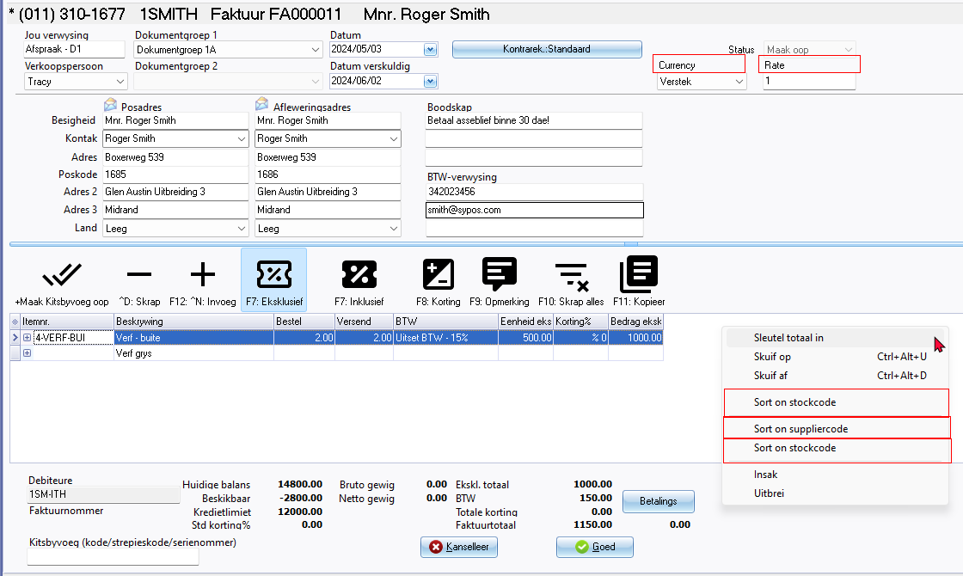

***Document lines - Context menu***

Sort on stockcode

Sort on stockcode (Duplicated)

Sort on supplier code

***Document - Footer - Context menu***

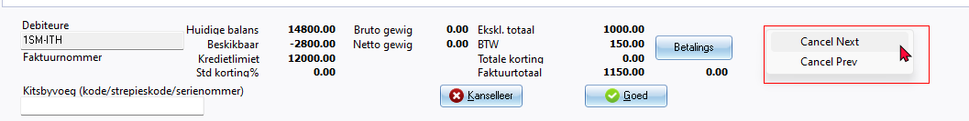

Cancel Next

Cancel Prev

***Documents - Contra account: Standard***

Lookup - Select account - Titlebar caption

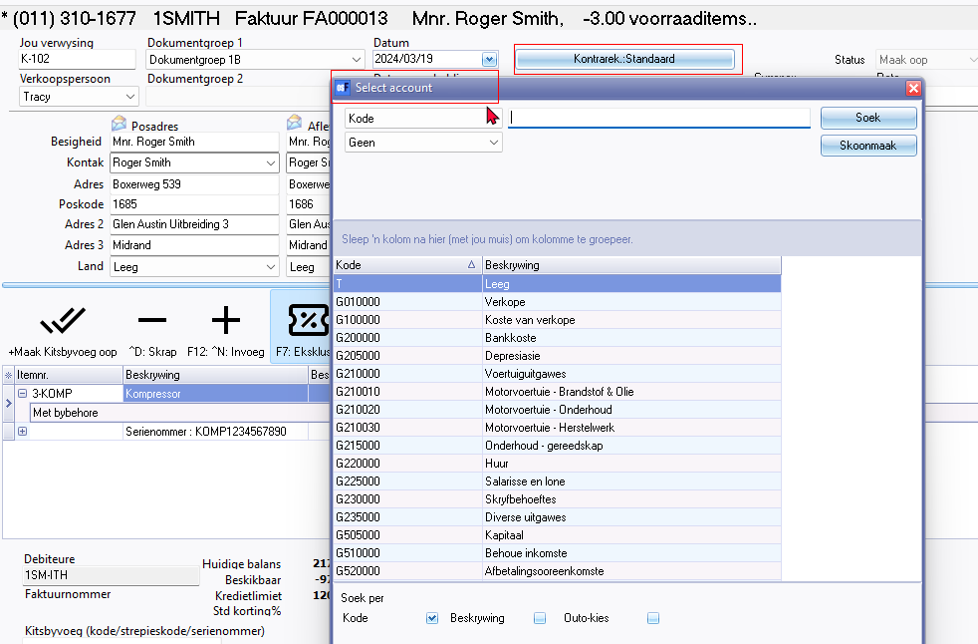

**Input → Confirm Shift+F3**

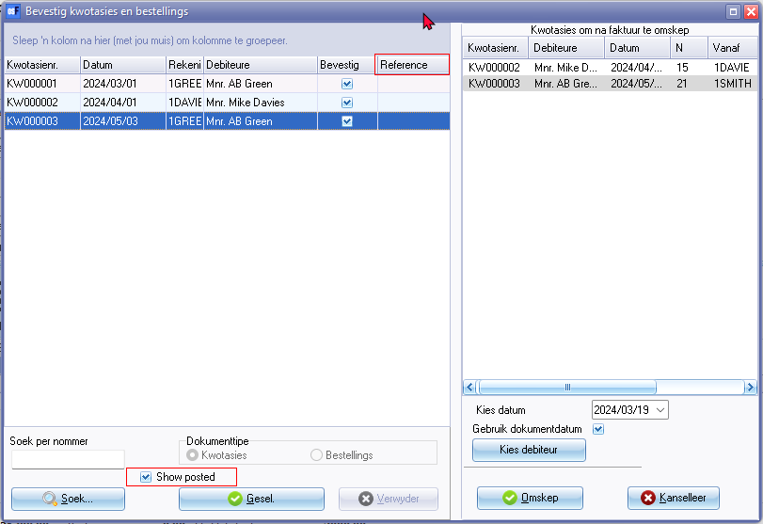

Reference (LanguageID 607 / 1285 / 1719 / 1974)

Show posted

**Documents context menu - XML import settings**

Documents grid - context menu

