Table of Contents

Import / Export (Setup ribbon) 1

*Import* 1

*Export* 1

*Export - Documents* 2

*Export - Stock* 3

*Export - Posted batches* 4

# Import / Export (Setup ribbon)

## *Import*

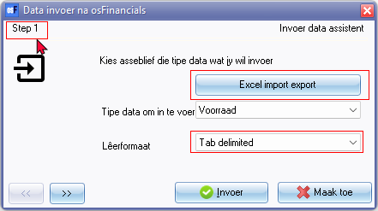

Step 1 - static on all 3 screens enter click next buttons

**Excel import** button - ID3270 = Spreadsheet import

File format (File type) selection on list

## *Export*

Increment Export (Stock, Accounts, Debtors, Creditors and Posted batches)

File format (File type) selection on list

### *Export - Documents*

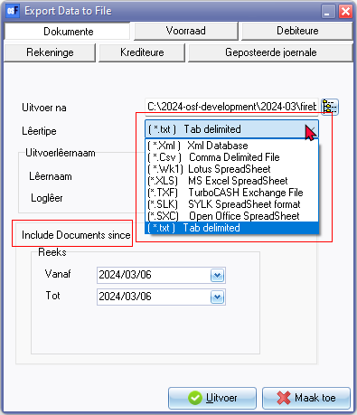

File format (File type) selection on list

Include Documents since

### *Export - Stock*

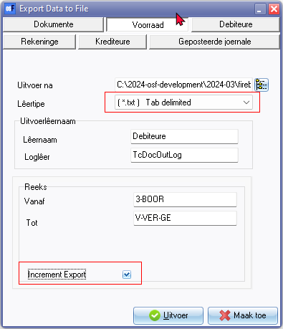

Increment Export (Also on Accounts, Debtors, Creditors)

Export - Stock - Lookup -

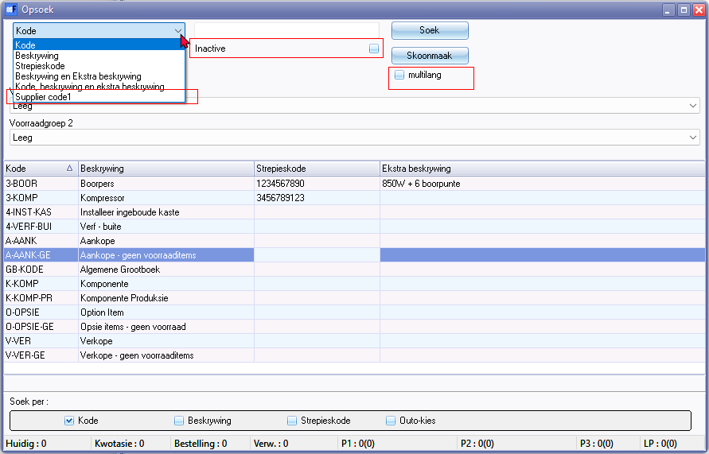

Footers does not update document quantities for stock

Export - Stock - Lookup - Sometimes the Stock lookup is empty but Footers displays update stock totals quantities and prices for stock (in the same database)

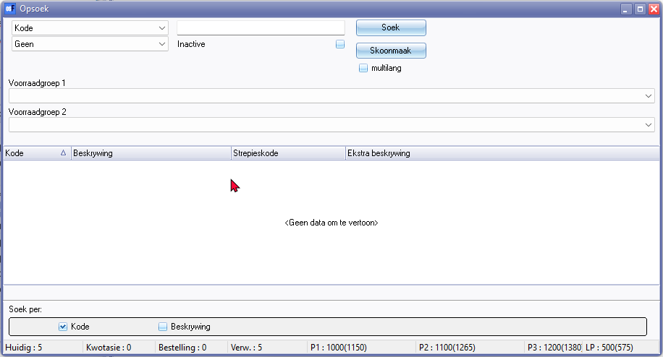

### *Export - Posted batches*

Increment Export

Export - Posted batches - Lookup -

Inactive

multilang

Filter Code , etc. - includes stock options - Supplier code

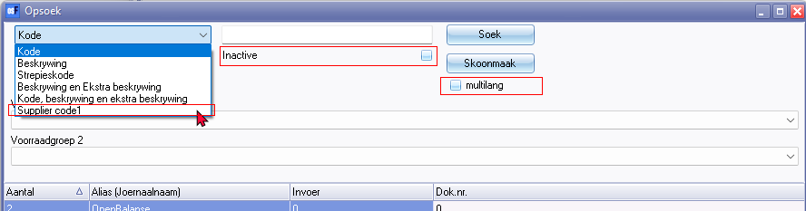

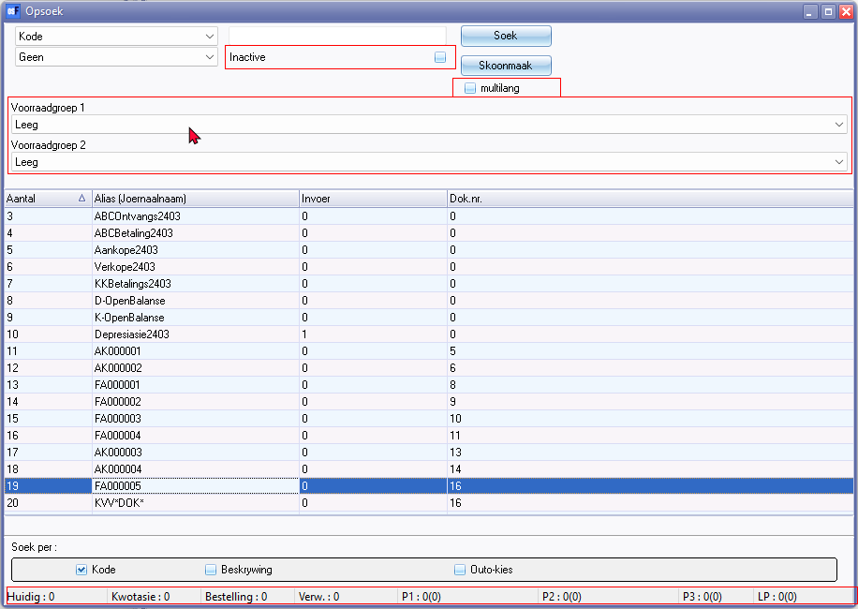

Footers does not update document quantities and prices for stock