Table of Contents

Point of Sales (Standard) 1

POS Setup 1

*Settings* 1

*Peripherals tab* 2

*Printer* 2

POS Invoicing 3

# Point of Sales (Standard)

# POS Setup

## *Settings*

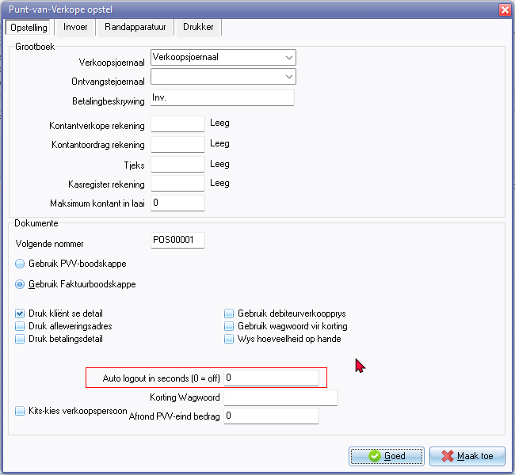

## *Peripherals tab*

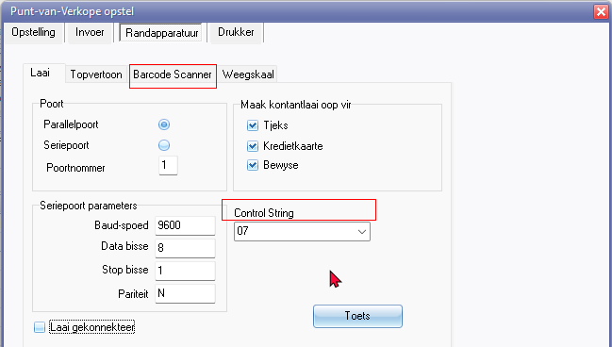

Barcode Scanner tab

Control String

## *Printer*

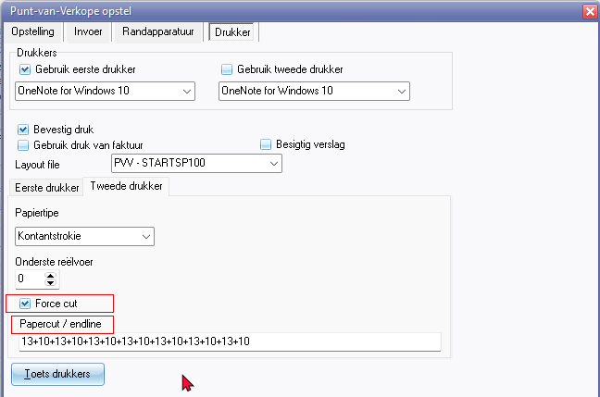

Same applies to Second printer

Force cut

Papercut / endline

# POS Invoicing

