Table of Contents

**Report designer** 2

***Select test document*** 2

***Reportman error parameter*** 2

***Page setup*** 3

***Printer setup*** 4

***Reportman menus*** 5

***Reportman menu - File*** 5

***Reportman menu - Edit*** 7

***Reportman menu - Preferences*** 7

**Structure / Data tabs** 8

**Database connections and datasets** 8

**Reportman Parameters** 9

**Report designer**

***Select test document***

Select test document id (3580)

No id so dropped the id in the label 3580 - Kies toetsdokument (in Afrikaans)

Lookup - Select doc (Titlebar caption) 3580

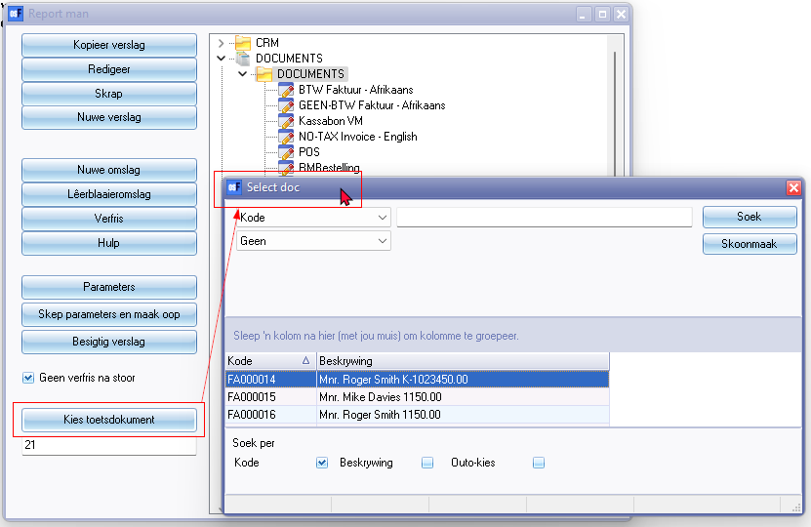

***Reportman error parameter***

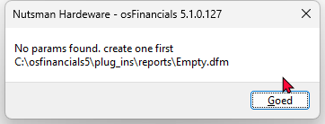

***Page setup***

Also accessed from the Reportman Preview screen.

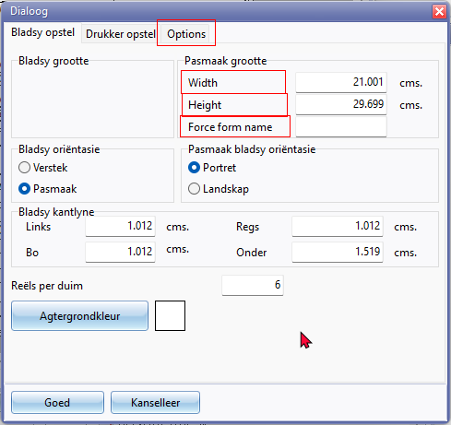

Options tab 1012

Width 1340

Height 3545

Force form name

***Printer setup***

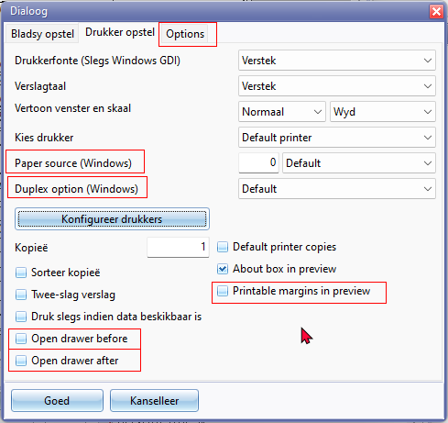

Paper source (Windows)

Duplex source (Windows)

Printable margins in preview

Open drawer before

Open drawer before

***Options***

Preferred save format

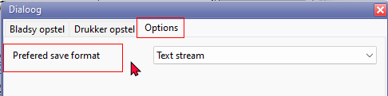

***Reportman menus***

***Reportman menu - File***

The **Print** and **Print Setup** screens is translated via your operating system's language.

Also on the Print option on the Reportman Preview screen is translated via your operating system's language.

**Druk** (**Ctrl+P**) – Dit sal die “*Print*”-skerm begin.

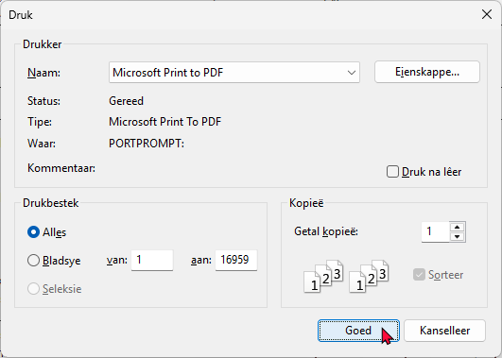

Printer to PDF when click **OK**, the **Save Print Output AS** title bar caption is not translatable. The rest of the file explorer is translatable.

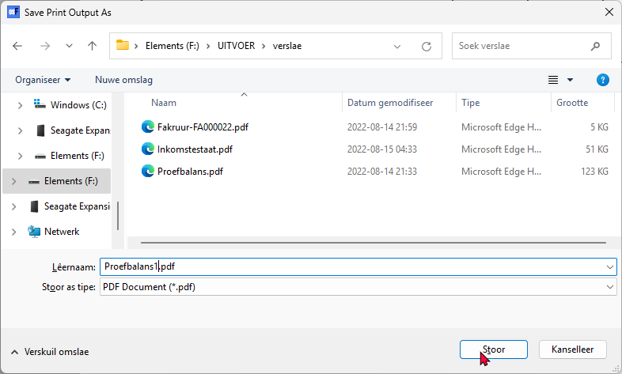

In Operating system language these options from the File menu in the Report designer is translatable.

The **Print** and **Print Setup** screens is translated via your operating system's language

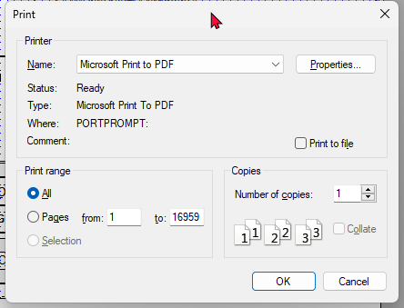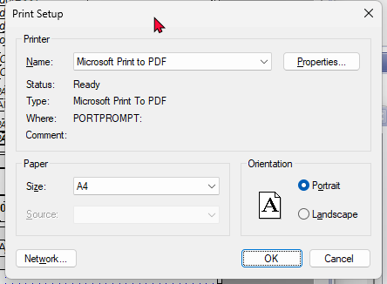

***Reportman menu - Edit***

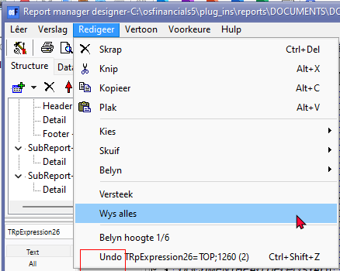

Undo

***Reportman menu - Preferences***

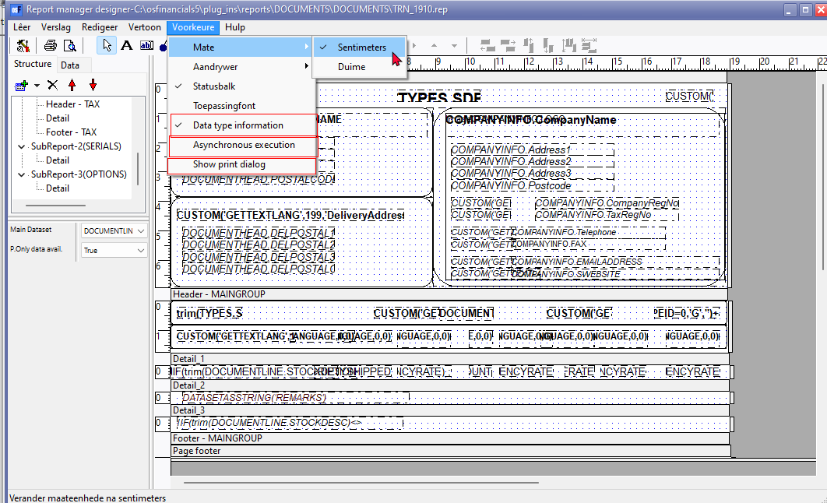

**Structure / Data tabs**

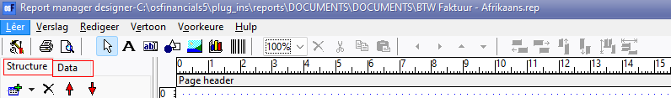

Structure

Data 1296

**Database connections and datasets**

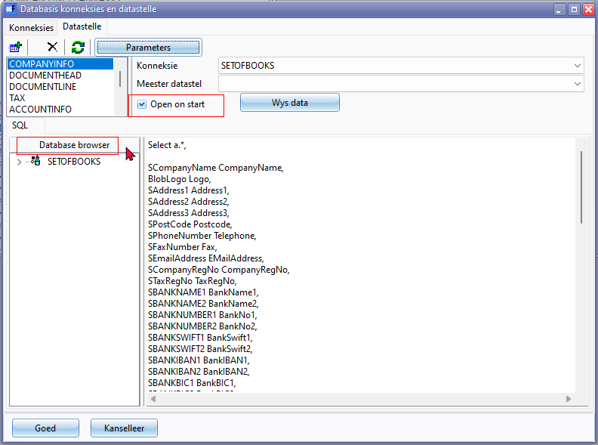

Database browser

Open on Start

**Reportman Parameters**

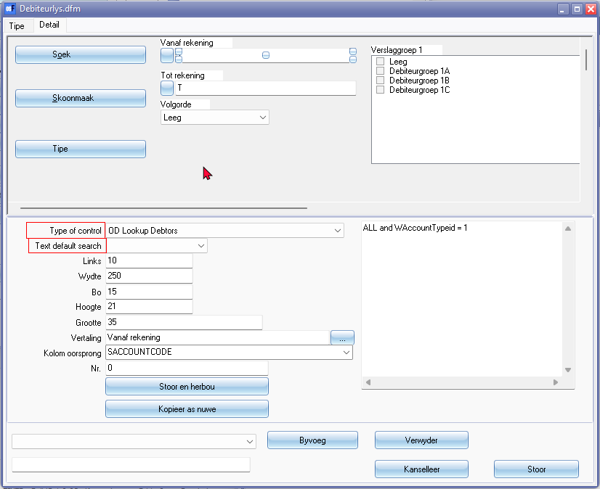

Type of control

Text default search