Table of Contents

Point of Sales (Standard) 1

POS Setup 1

*Settings* 1

*Peripherals tab* 2

*Printer* 2

POS Invoicing 3

**Reports ribbon**

***Ledger analyser***

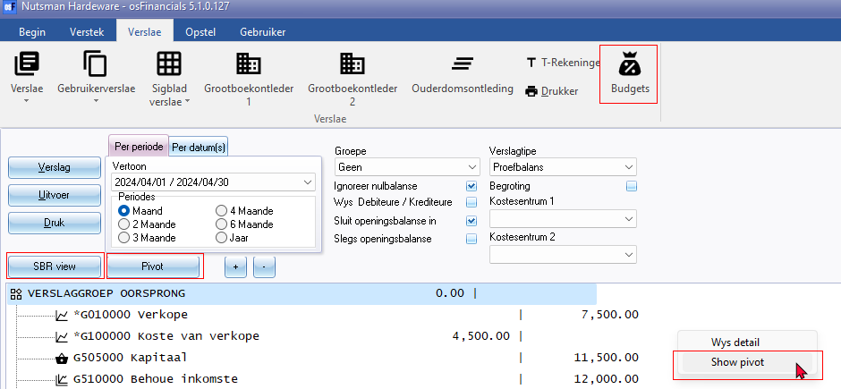

Ledger analyser - D / C - Debit Credit indicator

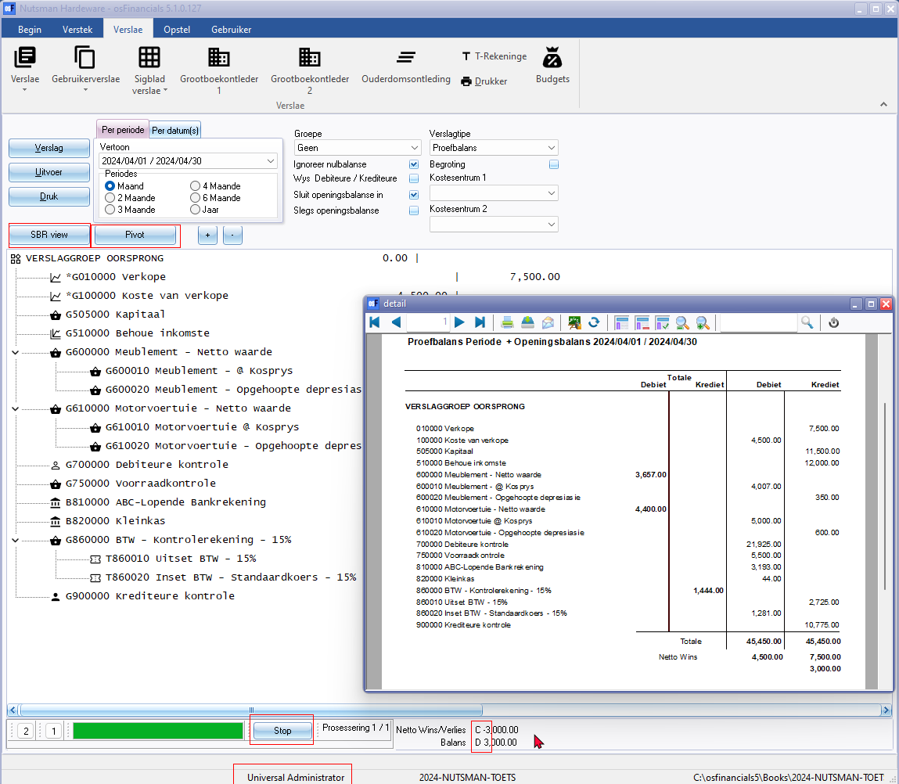

***T-Account viewer***

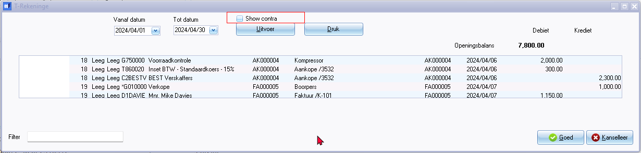

Show contra 2092

***Pivots***

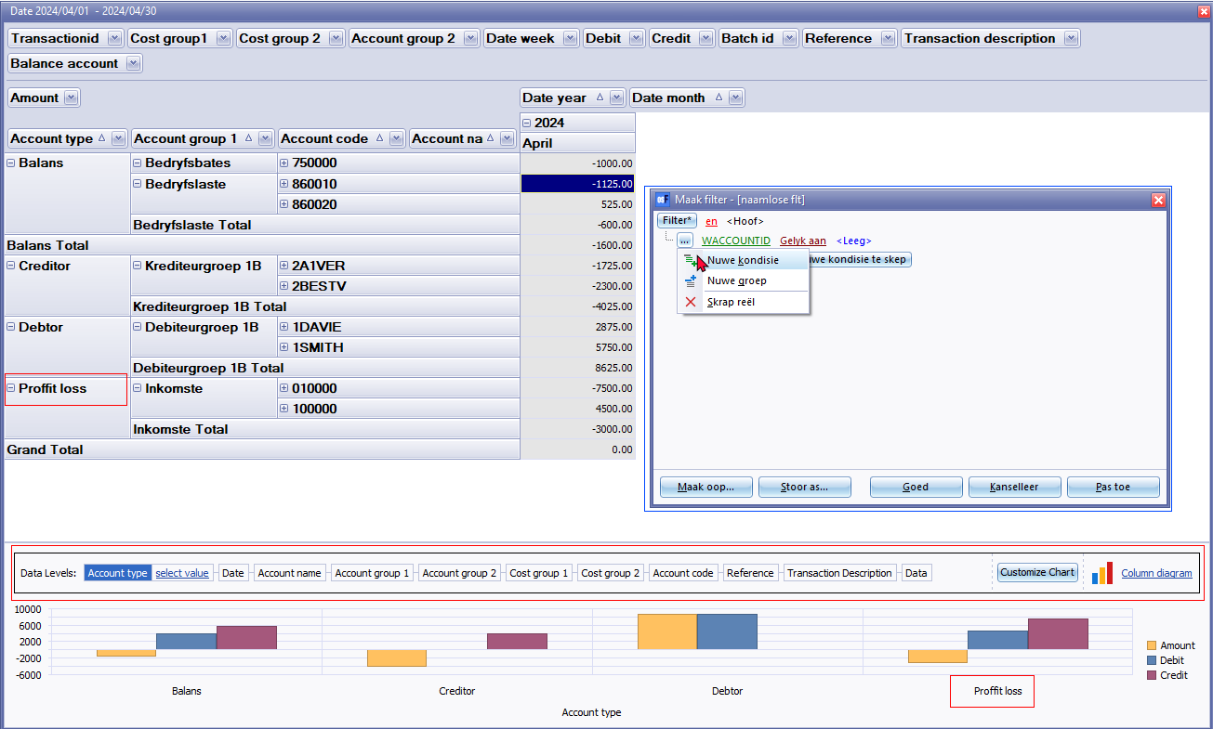

***SBR-view***

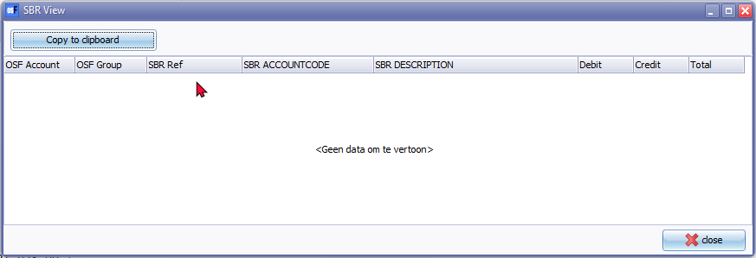

***SBR - Setup - Accounts***

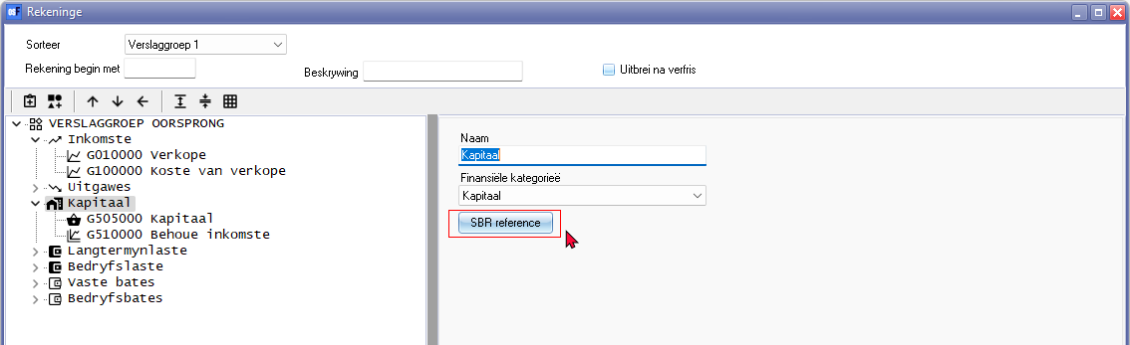

SBR reference button

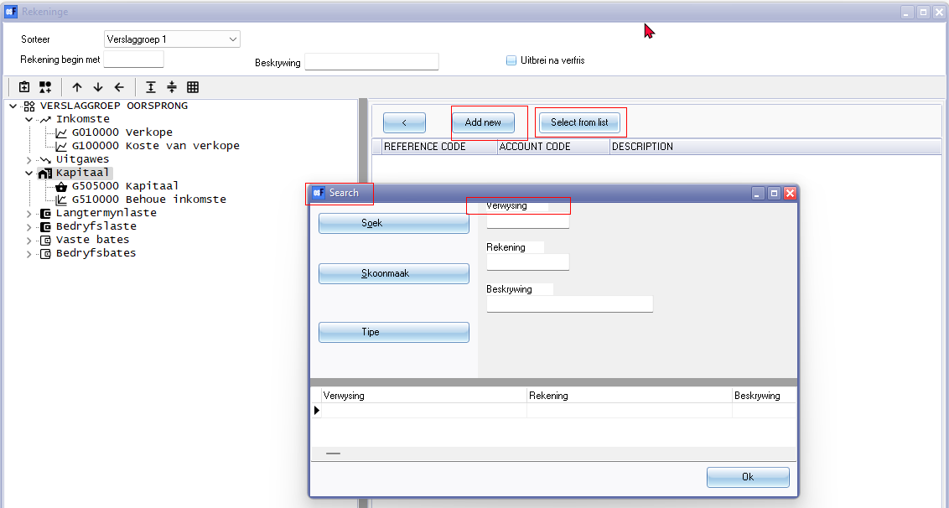

Add new

Select from list - Search in Titlebar

Ok button