Table of Contents

**Setup ribbon** 1

***Setup Accounts*** 1

***Documents setup*** 2

***Setup - Printer*** 2

***Setup groups*** 3

***Company info*** 4

***Company info - Address*** 4

***Company info - Options*** 5

***Setup - Countries*** 6

***Setup - Currencies*** 6

***Setup - Internet*** 7

***Setup - System parameters*** 8

**Setup ribbon**

***Setup Accounts***

Changing groups - Update groups of Sub-accounts within selected Main accounts

*Update subaccounts with this group?*

***Documents setup***

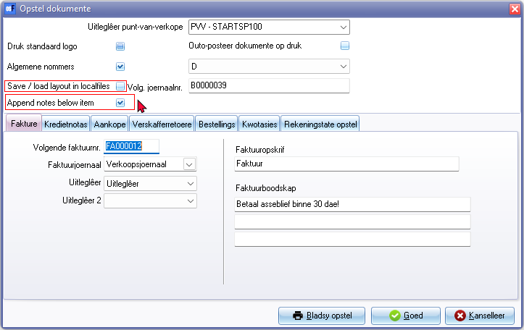

NOTE Print standard logo not working

* Save / load layout in local files
* Append notes below item

***Setup - Printer***

Accessed from

* Documents setup - Page setup button
* Printer (Reports ribbon)
* Setup **→** Printer menu
* Report designer / Reportman

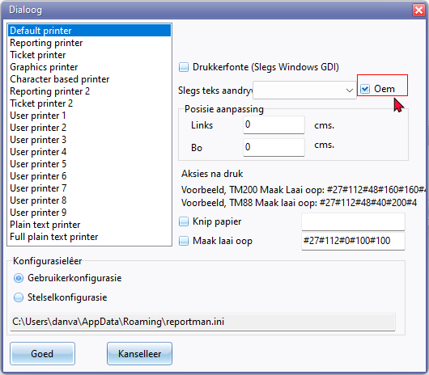

***Setup groups***

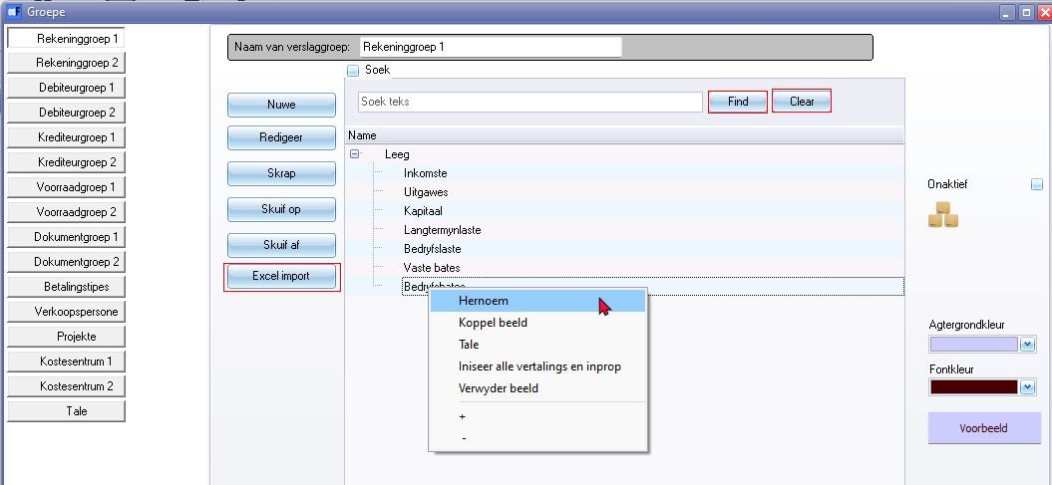

* Find 22434
* Clear 1016 (with Ampersand &Clear)

**Excel import** button - ID3270 = Spreadsheet import

* See **Import** on **Setup** ribbon - **Excel import** button
* On Batch entry and Stock grid - Export / Import tab

**+ -** om context menu collapse / expand and not consistent with > arrows on Setup **→** Accounts / Ledger analyser 1/2 and other screens.

***Company info***

***Company info - Address***

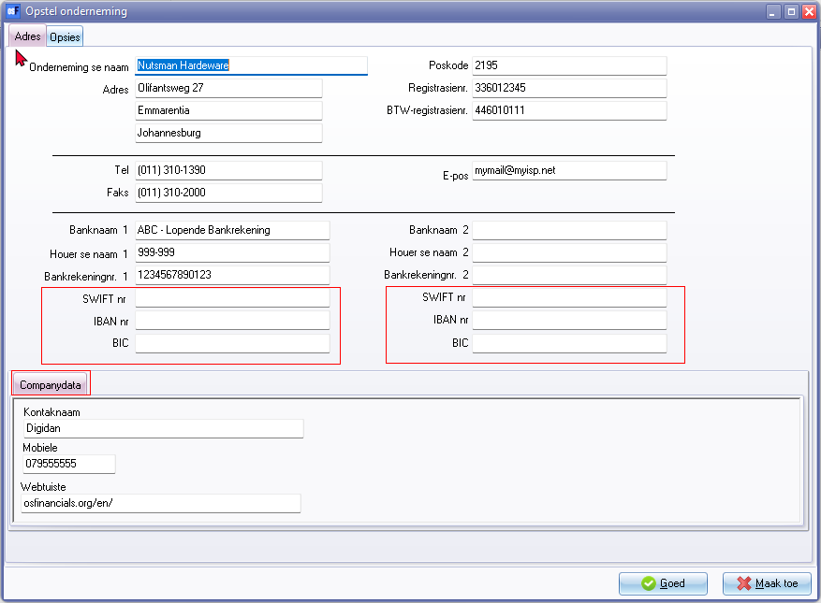

ID906015 - IBAN*

ID906016 - BIC*

ID906017 - SWIFT *

Companydata tab (SYSVARSEXT - table)

***Company info - Options***

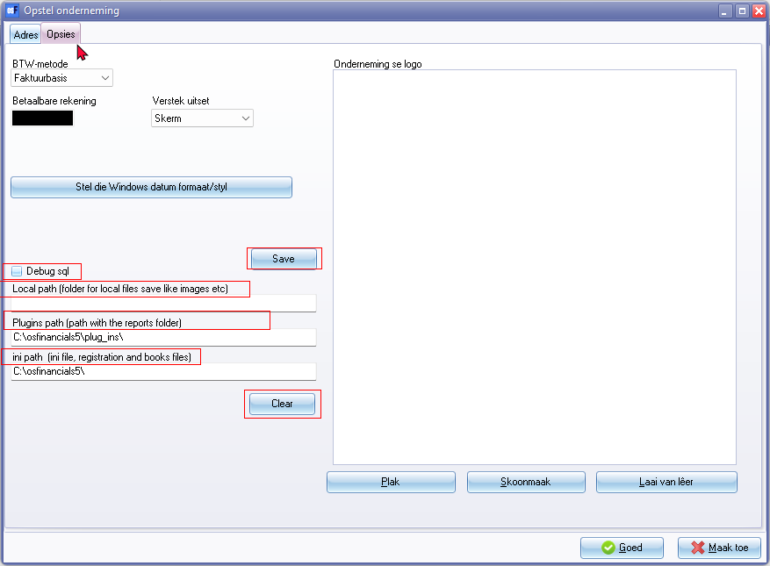

* Debug sql
* Paths
* Save button 726
* Clear button 1016 (with Ampersand &Clear)

***Setup - Countries***

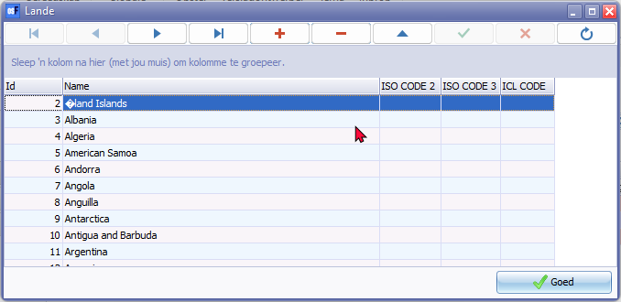

Column headings

Countries list only in English - Also in Debtors / Creditors / Documents

***Setup - Currencies***

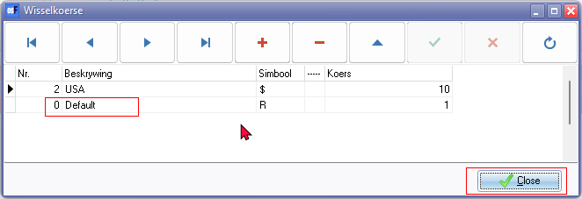

Close button 828

***Setup - Internet***

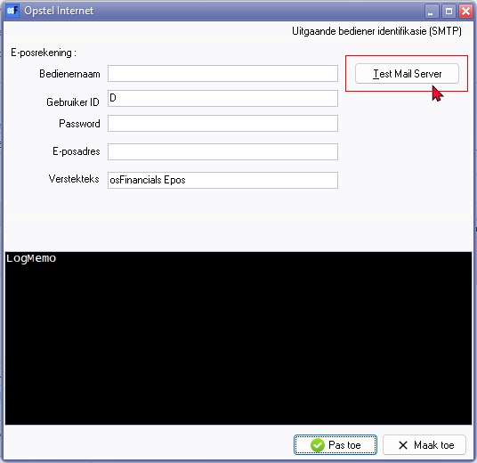

***Setup - System parameters***

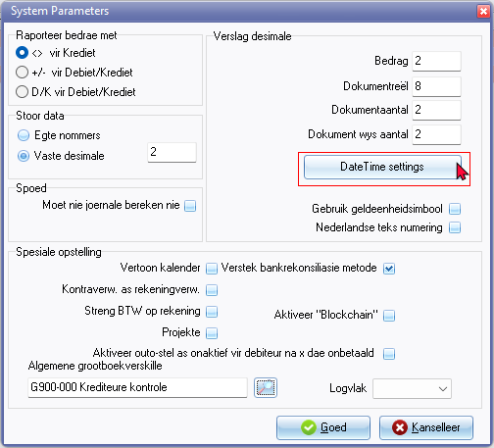

DateTime settings