Table of Contents

**Spreadsheet sales (Default ribbon)** 1

**Spreadsheet Import / Export** 1

**Spreadsheet import - Find account** 1

**Spreadsheet sales (Default ribbon)**

Error message

*Erro Batch not found. Please setup a batch in POS setup.*

Select the Sales journal "*Ledger*" section of the Setup **→** Point-of-Sale. Once this is done, you can access the Spreadsheet sales blank spreadsheet

**Spreadsheet Import / Export**

Data Import Export

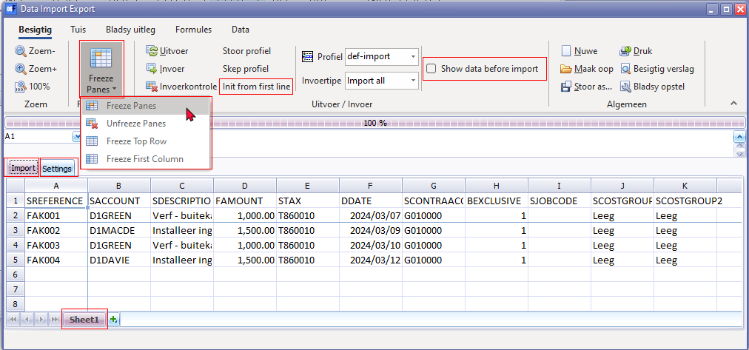

On the **View** tab most labels is translatable - but on the other tabs no data is translated.

**Spreadsheet import - Find account**

Find account - lookup titlebar

